RETHINKING PROSPERITY
Robert David Steele
We are at the end of the Industrial Era. This era has been a top-down “because I say so” era of control by the few, leveraging secrecy to enable massive corruption and waste as well concentrated wealth that has sucked value out of communities to the point of their demise.
There is good news. With the recent breaking of the ranks of the 1% elite – with the emergence of the concepts of Inclusive Capitalism (Lady Rothchild), Mutuality Economics (Mars Family), and Redemptive Capitalism (“black sheep billionaires” on the US West Coast) – we can now begin a new era. The new era returns us to the best practices of our indigenous forbearers and restores a definition of prosperity centered on abundance, balance, community, energy, holistic analytics, true cost economics, and open source everything.
In my view, prosperity is not about concentrated wealth – it is about distributed wealth. Prosperity is not about extracting value – it is about creating value. Prosperity is not about wealth in the moment – it is about sustainable wealth. Prosperity is also not about the evanescent physical, it is about the sustainable spiritual.
For thirty-five years, since 1979, I have been a professional intelligence officer. Below is how I would combine money and method to achieve a prosperous world at peace in which old concentrated money is protected, while infinite stabilizing wealth is created for the 99% now being abused by a mix of corrupt government, inattentive banking families, and complicit ignorant academia, labor, media, and religion.

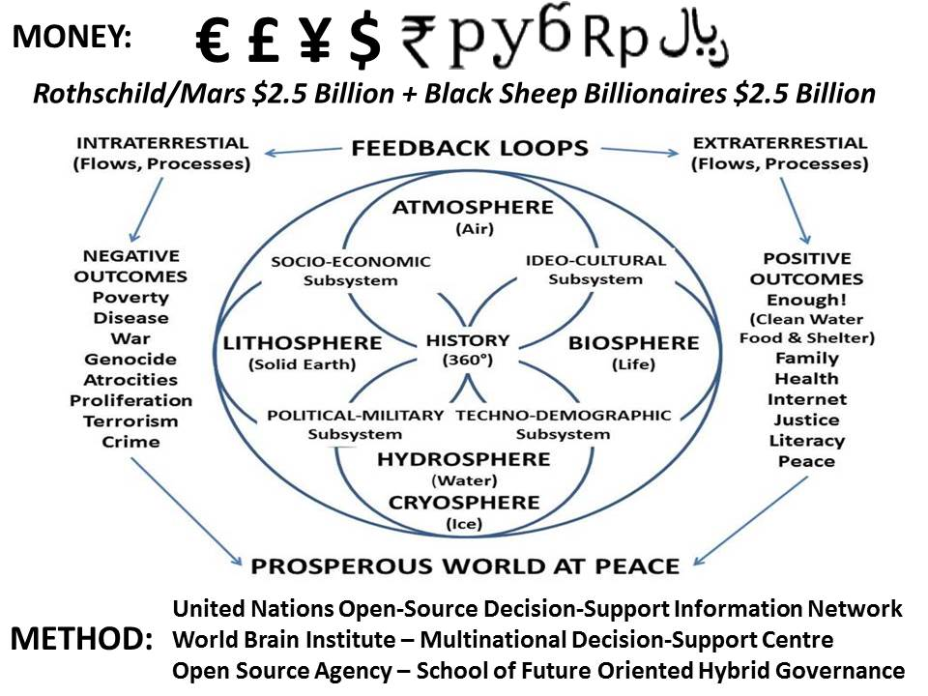
The three ideas that power the four methods shown above are holistic analytics, true cost economics, and open source everything engineering. I will not belabor the details, having published widely (but without notice to date) on these topics. Here I will just summarize each.
Holistic analytics – demand and design intelligence – must integrate – and enable the simultaneous understanding and development of wisdom about – all ten high-level threats to humanity as defined by the United Nations (UN) along with both the twelve core policies identified by Earth Intelligence Network and the 193 demographics centered on the BRICS [Brazil, Russia, India, China, and South Africa, to which I would add Indonesia, Iran, Nigeria, and Turkey]. On this latter point, Minister-Mentor Lee Kuan Yew is in my view on point: demography, not democracy, will determine the future. There are not enough guns (or nuclear bombs, or false flag Ebola attacks) to disarm this mass of humanity – we either help them create infinite wealth, or suffer a variation ourselves of the fate we have imposed on the billions of poor these past two hundred years.
True cost economics – supply intelligence – has been pioneered by Herman Daly (long overdue for a Nobel in my view) and expanded upon by many others, but it is not yet mainstream. While some academics claim “triple-bottom-line” accounting is accepted by mainstream accountancy, I see no evidence of that in the real world. True cost economics – establishing the amounts of clean water, fuel, toxins, child labor, tax and regulatory avoidance, among many other factors – is essential to eradicating the 50% waste characteristic of Western agriculture, energy, health, and military expenditures. Doing so is achievable quickly and at low cost – our real deficiency is one of integrity.
Open source everything engineering – design and manufacturing intelligence – is to embedded intelligence (the current “old” concept of getting industrial-era devices to talk to one another) as World Cup football is to village football. If software, services, packaging, and manufacturing embrace the open source everything meme, I speculate that we can cut a further 25% of the “true cost” of our rather poor design practices, and set the stage for creating a prosperous world at peace, a world that works for all.
As I write this the UN is thinking about how to address the seventeen Sustainable Development Goals (SDG) across 193 nations, most of which are governed by states that lack mature ethical evidence-based decision-support capabilities. If the UN runs to form, it will take the US$2.3 billion that has been pledged (half of which will not materialize), distribute that across a handful of “major” non-governmental organizations (NGO), and watch 80% of the donated money vaporize into “overhead” costs. What if, instead, the Rothschild and Mars families created a forum for the black sheep billionaires, an endowment of $5 billion – chump change in their world – and embraced the teachings of, among others, Dr. Russell Ackoff?
“The righter we do the wrong thing, the wronger we become.”
Do the right thing. It is vastly more profitable and it is assuredly more sustainable.

Robert David STEELE Vivas spent his first twenty years as the son of an Esso (Exxon) oil engineer across the Americas and Asia; his second twenty years as a Marine Corps infantry officer, spy, and co-founder of the Marine Corps Intelligence Activity (MCIA), and his third twenty years as a CEO and proponent of the global Open Source Intelligence (OSINT) movement. He is the #1 Amazon reviewer for non-fiction, reading in 98 categories, and holds degrees in defense studies, public administration, international relations, and political science. His two most recent books are THE OPEN SOURCE EVERYTHING MANIFESTO: Transparency, Truth, & Trust (2012) and INTELLIGENCE FOR EARTH: Clarity, Diversity, Integrity, & Sustainability (2010). He curates Phi Beta Iota the Public Intelligence Blog.

