Robert David Steele

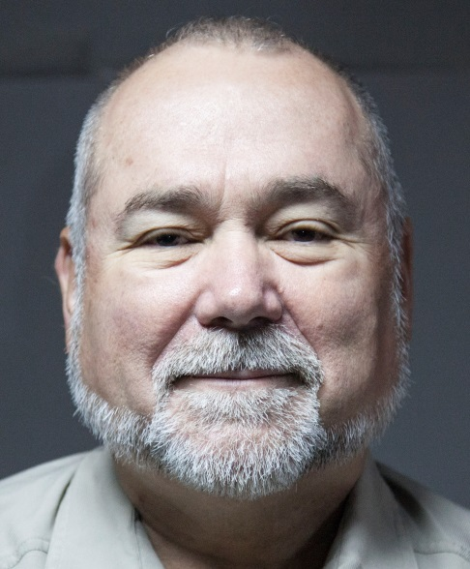 | Robert David Steele is an educator to all forms of organization – governments, corporations, non-governmental organizations, and universities in particular – who is uniquely competent at all-source collection management (know who knows); geospatially-based visualization of complex data; multidisciplinary and multilingual analytics; and compelling interaction with decision-makers facing painful choices and confusing opportunities. A former spy for the USA, an honorary hacker, and the #1 Amazon reviewer for non-fiction, reading in 98 categories, he has also been CEO of a for-profit company, Open Source Solutions Network, Inc., and is today CEO of an accredited educational non-profit, Earth Intelligence Network. Robert is known for his proponency of Open Source Intelligence (OSINT), teaching 7,500 mid-career officers from across 66 governments, and is today the foremost proponent for Applied Collective Intelligence, which integrates Holistic Analytics, True Cost Economics, and Open Source Everything, the latter an engineering and information management approach that is affordable, interoperable, and scalable.
The two most recent books by Robert Steele are entitled THE OPEN SOURCE EVERYTHING MANFESTO: Transparency, Truth, & Trust (North Atlantic Evolver Editions, 2012), and INTELLIGENCE FOR EARTH: Clarity, Diversity, Integrity, & Sustainability (Earth Intelligence Network, 2010). He has been recognized as a thought leader since 1994 when he was featured by Alvin Toffler in a chapter on “The Future of the Spy” and listed by Microtimes as an unsung hero striving to change the world for the better, but it is only recently that the larger public, shocked by Climate Change, Ebola, and rampant destabilization across Central Asia, the Middle East, and North Africa, is beginning to understand that governments and corporations are creating most of our problems through their uninformed decisions. With over a million and a half YouTube views and a profile in The Guardian that went viral, he is now a magnet for many others seeking to create organizations that are rooted in ethical evidence-based decision support. His motto, “the truth at any cost lowers all other costs,” is one that can help any organization thrive in times of chaos.
Bruce Sterling, writing in Hacker Crackdown: Law and Order on the Electronic Frontier says “Steele is about 100 times as smart and 10,000 times as dangerous as the best of the hackers, for he is successfully hacking the most challenging of bureaucracies...for the right reasons.”

Accomplishments |  | Education & Experience
- Designer of the Open Source Everything Hub  - Funded architecture for World Brain & Global Game  - Created global practice of Open Source Intelligence  - Created four strategic analytic models  - 2006 Earth Knowledge – Six Bubbles  - 1988 World Model – 144 Factors  - 1979 Cultural Intelligence Model  - 1976 Predicting Revolution – 12 Domains  - Most published intelligence pioneer in English  - Nine books, two with Forewords by Senators  - #1 Amazon Reviewer for Non-Fiction (98 Categories) |  | Academic Visitor, Loughborough University (UK)  CEO (pro bono), Earth Intelligence Network (501c3)  CEO, Open Source Solutions, Inc. (C Corporation)  USMC Intelligence, 2nd ranking civilian at the time  CIA, top human and technical operations performer  USMC, infantry, intelligence, S-1/Adjutant  Naval War College (Defense Economics)  MPA University of Oklahoma (Strategic Information)  MA Lehigh University (Predicting Revolution)  AB Muhlenberg College (Multinationals Go Wild)  Raised abroad as son of an oil engineer
Robert is a disciple of Buckminster Fuller (displace the dysfunctional system) and Russell Ackoff (reflexive practice, human in the loop, do the right thing not the wrong thing righter). His passion is to design and create an educational program fostering future-oriented hybrid governance rooted in holistic analytics and true cost economics.

