PERSONAL FOR AMBASSADOR SUSAN RICE
Dear Ambassador Rice,
The attached is being given to the Secretary General for holiday reading by a senior member of his staff.
I am among those who are appalled at the manner in which Hillary Clinton set you up for a fall on Benghazi. As a CIA veteran and a military veteran I know exactly what happened there, and why, and I am dismayed that your loyalty and professionalism were abused.
Whatever you decide to do, I hope you will consider inviting me to come talk to you informally.
Below I give you one really big idea that would make you the best informed person on the planet, and allow you to exercise an authority rooted in ethical decision-support, unparalleled in modern history.
An Open Source Agency funded at $125 million for a first year, going toward $2 billion at full funding, has been approved by the Office of Management and Budget senior staff, with one requirement: that the Secretary of State ask for it. A single letter from the President to OMB will yield $25 million in current year money, and a new presidential initiative at $125 million from 1 October 2013. The OSA will over time help justify the redirection of up to $100 billion from Program 50 (Military) to Program 150 (International Affairs), and will help the President cut a substantial portion of the 50% waste that now characterizes most Cabinet departments from agriculture to energy and health to the military….while still allowing for the creation of a 450-ship distributed Navy, a long-haul Air Force, and an air-liftable Army that over time allow the closure of most of our military bases overseas, and the return of the troops – and their purchasing power – to the USA.
First recognized as a need in 1969, prominently addressed by the Aspin-Brown Commission, the WMD Commission, and various other studies, the Open Source Agency appears on pages 23 and 413 of the 9/11 Commission report, as a proposed secret agency, which is completely contradictory to the need and the reality that the secret world cannot do open source with integrity. OMB agrees that the Open Source Agency should be a sister agency of the Broadcasting Board of Governors (BBG), both under the arms-reach auspices of the Undersecretary of State for Public Diplomacy. Stated in relation to the President’s needs at this time, the Open Source Agency would enable the entire Cabinet to contribute immediately and forcefully to Open Government, Citizen Engagement, Participatory Budgeting, Global Engagement, and more tangibly, to a national jobs retraining program for all those unemployed who need to retrain for the Information Era jobs market. Additional information is online at http://tinyurl.com/OSA2011.
The important thing here is that between your personal influence and the interest of the Secretary General assured if you choose to engage, it should be possible to create the positions and organizations shown in the attached one page high-level concept with three supporting point papers. I am best qualified to be the founding Director of the Open Source Agency, with absolute loyalty to you, but I would be glad to serve in any capacity. The longer paper is slated to be published in Fall 2013.
Bottom line: regardless of what you choose to do next – perhaps even remaining in NYC – as the god mother of the OSA you end up with more knowledge, more influence, and more total impact than either the Secretary of State or the Secretary of Defense, or anyone else for that matter. This is a master stroke only you can execute, in my view. For 20 years I have worked on this – take my hand, please.
Very respectfully,
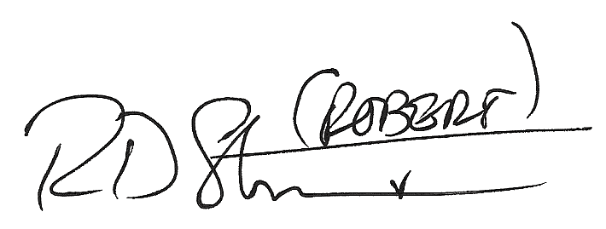

Robert David STEELE Vivas
CEO, Earth Intelligence Network

