Chapter 1:
DRAFT 6 OF 15
Public Governance & Public Intelligence
This chapter funded by Michael Kearns of Colorado.

A. Why This Textbook? 4
B. What Is Public Governance? 5
C. Hybrid Public Governance Brings Eight Tribes Together 6
D. Making A Difference – Four Domains Of Governance 7
E. What Is Intelligence? Why Does It Matter More Now? 8
F. Six Challenges Identified In 1990 – Still Not Met 9
G. Three Eras Of Intelligence 11
H. Intelligence As A Process 12
I. Intelligence As A Product 14
J. Intelligence As A Service 15
K. The World Of Intelligence 15
L. Creating A Smart Nation 16
N. Theory Of Intelligence 17

Reader’s Guide
Governance is the art and science of reconciling means (revenue) with ways (capabilities) toward ends (outcomes). Intelligence in both academic literature and popular perception has been considered the provenance of monarchs, dictators, and organized governments, consisting of secret war, espionage, and other acts often violating sovereignty, law, and even common sense. While still extant today, the modern meaning of intelligence is decision-support. Intelligence is a process, a product, and a service that provides ethical, legal, shareable, and actionable answers to decision-makers with specific questions—not to be confused with an information service. Intelligence (decision-support) is that which makes a difference. The world of intelligence is defined by the decision-maker being supported, and is as simple or complex as might be appropriate. There are eight “tribes” or communities of intelligence, each with their own distinct process, products, and services, but none actually producing intelligence in the proper understanding of the term. Managed correctly, all eight tribes should be sharing all information all the time, as well as the burden of sense-making, and in this manner creates a Smart Nation that governs for the good of all. A theory and practice of intelligence are lacking in the universal coherent sense – this book is a first step toward creating a theory and practice of intelligence useful to anyone, anywhere, on any topic, in any timeframe, toward any end.

A. Why This Textbook?
I decided to develop this book as a course of instruction, after examining a wide range of syllabi for classes in intelligence, and the standard books used in those courses. They are all deficient – at least in the English-language literature that I know so well – because they limit themselves to teaching intelligence as primarily a province of government, as a predominantly secret endeavor, and as a practice focused on national policy alone (Lowenthal 2011, Gill et al 2008).
While this is an intelligence textbook at its core, it comes wrapped in three layers that no other textbook has attempted—not because these three layers are difficult to integrate, but rather because too few dare to embrace clarity, diversity, and integrity in the public interest (Steele 2012). Intelligence reform is one of four reforms that – if achieved simultaneously, will comprise a transformation that enables hybrid governance that uses open-source decision-support to create a prosperous world at peace.
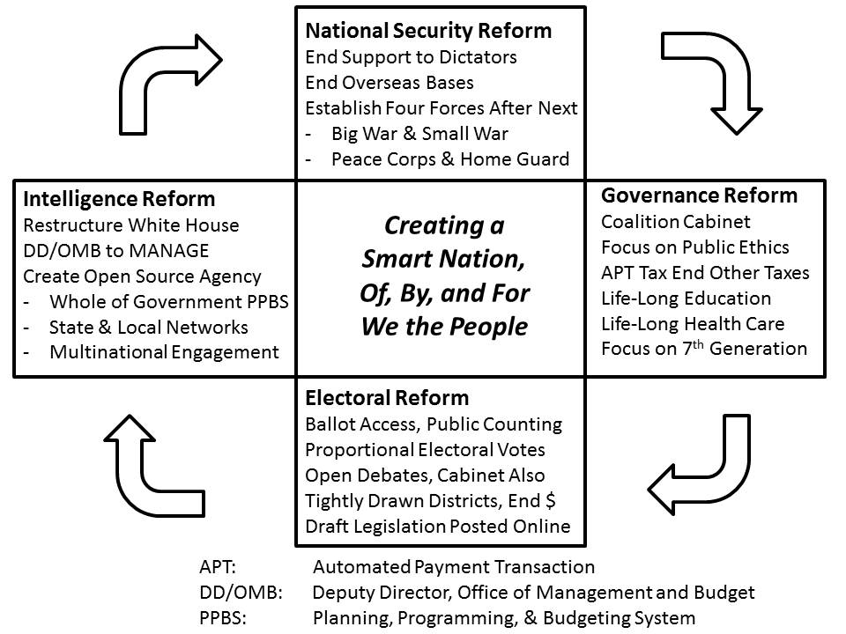
Figure 1. Four Integrated Reforms Centered on Ethical Evidence-Based Decision-Making

Our world is extraordinarily complex – and very delicate. This textbook will provide a framework for understanding the real world, for recognizing feedback loops, for connecting dots, and for evaluating the positive and negative behavior of the most complex and potentially dangerous life form, the human.

B. What Is Public Governance?
Public governance is both public – everyone has a role to play, a voice – and governance: the management and reconciliation of means (revenue), ways (capabilities and behaviors), and ends (desired outcomes). Education, intelligence, and research are the heart and soul of any given community, be it a clan or tribe, an ethnic diaspora, or an artificial state under a dictator or an elite. How the public is educated; how the intelligence profession is actualized; and how research activities are directed define the central character
Neither the State/Government with its penchant for abusing secrecy and funding violence nor the discipline of Public Administration in their present forms are central to the future of humanity in the 21st Century—both are now on the margins. This textbook provides a roadmap for hybrid governance using open-source decision-support that harnesses the collective intelligence of We the People to create public intelligence in the public interest.

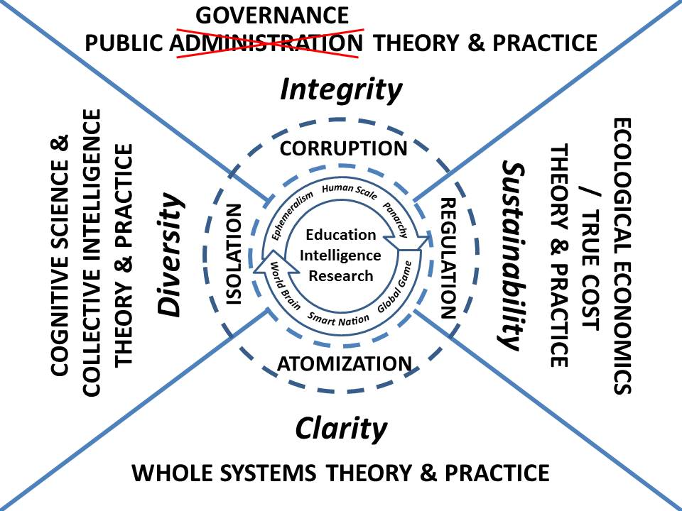
Figure 2. Concept for 21st Century Public Governance Leveraging Intelligence with Integrity
The concept of “public administration” has proven to be severely deficient, in part because in practice it has sought to document governance as it is rather than as it should be. Governments have been “administering” commonwealths in a very corrupt manner – not necessarily without honor, but in the face of severe information pathologies as well as undue influence from special interests.
Public Administration must evolve to integrate Cognitive Science & Collective Intelligence, Whole Systems, and Ecological/True Cost Economics. In so doing, it must restore integrity as the central attribute of humanity, leveraging clarity and diversity to achieve sustainability. It should more properly be defined as Public Governance—its method will be a mix of Open Source Everything (OSE) and Multinational, Multiagency, Multidisciplinary, Multidomain Information-Sharing and Sense-Making (M4IS2).
The emergence of information and information technology as a public good has changed the game and hence all of the rules. Hybrid forms of governance based on shared information and shared sense-making are the new possible normal, within which government is the least important of eight major sense-making communities, and informed non-violent civil resistance and orchestrated crowd-sourcing and crowd-funding are the new arbiters of public power.

C. Hybrid Public Governance Brings Eight Tribes Together
The eight communities that will share information and sense-making to achieve hybrid public governance are shown below: academic; civil society including labor and religions; commerce; government at all levels; law enforcement; media; military; and non-governmental/non-profit. Although all tribes have their secrets, the primary difference between the government world of secret intelligence and the rest of the world is that outside the government, secrecy is not the default, it is the exception.
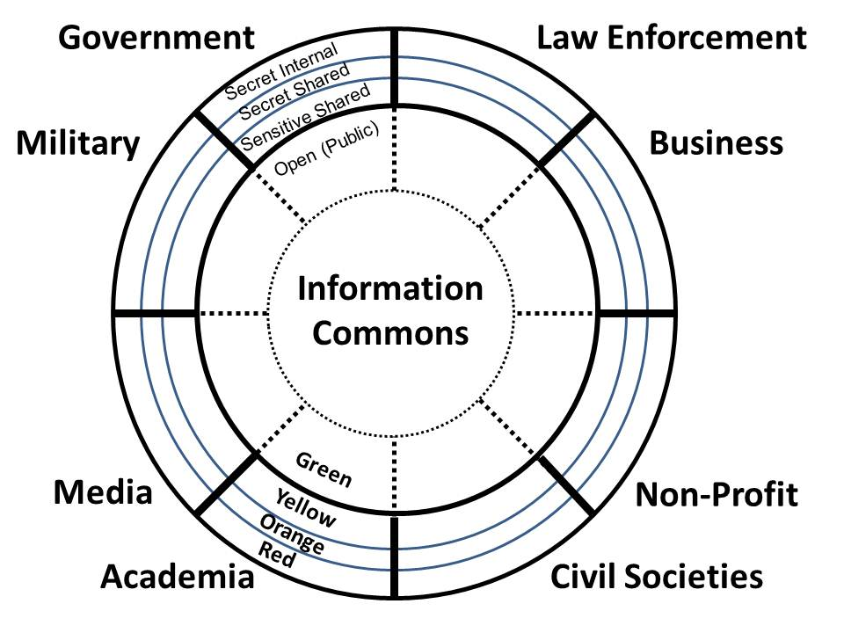
Figure 3. Eight Major Information-Sharing and Sense-Making Elements of Hyrid Governance
In the 21st Century the public will be the one constant, and the seamless integration of education, intelligence, and research across all boundaries will enable Panarchy empowered by Ephemeralism—connecting all minds to all information all the time: direct democracy at every level with tailored information being a substitute for land, labor, capital, and time.
The new discipline of public governance, augmented by a more mature discipline of public intelligence, will be radical—it will among other things call into question--challenge for re-examination--the US Constitution, all other Constitutions less that of Iceland, and the process and form of every public corporate charter ever written. If the discipline fulfills its potential, the outcome will be Smart Nations at Human Scale in the context of a World Brain and Global Game…Utopia. In the interim, one word will have to suffice....INTEGRITY.
Embodied in a single World Brain Institute that sponsors the Global Game and nurtures Centres for Public Intelligence around the Earth, this endeavor will reintegrate the sciences with the humanities.
The rest of this textbook will address how We the People can and must create public intelligence in the public interest. We cannot rely on organizations, especially governments

D. Making a Difference – Four Domains of Governance
I am constantly being asked for a bottom-line defense number. I don’t know of any logical way to arrive at such a figure without analyzing the threat,; without determining what changes in our strategy should be made in light of the changes in the threat; and then determining what force structure and weapons programs we need to carry out this revised strategy. Senator Sam Nunn (D-GA)
STRATEGY. In theory, a strategy is a 360 degree forward-looking concept for achieving goals, be they with respect to security or competitiveness, or other objectives. Powered by a vision, and credible only when grounded in a solid appreciation of reality both at home and abroad, a strategy is how a leadership proposes to allocate means (revenue) to create ways (force structure) so as to achieve ends (desired outcomes). Strategy is the WHY over TIME.
POLICY. Policy is how an individual Cabinet department or agency implements the national, state, or local strategy within their specific “stove-pipe,” but those with a skeptical view of public policy will be quick to recognize that most departments or agencies are captive to external as well as internal stakeholders with their own agenda. Policy is the HOW over TIME.
ACQUISITION. Acquisition is the process of requirements definition (generally not done properly or at all), design (generally done very badly), contract bidding and contract aware, and then procurement through buy or build. Acquisition is the WHAT over TIME.
OPERATIONS. Operations are the actual obligation and exercise of the people, physical and material and financial resources that have been authorized, appropriated, and allocated, and then budgeted for execution by individual sub-elements within a given department or agency. Operations can occur at the strategic, theater, or tactical levels, and generally display the coherent mobilization of a full range of capabilities across all mission areas, for example, aviation, artillery, infantry, and communications, each with their own logistics pipelines and other supporting infrastructure. Operations is the WHEN and WHERE and HOW over TIME and SPACE.

E. What Is Intelligence? Why Does It Matter More Now?
Intelligence (decision-support) is both a process and a product or outcome. It is also a service. Around the world—and especially so within the Anglo-American cabal—the existing courses and the existing practices of “intelligence,” including commercial intelligence, are deceptive, incomplete, and therefore inimical to the public interest.
Intelligence (decision-support) is about assuring any individual, any group, seeking to make a decision, that they are making that decision on the basis of all available truthful information pertinent to their decision. Identifying and dealing with information pathologies – and with deeply embedded liars, thieves, and the occasional traitor whose agendas are not at all in the public interest—is a major definitional aspect of intelligence as a process, product, and service.
Intelligence matters more now because we are at the end of an Industrial Era that has seen the USA consume and waste 25% of all of the resources in comparison to the rest of the world; and we have reached Peak Oil and Peak Water at a point in time when poverty, infectious disease, and environmental degradation have all surpassed inter-state conflict and other high-level threats as more likely to cause catastrophic losses to humanity. It in this context that intelligence matters, and must be done by all.
If the USA was the primary nation in the past century, China is the primary nation in this century, not only because it is rising, but because it manifests all ten of the high-level threats within itself.
The truth at any cost lowers all other costs. Counter-Intelligence (CI) is particularly concerned with those who strive to insert false information into deliberations, misrepresenting its provenance. There are seven significant changes in the craft of intelligence that are aligned with the shift from the Industrial Era to the Information Era and from Epoch A to Epoch B (discussed in Chapter 3). Below are seven fundamental differences between “tired” and “wired” intelligence (decision-support).
The first big change is that whole systems thinking must replace stove-piped thinking. Even now, with policy the avowed client for intelligence, such intelligence as may be produced is fragmented – stove-piped – and there is no Whole of Government thrust that might help the President and the Office of Management and Budget (OMB) identify trade-offs within the whole. In the face of ingrained corruption, intelligence has little effect on strategy, acquisition, force structure, or force employment and deployment.
Secondly, true cost or ecological economics must be the foundation for our deliberations. The true costs of decisions – the now externalized costs in wasted water, utilized fossil fuels, generated toxins, child and slave labor – can no longer be ignored. Intelligence must be holistic in its sources and methods, be rooted in history, and be true to future generations.
A third important change is that government cannot govern by itself. There are seven other information-intelligence “tribes” or communities: academic, civil society (including labor unions and religions), commerce, law enforcement, media, military, and non-government/non-profit. Hybrid governance, based on information-sharing and shared sense-making processes, has already displaced “sovereign” governance by being more informed and therefore both more affordable and more effective in the short-term as well as sustainable in the long-term.
The fourth change is that intelligence must grow beyond policy to support strategy, priorities or Whole of Government management, acquisition, and operations (regional and tactical). Policies should follow from a strategy, and a strategy should follow from a proper (truthful) understanding of all of the threats, all of the true costs of all of the policies, etcetera.
The fifth change is the shift from unilateral policy-intelligence to multinational everything. This change is demanded if all of the above changes are to take full effect, and not only must government embrace, nurture, and call upon the other seven information “tribes” or communities, but it must as the same time embrace, nurture, and call upon all other governments and their eight tribes to create a World Brain and Global Game useful to all.
A sixth change is technical and follows from all the above – Open Source Everything (OSE). It is not possible to create M4IS2, without universal adoption of OSE – from an Autonomous Internet that cannot be shut down, with Open (free) cellular service for the five billion poor and on to Open Cloud and Open Spectrum, intelligence must evolve into a World Brain and Global Game, both founded on OSE.
The seventh and final change is that the profession of intelligence – when it earns the honor of that accolade, “profession,” must treat the public as its primary audience, such that corrupt policy-makers and corrupt acquisition managers and corrupt or undisciplined commanders cannot ignore intelligence. Secret intelligence, however comprehensive and authoritative, can be ignored in favor of ideology and special interests that profit at the expense of all.
Below is a table that defines seven attributes of traditional intelligence, and seven corresponding attributes of 21st Century intelligence.
BROKEN (TIRED) INTELLIGENCE |  | HOLISTIC (WIRED) INTELLIGENCE
Stove-Piped | 01 | Whole Systems
Devoid of Economic Integrity | 02 | True Cost Economics
Government-Centric | 03 | Eight Tribes*
Focus on National Security Policy | 04 | Focus on Everything, for All, As Needed
Unilateral | 05 | M4IS2**
Top Secret Proprietary Vapor-Ware | 06 | Open Source Everything***
Secrets for the President | 07 | Public Decision-Support for All
* Academic, Civil Society, Commerce, Government, Law Enforcement, Media, Military, Non-Government/Non-Profit
** Multinational, Multiagency, Multidisciplinary, Multidomain Information-Sharing and Sense-Making
*** Including Open Access, Open Cellular, Open Cloud, Open Hardware, Open Software, Open Spectrum and more.
Figure 4. Broken (Tired) Versus Holistic (Wired) Intelligence

F. Six Challenges Identified in 1990 – Still Not Met
An alternative perspective was developed in 1990 as the fall of the Berlin Wall, the rising threat of transnational crime centered on narcotics, and the evident inability of the US secret intelligence community to do its job, brought forth a flood of articles and a few books, this flood cresting a decade later (Steele 1990).
Specific challenges identified in 1988, briefed internally across the national security network, and ultimately published, have not been addressed responsibly or competently in the quarter century to date, and join the changes itemized above as an agenda for transformation, bearing in mind the following from Ackoff (2004):
Reformations and transformations are not the same thing. Reformations are concerned with changing the means systems employ to pursue their objectives. Transformations involve changes in the objectives they pursue.
If we are to transform national intelligence—both within the severely retarded secret world as well as within the emergent private sector—we must abandon old mind-sets and biases. If we are to transform governance, national security, and our electoral system, we must restore the integrity of intelligence.
Challenge Number One: Meeting the Intelligence Needs of Public Programs
“Today there is insufficient emphasis on defining and meeting the intelligence needs of overt civilian agencies, law enforcement activities, and contingency military forces.”
Challenge Number Two: Indications & Warnings of Revolutionary Change
“Our intelligence and foreign affairs communities have demonstrated only a limited understanding of revolutionary change, no methodology for studying the preconditions, precipitants, and actualization of such change, no framework for ensuring collection and analysis priorities respect the importance of all the dimensions within which revolutions can occur, and no indications & warnings (I&W) capability suitable to this challenge.”
Challenge Number Three: New Theory & Methods of Counterintelligence
“Closely related to our severely deficient clandestine [Human Intelligence] HUMINT capabilities and our lack of understanding of foreign entities is our virtually complete vulnerability to penetration by representatives of non-governmental groups posing a non-convention threat to our national security.”
Challenge Number Four: Developing an Information Technology Strategy
“We need a national information technology architecture and management infrastructure that integrated telecommunications, computing, and analysis, and enables the full exploitation and integration of data from human, signals, imagery, and open sources.” (Emphasis added.)
Challenge Number Five: Establishing a Responsive Requirements System
“We need a national intelligence requirements systems that is useful in the management of resources; is cross-disciplinary, automated, and “zero-sum;” and is responsive to individual customers, allowing them to track the satisfaction of their requirements by discipline, topic, country, and timeframe.”
Challenge Number Six: Realigning Resources in an Era of Radical Change
“There is limited experience in managing resources in a declining fiscal environment while simultaneously identifying emerging threats and rapidly reallocating resources to meet those threats. Perhaps of greater concern, we appear reluctant to establish a flexible process for fulfilling this fundamental requirement. The bitter resistance of both the mainstream military and the intelligence community to such concepts as ‘low intensity conflict,’ ‘special operations,’ the exploitation of ‘open sources,’ and support to law enforcement agencies, all portend an era of bureaucratic helplessness and inertia precisely at a time when innovative, flexible, cooperative efforts are going to be critical to our success and our Nation’s security.”
From 1988 to 1993, I laid all of this out and also managed two international conferences to ensure that these ideas — and the relevance of open sources of information – were clearly presented. I was ignored then and I have been marginalized since. This is a clear example of an information pathology, the ability to ignore “inconvenient truths,” henceforth know as Willful Ignorance. My more detailed critique of the secret world is contained in my first book—little has changed (Steele 2000).

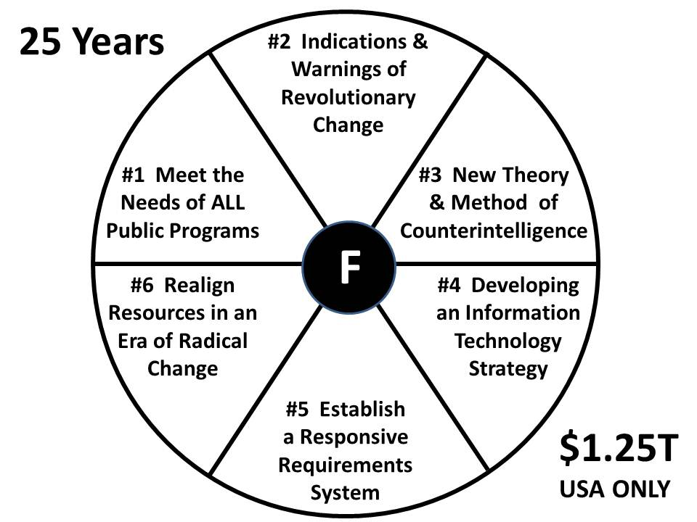
Figure 5. Six Fundamental Failures of US Intelligence – From 1988 - 2012
The primary purpose of the above section is to show in the starkest possible terms how little changes when money flows without limit or accountability. I do not speak only of the USA, but of all countries where “intelligence” is treated as the province of governments, generally secret, and generally focused very narrowly. In the case of the USA, $1.25 trillion dollars – roughly $50 billion a year on average over the period, has been wasted to provide “at best” 4% of what the President or a major commander needs (Zinni 2012), and nothing for everyone else (Steele 2009).

G. Three Eras of Intelligence
The craft of intelligence has gone through two eras and is now entering a third new era. The first era, running from the first days of recorded history and still to date, is the era of secret war, surreptitious entry and theft, and bribery to achieve ends inconsistent with those of the host country or target organization. In this tradition, intelligence is generally the province of governments, mixing dark side diplomacy and military spies, augmented by a separate track of agricultural and industrial espionage and bribery among multinational banks and corporations for whom practices that verge on the sharp and questionably ethical are a means toward illicit profit. This remains—and wrongly so—the public perception of what “intelligence” is and should be.
The second era of intelligence, at least among the prominent Western nations and the USA in particular, was defined by Sherman Kent with his emphasis on strategic analytics (Kent 1965) but was immediately diminished by the unchecked expansion of clandestine and covert action operations, something never intended by President Harry Truman when he first authorized the Central Intelligence Agency (CIA) (Truman 1963).
The second era of intelligence also saw the emergence of very large commercial educational research programs as well as government and commercial research programs; and also Business Intelligence (data mining dashboards), Competitive Intelligence (narrow), and Commercial Intelligence (e.g. 360°). All of these failed to share data or evolve together. A modest literature on how the academy has failed to maintain its position as providing critical thinking skills to generations of students and in diminishing its place in providing original thought to the narrow and short-term ends of commercial and government contracts exists, as does a varied literature on bespoke research for the marketplace.
The second era also ushered in the use of technology, with collection displacing analysis while also failing to provide for processing of all that is collected. Coupled with the lack of outreach and the narrowness of external research efforts, the second era has failed to understand the world, including cause and effect. Ignorance has been the result.
The third era is the era of the Smart Nation leading toward the World Brain and Global Game (the first is the content, the second the method), focusing on uniting the “eight communities” of intelligence, creating a local to global M4IS2 network with call center nodes in each region, and ideally underpinning that with either an Open Source Agency under diplomatic auspices in the USA, or a privately-funded venture that upholds stated principles of integrity such as my mooted “Virgin Truth.”
Collective Intelligence is in its infancy. The craft of intelligence must – will – eventually turn every citizen into a collector, producer, and consumer of intelligence (decision-support) in a pervasive manner not yet accepted by governments or corporations. Intelligence—decision-support—is an inherent responsibility of every citizen who wishes to foster democratic government, just society, and moral commerce.
This book is a handbook for the third era of intelligence (decision-support), the era of providing decision-support on all topics in the public interest, in all languages, all the time.

H. Intelligence as a Process
The intelligence process should not be confused with intelligence products (mostly classified compendiums of information, not actually decision-support products), nor should it be confused with intelligence services (a mix of decision-support in many forms).
The intelligence process, commonly known as the “intelligence cycle” integrates the following elements, each of which tends to be corrupted by omission or flawed implementation. Executed in a linear repetitive manner, this is an industrial-era process that more often than not fails to satisfy.
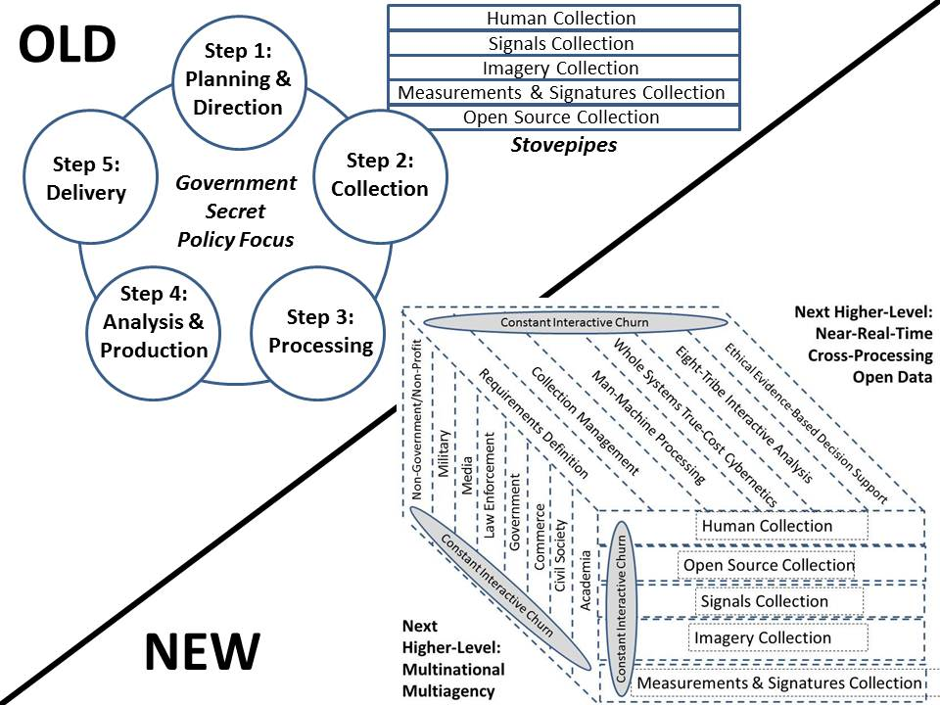
Figure 6. 21st Century (Cybernetic) Intelligence Process
The traditional or Industrial-Era intelligence cycle has consisted of planning & direction, collection, processing, analysis and production, and dissemination.
The modern intelligence cycle is both more nuanced, and executed in a more complex distributed manner. It differs from the traditional cycle in very important ways:
(1) Open sources (in all languages and mediums) are the source of first resort and easily shared in near-real-time across all possible boundaries.
(2) All eight tribes of intelligence (academia, civil society, commerce, government at all levels, law enforcement, media, military, and non-government/non-profit) are part of the intelligence campaign plan
(3) M4IS2 is practiced from the moment of source ingestion, not just at the end.
(4) Decision-makers are connected to sources directly, in real-time, to create intelligence not previously published.
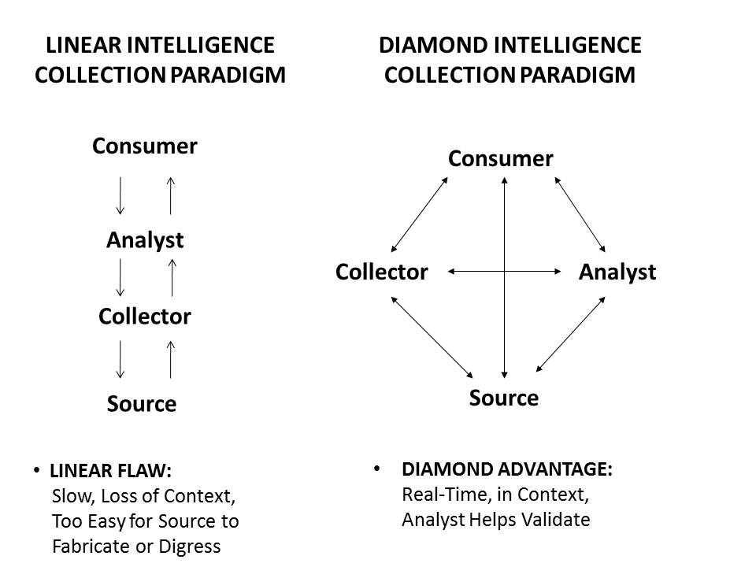
Figure 7. Old Linear Intelligence Process versus New Diamond Intelligence Process
The principal different between the old and the new processes as depicted in Figures 6 and 7 is that the old process has been and remains severely compartmented – security is more important that sharing, and very substantial inefficiencies in collection, processing, and analysis are accepted as an inherent cost of doing intelligence that is secret and for a limited audience (the President, a few others). The old process excluded at least 80% of the relevant sources and expert views. The new process is cybernetically very efficient and transparent, and optimizes the speed, depth, and breadth of information that can be shaped into decision-support for a specific person, while also optimizing. The new process understands that security comes more from trust in shared information and accurate information, rather than from the control of very secretive information that is not shared.

I. Intelligence as a Product
Most intelligence products are actually information products, not decision-support or true intelligence. Intelligence products include databases, country profiles, leader biographies, a wide range of estimates or forecasts, and many issue-oriented reports – not of these provide decision-support with precision.
If an intelligence report does not address a very specific requirement from a specific person or specific decision group, it is information, not intelligence.
Most products take too long to create (including long editing cycles), are too general in nature, are too lengthy, and are generally very constrained in their utility by virtue of their pretense in being classified or restricted and therefore not shareable.
An intelligence product must support a decision -- the ideal intelligence report is one word, one paragraph, one image, one page. Anything more has not been sufficiently discriminated and distilled.
This will be discussed in greater detail in Chapter 11.

J. Intelligence as a Service
Unlike intelligence as a process far removed from the day-to-day needs of the decision-maker being supported (often taking on a life of its own without regard to the fact that no one is dependent on anything it does); and unlike intelligence as a product that is generally generic in nature and not tailored to support a specific decision by a specific decision-maker, intelligence as a service is – or at least could be and should be – totally focused on the needs of each and every decision-maker at every moment in their day and into their near, mid-, and long-term futures.
A well-managed intelligence service would have an intelligence professional – a specialist in requirements definition and collection management as well as all-source analytics – in constant contact with one or more decision-makers being supported, asking three questions on a recurring basis:
(1) What would have liked to know yesterday that neither of us anticipated?
(2) What do you need to know today (and precisely when today) that neither of us anticipated?
(3) What emerging needs for decision-support have you identified since we last spoke, for tomorrow or any future date?
The intelligence professional always keeps in mind the following distinctions:
DATA: The raw direct human observation or articulation, raw image, raw signal, raw signature, or in machine terms, the lowest possible element of information that can be isolated in and of itself with its own provenance.
INFORMATION: Elements of data that have been combined by machine or human processing to provide a larger mosaic, a building-block of knowledge, that is of generic value to multiple parties.
INTELLIGENCE: All-source information that has been deliberately discovered, discriminated, distilled, and delivered to a decision-maker or group making a decision. Intelligence is defined by the output, not the inputs.
DECISION-SUPPORT: The conversion of information, which costs money, into intelligence, which makes money–or achieves other goals, public, and private, of specific interest to a specific individual or body making a decision of import.
Public intelligence does not include the kinds of DIRECT ACTION including agents of influence, propaganda, and paramilitary operations such as some governments allow their secret intelligence services to practice. Public intelligence is inherently ethical, legitimate, transparent, and truthful.

K. The World of Intelligence
Intelligence is not a profession just yet because it has failed to establish itself as essential and it has failed to establish a replicable process, product, and service across all eight tribes. While there are four areas where intelligence can make a significant difference regardless of the functional domain (strategy, policy, acquisition, operations), the reality is all eight of the tribes of intelligence fail to achieve their potential, in part because no one is held accountable for failing to demand and utilize intelligence (decision-support). Decision-makers have three choices when they are considering a potential contribution from the world of intelligence: a) do nothing; b) do it themselves with direct outreach; or c) engage any among a wide variety of information providers, generally in an ad hoc manner that is not timely, complete, or focused. The worst decision-makers believe they are their own intelligence professionals and do not understand the value proposition that intelligence represents when done well.
LEVELS OF ANALYSIS. There are four levels of analysis – strategic, operational, tactical, and technical. The threat changes depending on the level of analysis, as do the time/energy implications of specific course of action.
PRINCIPAL DIMENSIONS. The principal domains for applied intelligence are the political-military, socio-economic, ideo-cultural, techno-demographic, and natural-geographic. These are discussed in more detail in Chapter 3: The Human Factor – Theory & Practice.
HARD TARGETS versus GLOBAL COVERAGE. While “hard targets” are a term used in secret government circles, every organization has its equivalent. Most corporations make the mistake of looking only at their competition, rather than the total environment, technologies outside their normal area of interest, and new marketplaces. Similarly, academic research has to date been fragmented by discipline and sub-discipline, rather than multi-disciplinary. To really “do” intelligence, one must cast a wide net and strive to connect to all relevant information in all relevant languages all the time.
NATIONAL ACTORS, NON-STATE ACTORS, & INDIVIDUALS. Governments continue to emphasize other governments, and most governments suffer from a severe lack of attention to what intelligence can do for them on the domestic front. Corporations tend to focus on competitors, and overlook all the other forms of organization. As government are increasingly found to be “failed states” (including Western states that allowed Central Banks to destroy the Western economy with fraud), it is becoming clear that 21st Century governance must become hybrid governance, engaging all forms of organization, using shared information to come together to make sense – to create intelligence – that allows for constructive harmonization across all boundaries. At the same time, individuals – all of them – are becoming more capable as pinpoint sources, ad hoc collaborators, and of course potential threats. Dr. Stephen Cambone nailed this in 2004, after which I observed that our secret world is not trained, equipped nor organized to study individuals.

L. Creating a Smart Nation
In an age characterized by distributed information, where a majority of the expertise is in the private sector, the concept of “central intelligence” is an oxymoron. In an age where General Tony Zinni, USMC (Ret), has stated on the record that only 4% of his Central Command information and insight came from secret sources and methods, the persistent spending of $60 billion a year on that 4%, and next to nothing on open sources and methods in 183 languages we do not speak, must be defined as institutionalized lunacy.
The greatest threat to both national security and national economic competitiveness is ignorance—uninformed decision-making. Intelligence communities are slowly discovering that they should not send a spy where a schoolchild can go, and that spies are not harnessing the vast distributed intelligence of the private sector, nor knowledge in 183 vital languages.
Unfortunately, the culture of intelligence in most countries believes that its uniqueness rests on secrets rather than thinking—on producing secrets rather than informing policy.
. . . . . . .
In the Age of Information, the absence of a National Information Strategy is tantamount to abdication and surrender—the equivalent of having failed to field an army in World War II, or having failed to establish a nuclear deterrent in the Cold War. This view is both an orientation for citizens and bureaucrats and a call to arms for both policymakers and legislators. It is a fundamental premise of this view that in the Age of Information, the most important role of government—at the Federal, state, or local level—will be the nurturing of the “information commons.”
. . . . . . .
The “information continuum” for any nation is comprised of the nine major information-consuming and information-producing sectors of society: schools, universities, libraries, businesses, private investigators and information brokers, media, government, defense, and intelligence.
. . . . . . .
Distributed information is more valuable and yet less expensive than centralized information. The art of information governance in the 21st century will focus on harnessing distributed centers of excellence rather than on creating centralized repositories of information.
“Just in time” information collection and intelligence production is far less expensive and far more useful to the consumer of intelligence than ‘just in case” collection and archiving
. . . . . . .
The new paradigm for information acquisition is the ‘diamond paradigm” in which the consumer, analyst, collector, and source are all able to communicate directly with one another. The old paradigm, the ‘linear paradigm” in which the consumer went to the analyst who went to the collector who went to the source, and back up the chain it went, is not only too slow but is also unworkable when you have a fast-moving topic with many nuances that are difficult to communicate. Today and in the future, the information manager’ greatest moment is going to be when a consumer can be put in direct touch with exactly the right source who can answer the question directly, at low cost, by creating new knowledge tailored to the needs of the consumer, at that exact moment.
. . . . . . .
The most important information resource is the employee. Every employee must be a collector, producer, and consumer of information and intelligence. This is called the “corporate hive” model, and it is the foundation for creating a “smart nation.” If every personnel description does not list as task number one: “collect and report information useful to the organization,” and if organizations do not provide a vehicle and a protocol for sharing information among employees, then by definition the organization is “dumb.

N. Theory of Intelligence
There is no theory of intelligence today in part because the practice of intelligence has been dominated by the secret government world; bastardized by the commercial world, and ignored by the academic world. No one has been held accountable for failing to be professional in a holistic manner. This is unfortunately true of many other professions and topics. The best book in English on the theory of intelligence (Gill et al 2008) suffers the same limitations characteristic of the best textbook (Lowenthal 2011) – it combines the false assumption that government is the primary practitioner of intelligence and it offers no coherent framework for analysis.
Intelligence is decision-support. A theory of intelligence must strive to create a model of process, product, and service that can be applied to an infinite range of tangible and intangible questions (requirements) from decision-makers or decision-making groups.
At its essence, theory is a model that scales and adapts, that guides the collection of data, that strive to explain cause and effect, that measures costs (true costs as well as false costs such as political, perceptual, or contrived spiritual costs), and that can, when applied with integrity, forecast the emergence of threats, opportunities, or outcomes.
Theorizing is thinking. There are three forms of thinking.
DEDUCTION. From a foundation of general principles, assume a probable cause or outcome. Deduction relies heavily on others for prior observations, hypotheses, and demonstration of the validity of those hypotheses.
INDUCTION. From specific observations, arrive as general principles. This is where the traditional pioneers have been, creating models and hypotheses derived from their original work. This is also where a great deal of competition takes place, as well as duplication of effort as various countries and corporations and universities all do the same thing without harmonizing their effort within a discipline or across multiple disciplines.
ABDUCTION. Associated with integral and collective intelligence, abduction first respects the likelihood that there is no perfect answer and that each individual or group will have a variation of the answer appropriate to their context. Abduction at root is about openness to diversity, clarity of articulation, and integrity in embracing, applying, and modifying any given model. Abduction is how collaborative endeavors proceed.
Below are the eight levels of human intelligence with integrity as defined by Ken Wilbur (2000), in ascending order:
Value Meme (vMEME) | % Adults | % Power
(1) Beige: Archaic-Instinctual. The level of basic survival | 0.1 | 0.0
(2) Purple: Magical-Animistic. Forms into ethnic tribes. | 5.0 | 1.0
(3) Red: Power Gods. Individual sways others, basis of feudal empires | 15.0 | 4.0
(4) Blue: Conformist Rule. Life has meaning, hierarchies, obey orders. | 40.0 | 30.0
(5) Orange: Scientific Achievement. Self escapes herd, materialistic. | 29.0 | 45.0
(6) Green: The Sensitive Self. Communitarian, pluralistic relativism. | 10.0 | 15.0
(7) Yellow: Integrative: Natural systems, nested hierarchies, emergence | 0.5 | 2.5
(8) Turquoise: Holistic. Living blending of levels and forces. | 0.5 | 2.5
Figure 8. Eight Levels Of Human Intelligence With Integrity
The traditional intelligence communities, be they government or commercial, have been stuck at level 4 (Conformist Rule). They cannot claim to have achieved level 5 (Scientific Achievement) because their collection varied from incomplete to incoherent, they do not process all that they collect, they ignore a vast array of information in multiple mediums and many languages, and they do not actually produce intelligence (decision-support), but rather classified information.
The pioneers today are well into level 7 (Integrative) with an arm into level 8 (Holistic). These two levels cannot become pervasive without embracing the combined precepts of OSE and M4IS2.
APPENDIX 1
Advanced courses of instruction may use Appendix 1: On Truth, as a companion reading at this time.
TERMS OF REFERENCE

Abduction
Analysis
Clandestine
Collection
Context vs. Content
Covert
Craft
Culture
Cycle
Data
Decision-Support
Deduction
Diamond Paradigm
Direct Action
Dissemination
Distributed
Global Coverage
Governance
Hard Target
Human Factor
Induction
Information
Information Continuum
Information-Sharing
Just in Time
Linear Paradigm
M4IS2
Multi-Domain
Open Source Everything
Open Source Intelligence
Organization
OSE
OSINT
Processing
Product
Production
Purpose
Revolution
Secrecy
Secret War
Sense-Making
Service
Smart Nation
Strategic Analytics
Theory
Timeliness
Valuation of Information
Willful Ignorance

READINGS
2013 Dover, Rob, Michael Goodman, and Claudia Hillebrand (eds.), Routledge Companion to Intelligence Studies. Oxford, UK: Routledge.
- Ferris, John, Strategists and Intelligence, pp.
- Omand, David, The Cycle of Intelligence, pp.
- Phythian, Mark, Cultures of Intelligence, pp.
- Sims, Jennifer, Philosophy, Theory and Intelligence, pp.
- Steele, Robert, The Craft of Intelligence, pp.
- Warner, Michael, Theories of Intelligence, pp
2013 “The Craft of Intelligence” in Dover, Goodman, and Hillebrand (eds), Routledge Companion to Intelligence Studies (Oxford, UK: Routledge)
2012 The Human Factor & The Human Environment: Concepts & Doctrine? Implications for Human & Open Source Intelligence 2.0, PBI
2006 “Open Source Intelligence” in Loch Johnson (ed), Strategic Intelligence: The Intelligence Cycle (Westport, CT: Praeger), Chapter 6, pp. 96-122.
2006 INFORMATION OPERATIONS: All Information, All Languages, All the Time – The New Semantics of War & Peace, Wealth & Democracy. Oakton, VA: OSS International Press. [Free Online]
- Garigue, Robert, Technical Preface, pp. 7-13
- Introduction, pp. 19-27
2006 Information Operations Book Briefing, 50 slides
2005 Saiter, Sean M. (2005). A General Introduction to Integral Theory and Comprehensive Mapmaking. Journal of Conscious Evolution (Issue 1).
2002 THE NEW CRAFT OF INTELLIGENCE: Personal, Public, & Political – Citizen’s Action Handbook for Fighting Terrorism, Genocide, Disease, Toxic Bombs, and Corruption. Oakon, VA: OSS International Press. [Free Online]
- Preface, pp. xi-xii
- Overview of Citizen-Centered Intelligence, pp. xiii-xviii
- Key Aspects of Intelligence as a Craft, pp. 11-24
1997 “Intelligence and Counterintelligence: Proposed Program for the 21st Century,” White Paper.
1995 “Creating a Smart Nation: Strategy, Policy, Intelligence, and Information,” Government Information Quarterly 13/2, pp. 159-173. 2008 Full Text Online
1990 “Intelligence Challenges in the 1990′s: Recasting National Security in a Changing World,” American Intelligence Journal (Summer/Fall).
ASSIGNMENTS
Complete the readings. For extra credit identify additional relevant readings, preferably free online and preferably reflecting a perspective other than Anglo-American; be ready to identify and summarize.
You are in charge of your organization. One third of your people have just announced they are retiring or going to work for someone else. The remaining two thirds are generally too young to step up to the responsibilities of those who are leaving. What do you need to know to address this unexpected challenge? What do you wish you had known a year ago? Five years ago?
QUESTIONS
1. What is decision-support?
2. What is Open Source Everything (OSE)?
3. What is – generally speaking – M4IS2?
4. Discuss the human factor – individual, social, and organized.
5. What is governance?
6. What is a Smart Nation?
7. Is decision-support defined by its inputs, its process, or its outputs?
8. Discuss the difference between data, information, and intelligence (decision-support).
9. Name the eight tribes of intelligence – suggest other tribes and discuss.
10. Should the intelligence function always include covert action and secret war?

Then Chairman of the Senate Armed Services Committee (SASC).
This section is drawn verbatim from Robert David Steele, “The Craft of Intelligence,” in Dover et al 2013.
Academic, Civil Society (including Labor and Religion), Commerce, Government (all levels), Law Enforcement, Media, Military, Non-Government/Non-Profit.
M4IS2: Multinational, Multiagency, Multidisiplinary, Multidomain Information-Sharing and Sense-Making.
Covert action by governments, including agents of influence who commit treason by advocating courses of action not in the interest of their own publics; media assets who spread disinformation, and paramilitaries that violate international law – and corporate equivalents such as described by John Perkins (2005) – are not addressed in this book, which focuses on legal, ethical, open intelligence in the public interest, as can be carried out by any of the eight “tribes” of information and intelligence. This book is about ethical and legal intelligence for everybody.
This section is excerpted from Steele (1995).
Numbers adjusted proportionally to correct over-statements previously exceeding 100% in each column.

