Robert David Steele

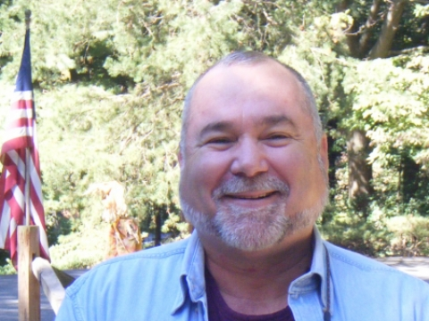 | Robert David Steele has deep faith in the average citizen and is a passionate advocate for both governance reform and the emergence of a citizen's intelligence network in which we all know more, sooner, than the government – or any bank or corporation – does, and use that power. He is the leading proponent for Open Source Everything, Future-Oriented Hybrid Governance, and Democratic Collaborative Capitalism. As founder and CEO of Earth Intelligence Network, he led a 24-person team in designing a modern digital World Brain and Global Game essential to achieving Ethical, Collaborative, Gifting, Human-Centric, Inclusive, and Redemptive Capitalism. A strong advocate of Truth & Reconciliation, he believes that we can create a prosperous world at peace with Open Source Everything.
World-Changing Thought Leader

The two most recent books by Robert Steele are entitled THE OPEN SOURCE EVERYTHING MANFESTO: Transparency, Truth, & Trust (North Atlantic Evolver Editions, 2012), and INTELLIGENCE FOR EARTH: Clarity, Diversity, Integrity, & Sustainability (Earth Intelligence Network, 2010). He has been recognized as a thought leader since 1994 when he was featured by Alvin Toffler in a chapter on “The Future of the Spy” and listed by Microtimes as an unsung hero striving to change the world for the better, but it is only recently that the larger public, shocked by the combination of Edward Snowden’s revelations and fuller understanding of the 935 lies that led to war in Iraq, has been ready to listen. With over a million and a half YouTube views and a profile in The Guardian that went viral, he is now a magnet for many others seeking to create the alternative sustainable economy that is human-centric, ethical, and in full harmony – a prosperous world at peace. His starting point is the combination of Open Source Everything with wholistic analytics and true cost economics, information-sharing and sense-making without borders in public service.
Bruce Sterling, writing in Hacker Crackdown: Law and Order on the Electronic Frontier says “Steele is about 100 times as smart and 10,000 times as dangerous as the best of the hackers, for he is successfully hacking the most challenging of bureaucracies...for the right reasons.”

Accomplishments | Education & Experience
- Designer of the Open Source Everything Hub  - Funded architecture for World Brain & Global Game  - Created global practice of Open Source Intelligence  - Created four strategic analytic models  - 2006 Earth Knowledge – Six Bubbles  - 1988 World Model – 144 Factors  - 1979 Cultural Intelligence Model  - 1976 Predicting Revolution – 12 Domains  - Most published intelligence reformer in English  - #1 Amazon Reviewer for Non-Fiction (98 Categories) | CEO (pro bono), Earth Intelligence Network (501c3)  CEO, Open Source Solutions, Inc. (C Corporation)  USMC, 2nd ranking civilian  CIA, top human and technical operations performer  USMC, infantry, intelligence, S-1/Adjutant  Naval War College (Defense Economics)  MPA University of Oklahoma (Strategic Information)  MA Lehigh University (Predicting Revolution)  AB Muhlenberg College (Multinationals Go Wild)  Raised abroad as son of an oil engineer
At the Practical Intersection of Political, Spiritual, Physical, & Financial

Robert is a disciple of Buckminster Fuller (displace the dysfunctional system) and Russell Ackoff (reflexive practice, human in the loop, do the right thing not the wrong thing righter). His ideas could lead a bloodless return to Eden.

