MEMORANDUM
Date: 10 June 2013
From: Robert Steele
To: Nelly Mobula
Subj: Comments & Suggestions on Mali and Open Source ISR Technology
Proposed Actions:
- Provide a literature review on current security situation in Mali.

  - Literature Review

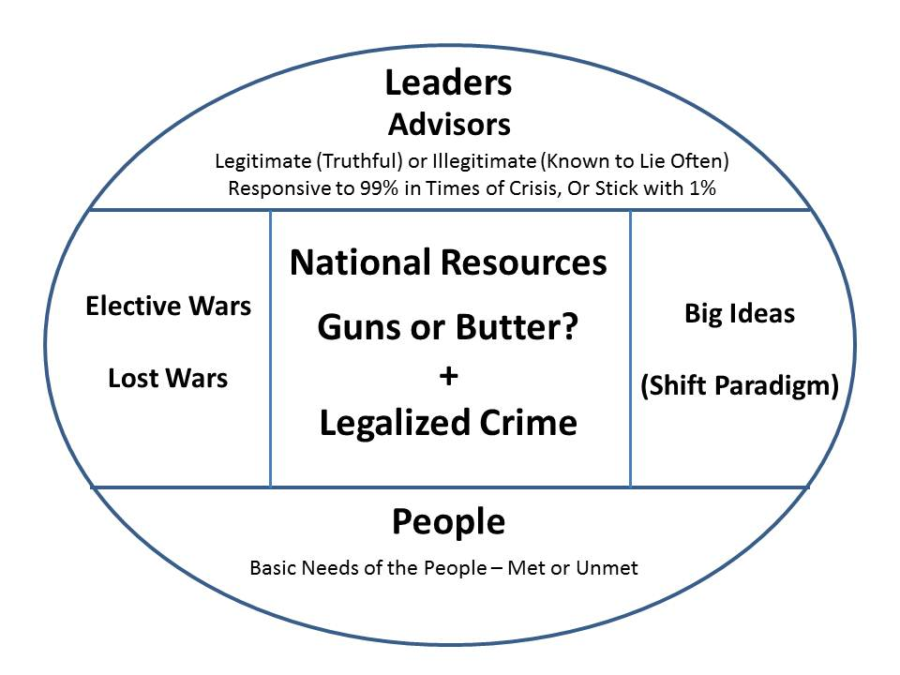
The literature review should be carefully defined to not only include an appreciation of the current security situation in Mali, but to address the degree to which we have sources and methods relevant to understanding each of the critical stabilization & reconstruction domains (political-legal, military, socio-economic, ideo-cultural, techno-demographic, and natural-geographic). A model for predicting revolution is available and can serve as a template for source and gap discovery. Here to side is a very simplistic overview of the model. The complete model is shown on the next page. Also useful is the Marine Corps model on Planning and Programming Factors for Expeditionary Operations in the Third World. Most literature reviews pay no attention to the military and logistics concerns of our forces.

Cf. 2011 Thinking About Revolution in the USA and Elsewhere (Full Text Online for Google Translate)

Cf. USMC Expeditionary Environment Analytic Model (Robert Steele, Study Director)

The literature review should emphasize tribes and their history, not only “modern” organizations.

No credible literature review can be done without assuring coverage in languages other than English, particularly French, and without integrating both published and unpublished knowledge from each of the eight tribes of intelligence (academia, civil society including labor and religion, commerce, government at all levels with local being most important, law enforcement, media, military, and non-government/non-profit). Among these the African Union (AU), the newly established European Union Emergency Response Centre, and the new NATO Civil-Military Affairs Fusion Centre are all recommended as full partners in this endeavor, along with the local Embassy of every country that has a substantive investment in Mali.

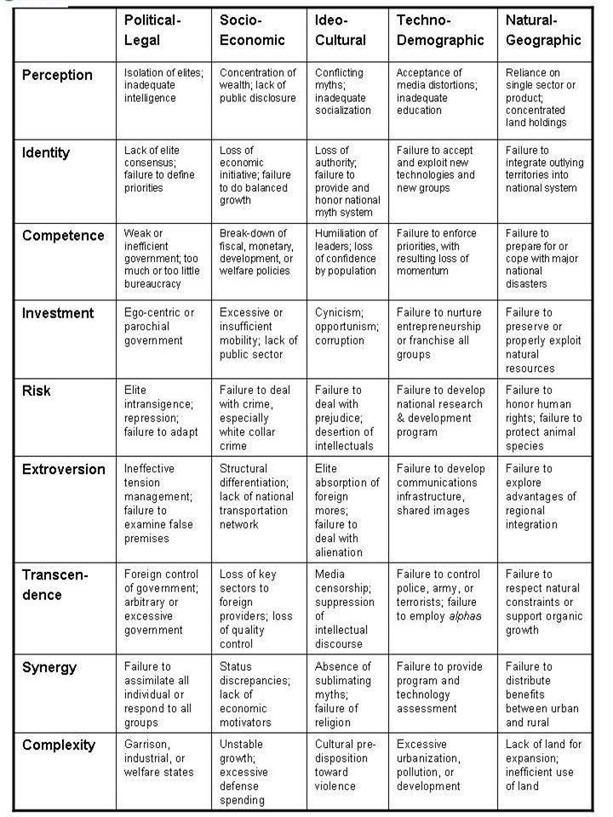
Citation analytics can be used to identify the top 20 published academic authorities in English, use DIALOG RANK and File 7 (Social Science Citation Index). They in turn can be asked to identify the top unpublished experts.

LEXIS-NEXIS can be used to identify the top journalists reporting on Mali and the surrounding area, and also to identify their top quoted sources.

Various commercial databases and the US Commercial attaché can be used to identity top US, French, and other countries operating in Mali, for the purpose of inviting them to provide any internal risk assessment and forecast documents in return for receiving a copy of the finished study.

A survey of social media commentators and clusters can be done by one skilled at using the various tools developed by the legal ethical information hacking community, most not understood by bureaucracies.

Expert: Mary Ellen Bates. mbates@batesinfo.com

Expert: Neal Rauhauser nrauhauser@gmail.com

Expert: Robert Steele robert.david.steele.vivas@gmail.com

  - Human Expert Network

80% or more of what is known by the authors and experts discovered in the literature review has never been published. This is particularly true with respect to knowledge of corruption, foreign influence, and other destabilizing factors.

A significant amount of what will be found in the literature is incomplete or false. Information pathologies abound.

It is essential to form a human expert network that is at least one third African indigenous and at least one fifth French, to elicit this relevant information and to establish a legal ethical open source network for maintaining currency in the local situation.

Within any given government, there are fifteen slices of Human Intelligence that should be sought out and leveraged.

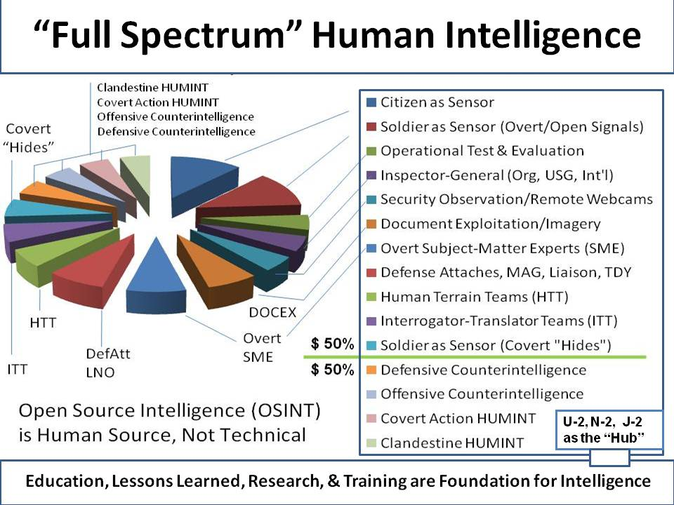

Now imagine the above applied to at least five countries (US, France, Mali, Niger, Nigeria), pooling all that talent with a skilled human facilitator managing a network of telephone calls, emails, skype sessions, and some face to face sessions.
The primary problem with US intelligence – both civilian and military – is that it does not exist to provide decision-support, but rather to move money in the most expensive ways possible. The solutions for Africa are by definition human, time-intensive, low-cost, culturally challenging, and constantly changing. This is not something CIA, NSA, or DIA can handle in their present configurations.
Al Jazeera would be a very useful partner, along with the local cellular company. Here is a map of current Mali views on French intervention. Cf. Mali Speaks, Al Jazeera Generally speaking, most of what is available from digital open sources is not tailored to the need. A cellular coverage map for Mali would be useful, along with a deliberate plan to install cellular towers as a means of making low-cost human observation and reporting much easier to establish.

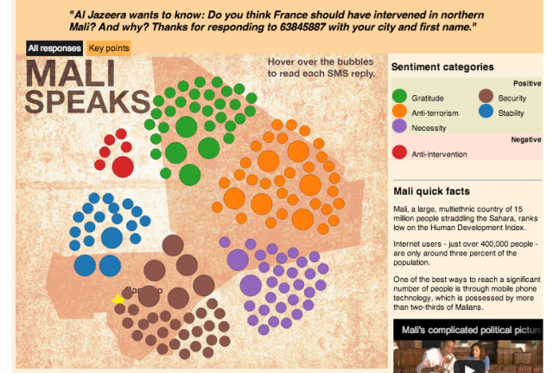A

Expert: Robert Steele robert.david.steele.vivas@gmail.com

  - Geospatial Materials

There are no 1:50,000 combat charts (military maps with contour lines and precision sufficient for combined arms operations and rescue missions) for Mali. The National Geospatial Agency (NGA) will mis-represent what it has and will deny, until put to the test, that it cannot fulfill any requirement for 1:50,000 hard copy maps that can be shared with all possible stake-holders in any stabilization & reconstruction effort. Their claimed digital coverage is “swiss cheese” and far from being offered as anything other than an image map lacking in precision and also difficult for any lay person to comprehend and utilize. It costs several million dollars and takes months to create these essential maps—despite this being an issue with the Foreign Intelligence Requirements and Capabilities Plan (FIRCAP) national level committee in 1992 when Mapping, Charting, & Geodesy (MC&G) was added as a priority category. We continue to neglect the third world – an international solution to Third World combat charts can be partially addressed by Russian military combat charts for Africa, although Mali is not one of the countries they cover.

Below is a precise summary of where we are on Mali and also on Niger and Nigeria:
Mali
a. still not completely mapped by anyone. Theoretically would be about 1560 1:50K sheets at 15x15 minutes for 100% coverage.
b. to the best of our knowledge 80 sheets to date have been produced, mostly in south.
c. we hold less than 10 sheets; our website will be updated in coming day or two.
d. We have never been there; no acquisition trips planned.
e. Latest SPOT 6 system imaged entirely of Mali late 2012/early 2013. It’s available commercially, probably would make a decent 50K photomap product.
f. best complete topographic coverage at 1:200K scale (Russian); we have half of this (northern ½ ) in off-the-shelf vector GIS.
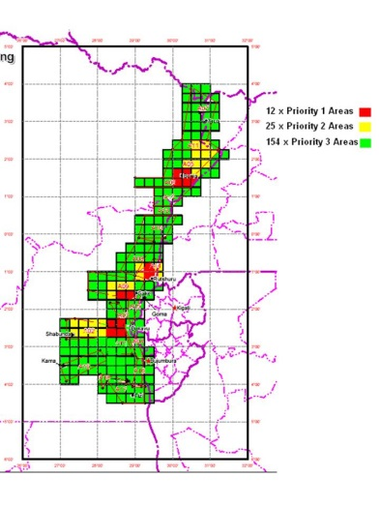
Here to the side is what I did for General Patrick Cammaert, RN NL, when he was force
commander Eastern Congo. East View prepared the lay-down, and General Cammaert’s U-2 prioritized his need. NGA refused to fill the need. East View could have done it for $3 million, but the Dutch government elected to meet the need as a contribution to the UN using its own capabilities. What is important here is to understand that the lay-down and the prioritization of need is the first step toward 1:50,000 combat chart production.

Niger

a. still not completely mapped by anyone. Theoretically would be about 1600 1:50K sheets at 15x15 minutes [RS: this has direct bearing on US plans to extend the Mali incursion into Niger oil fields]
b. to the best of our knowledge 215 sheets to date have been produced, mostly in south.
c. we hold maybe 20 sheets; our website will be updated in coming day or two. However, some (very) modest additional coverage at 50K comes from the above Nigerian maps for the Niger-Nigerian border.
d. We have been there once, in Oct 2012. Were denied the 50K sheets, but made some progress. Probably could acquire those that exist if we went back. Alternative non-Niger sources for some of these maps would be IGN France but that rarely works well.
e. best complete topographic coverage at 1:200K scale (Russian)

Nigeria
a. completely mapped at 1:50K by national authorities; 1276 15x15 min sheets for 100% coverage
i. spread over several series from the 1960s to the present; active update program underway.
ii. exact sheet numbers/names/locations/dates
iii. EVG currently has some version for 1096 of the 1276 50K sheets and no version for 180 50K sheets. Graphic to be supplied tomorrow shows details.
iv. numbers subject to change at any time as sheets trickle in, including newly-produced sheets.
v. our 1:100k holdings cover some of the 50K gaps.
b. for 1000 of the 1096 sheets we hold, we have complete planimetric vectors (all features except contours) as GIS data. It’s not bad.
c. we’ve been there three times in the last two years. Good contacts, but progress is difficult. No new acquisitions trips planned in the near future. When they are, this happens from our Nairobi office.
d. best complete topographic coverage at 1:200K scale (Russian)

Expert: Kent Lee, CEO, Eastview Geospatial Kent.Lee@eastview.com

You are already familiar with Crisis Mapping and emergent humanitarian technologies that leverage crowd-sourcing and crowd-seeding. I think highly of Dr. Patrick Meier and all that Crisis Mapping is doing, particularly in relation to harvesting both indigenous observations in any language, and instant translations into English across a globally-distributed diaspora. They are not, however, a provider of high-quality maps that can be used for complex operations. They are quite well suited to providing terminal landing zone photos and geospatial coordinates for precision parachute drops and other forms of vertical lift assistance.

Expert: Patrick Meier, PhD meier.patrick01@gmail.com

- Conduct a study on security, surveillance and intelligence firms currently present in Africa and their area of operations, technology use and adaptability.

A collaborative effort with the EU Emergency Response Centre, NATO, the UN, and the Red Cross would be most helpful. As a general rule, all existing private sector firms are expensive and unreliable. Their focus is on moving money from the client to their bank, not on actually creating a deep understanding of the area. Efforts to collect video are generally ineffective because there is no one to actually watch the video – this is why pilots and human observation are most effective, along with ground monitors. All of these firms specialize in “butts in seats” approaches to current events – they are not historically, culturally, or linguistically astute.

The time is right for working with the African Union to create a regional multinational decision-support centre that combines deep regional knowledge with constant monitoring and advanced analytics. This would be a very low cost endeavor, staffed by individuals on rotation from all eight tribes across interested countries. The reality is that what is needed does not exist because the US Government does not know how to do holistic 360 degree coverage in a multilateral manner – virtually all US secret intelligence on Mali is non-existent or worthless. This has to be solved of, by, and with Africans.
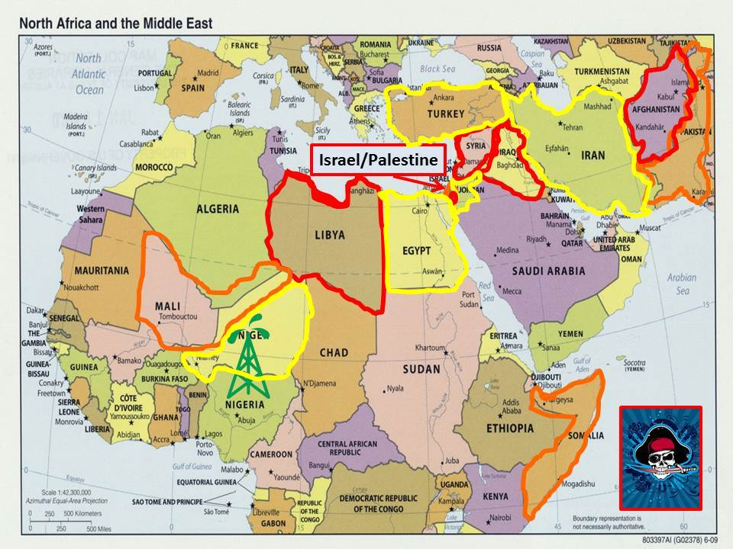
I earnestly believe that if you can get the EU, NATO, and AU to come together, we can create the first ever Multinational Decision-Support Centre for Africa (ideally on the shores of the Mediterranean) with Mali, Niger, and Nigeria as the first test case. The “swath of destruction” that the US has been creating is of grave concern to everyone else, we need to recognize that what we are doing is not working, and try something transformative and new.

The NATO Allied Transformation Command (ACT) in Norfolk (especially their C4IS4/NNEC division as well as their Civil-Military Fusion Center), is perfectly positioned to be a partner to NDU in this endeavor, and to elevate the matter to the attention of the new commander of NATO, General Breedlove, as well as the NATO Secretary General who could invite the EU and AF. This could also yield $25M in first year money for an Open Source Agency and a Multinational Decision Support Centre pilot project. OMB has previously approved the Open Source Agency at a $125M IOC and $2B FOC, but this will only happen if NDU and NATO prevail on Secretary of Defense to approve and ask for the Open Source Agency. The pilot could be run at NDU. [I am a qualified candidate for the position of Director of the Center for Hemispheric Defense Studies, but am not expecting any action on this – they have not even done interviews. From where I sit, NDU leadership is oblivious to the opportunities inherent in my 20 years of pioneering, and I feel very helpless in being unable to reach NDU leadership and inspire them to act.]

Commercial intelligence should be considered – the best are very efficient and do direct on the ground investigations that cannot be done by any secret intelligence community. A small sample of a specific survey (Gao, Mali) is attached as a separate document. The ability of commercial legal ethical intelligence to contract with indigenous sources under cover support plans, and to acquire precisely what is needed in near real time at very low cost, is explicitly refused by the US secret intelligence world.

Expert: Mats Bjore, CEO InfoSphere, co-founder SILOBREAKER mats.bjore@infosphere.se

Expert: Serge Da Deppo, NATO ACT (Norfolk) serge.dadeppo@act.nato.int

- Investigate on open source ISR technology available for a multinational collaborative endeavor.
It is helpful to break this challenge down into multiple pieces: collection, communications, analytics, and decision-making. It is also helpful to understand that most commercial vendors lie about the degree to which they are open source. The time has come to create a total open source public intelligence and public decision-support network – what NATO would call Network-Enabled Capability for the simple reason that this is the only kind of network that is affordable, scalable, shareable, and therefore likely to persist and perform as desired. While Google Maps have made a major contribution, and they can be leveraged, they lack coverage of many Third World area at the neighborhood level of granularity, and the company as a whole is too eager to “own” all their data, making them an undesireable partner for the long-run, and certainly not in Africa. It is VITAL that any approach understand ALL of the opens that can be brought to bear – not just software and hardware. Cf. Open Source List.
The four existing prior US Government endeavors that merit presentation to the group include DARPA STRONG ANGEL, and the Synergy Strike Force / UnityNet, and US Special Operations Command J-23 and the historical Computer Aided Tools for the Analysis of Science & Technology (CATALYST) (graphic below). The best current commercial option is SILOBREAKER, three screen shots below on Mali, which is not just an analytic tool but also a collaborative work tool. It needs to be extended and open sourced, but it is the best starting point. It is multi-lingual in its search and presentation capability.
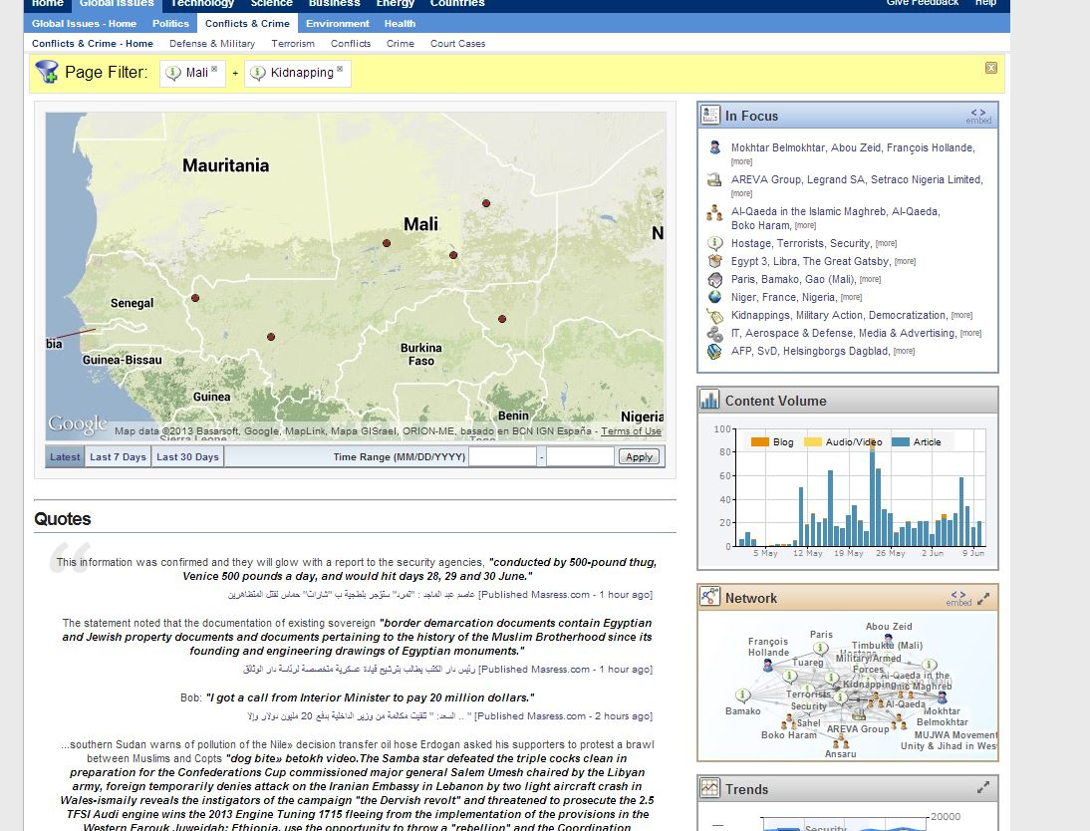
On the next page are two additional screen shots. This is a stable commercial product that has been active in the marketplace as “best in class” for a number of years. I consider it vastly superior to i2 and Palantir, both of which are in my view fraudulent in their representations and costly in their data ingestion and data conversion constraints.

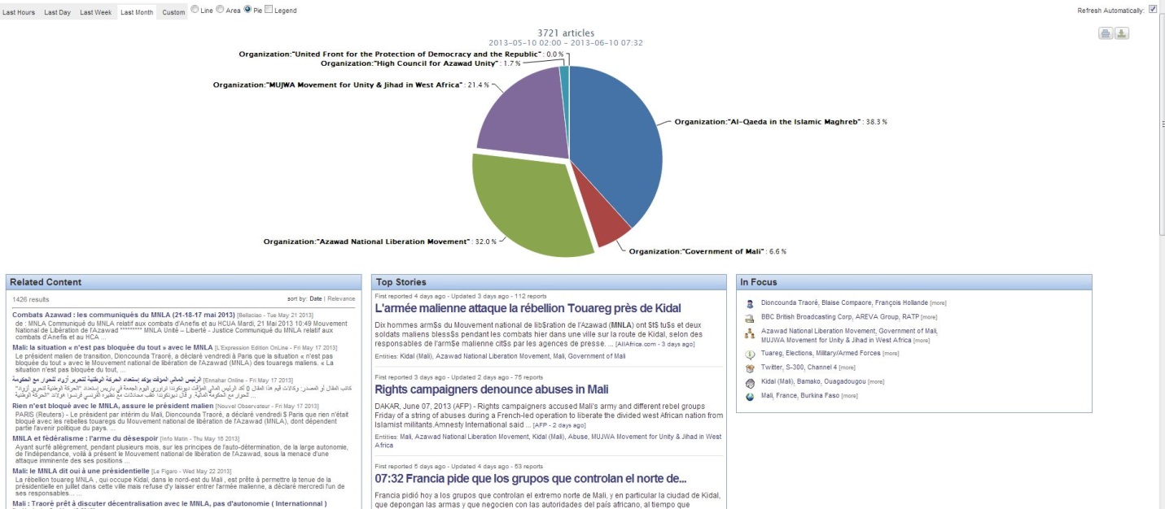
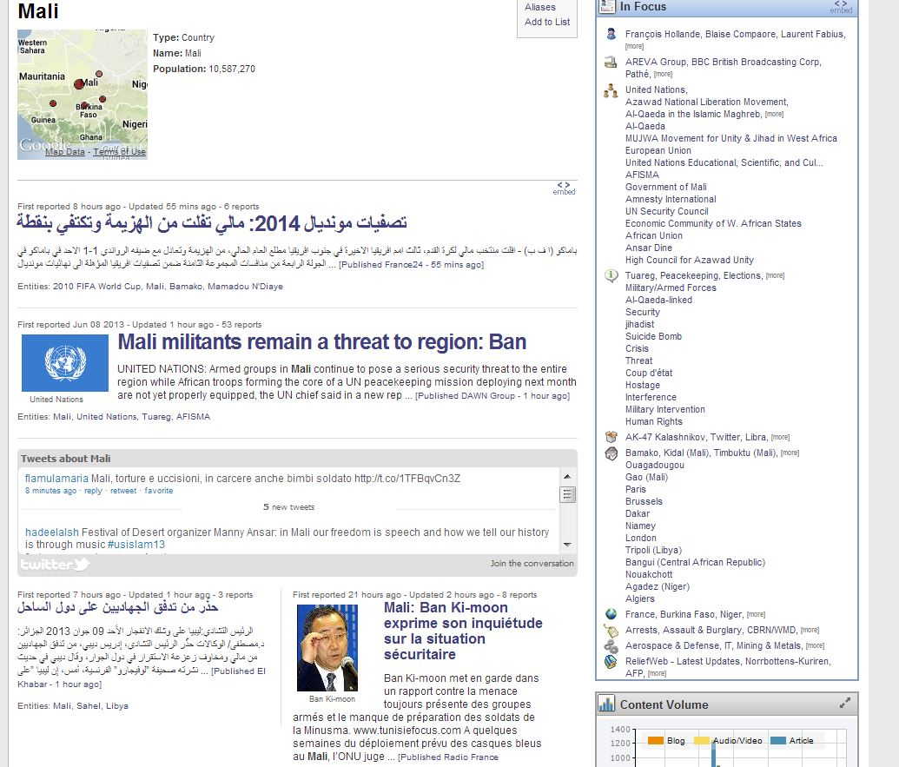

Expert: Dave Warner (PhD MD) davewz@gmail.com
Expert: Mr. James Hardee, USSOCOM James.Hardee@socom.mil
Expert: Mats Bjore, CEO InfoSphere, co-founder SILOBREAKER mats.bjore@infosphere.se

Expert: Serge Da Deppo, NATO ACT (Norfolk) serge.dadeppo@act.nato.int
Expert: Robert Steele robert.david.steele.vivas@gmail.com

Collection. The ideal solution is a data standard that allows any imagery taken by any digital device to be integrated into a larger mosaic Devices with geospatial positioning should be imprinting that data on each image.
Communications. It is increasingly clear that cellular source protection is needed, and that we must device means of providing both free cells phone and secure cell phones to individuals. While we can get along in the near term without this capability, I believe that security is going to become a demand and an expectation for those willing to share information from within conflict areas, to an external analytics centre. As the recent explosion of public concern over NSA PRISM has shown, the general assumption is that nothing is private – this is going to become a major issue across cultural, tribal, and other boundaries…..and rightly so. Transparency, truth, and trust go together.
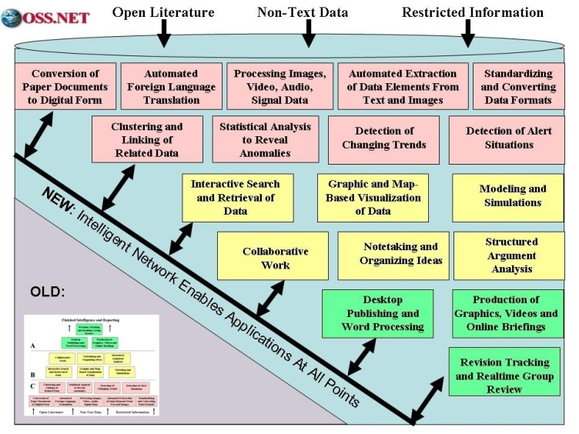
Analytics. None of the commercial offerings – and I single out i2 from IBM and Palantir – is acceptable for open source sharing and scaling. There are 18 functionalities shown here from CATALYST, most are not yet available in open source but should be. An EU – NATO – BRICS – AF effort could make this happen, soon. Agreeing on an open source standard for this international endeavor will change everything.
Decision-Support. The US Government consistently fails the transparency and trust test, more often than not because it does not have anything useful to share, but also because its obsession with unilateral secrecy and bilateral information sharing have made it completely ineffective in a multilateral setting, and especially so when stake-holders are non-governmental. To achieve reliable decision-support on Mali or anything else, three things are needed:
a. Broad open source collection in all relevant languages, mediums, and domains.
b. Broad human network, both across a network and face to face, trusting each other with information
c. Analytic tools able to ingest, process, visualize, connect, and otherwise manage multi-media and multi-language information so as to assist the human-centric sense-making and consensus process.
None of this exists for Mali or anywhere else, and particularly with respect to open source technology and multinational everything human collaboration. There is a huge opportunity here to develop a model that could scale and spread rapidly.
Respectfully submitted,
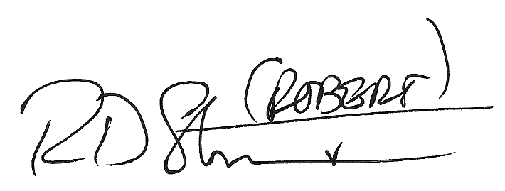
Robert David STEELE Vivas
CEO (pro bono), Earth Intelligence Network
Publisher, Phi Beta Iota the Public Intelligence Blog (“The truth at any cost lowers all other costs.”)

