Is this the year in which populism defeats the two-party system, when the US stops borrowing to finance waste, and when the NSA debacle outrages the American people to the point that they call for a radical overhaul of the government?

Rethinking Intelligence
Seven False Premises Blocking Reform
Robert David Steele
As Congress returns from its holiday recess, I believe there are at least three things on the mind of each Member:
First, is this the year in which populism defeats the two party-party system and in the process sees the electoral defeat of the majority of the House and a third of the Senate?
Second, is this the year that the US finally stops borrowing a trillion dollars a year to finance a government that is 50% waste – documented waste from agricultural products going into the trash to energy lost to fraudulent health to military weapons acquisition?
Third, is the NSA debacle going to be the precipitant – the catalyst – that outrages the American people to the point that they call for a radical overhaul of big government (to reform Congress, the Executive and the Supreme Court)?
It is in that context that we who have been intelligence reformers for these past two decades ask the readers of Reality Sandwich, around the world, to rethink the term, “intelligence.”
Below are seven premises that have allowed a secret intelligence community costing the US taxpayer as much as $100 billion dollars a year (today roughly $75 billion a year) to exist without being held accountable for systemic and specific failures. Up to this point, it has also not been held accountable for acts that fit within the internationally recognized parameters of crimes against humanity: from the rendition and torture programs (carried out with impunity), to extra-judicial killings via unmanned aerial vehicles or drones across Africa, the Middle East, and Central Asia, to deeply intrusive and persistent surveillance of everyone here at home – warrantless.
Secrets are intelligence
This is the most insidious, pernicious, and ultimately treasonous premise. The US Intelligence Community (IC) is not intelligent and it does not produce intelligence. Intelligence in the context of national “need to know” is decision-support. Decision-support is an output, something tangible that can be measured. The impact of decision-support on a decision can be measured both in the moment and over time. The secret world would have us believe that anything secret is intelligence, when in fact most of what the IC does is collect information by technical means, avoid processing most of it, and produce very little useful analysis. As General Tony Zinni, USMC has stated (at the time he was the Commander In Chief of the US Central Command or CINCENT), “At the end of its all, classified intelligence provided me, at best, with 4% of my command knowledge.” Asked later to explain the math, he outlined how he and his J-2 determined that 80% of their useful intelligence was from open sources and methods, and within the final 20% that was provided by secret sources and methods, 80% of that could be bested by open sources and methods once these were engaged.
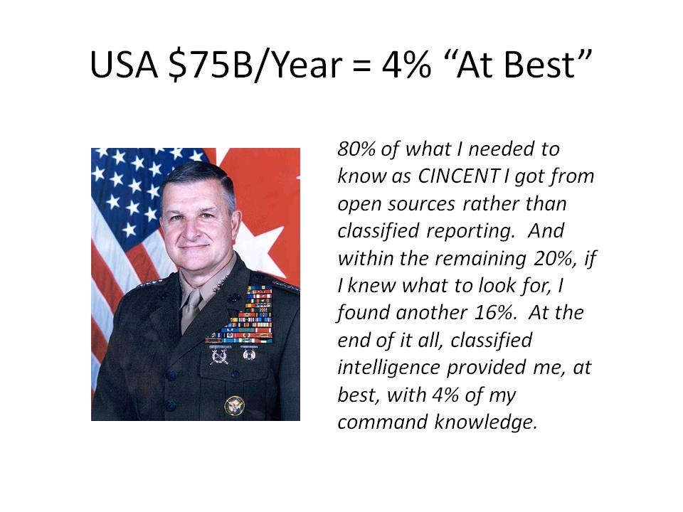
When President Harry Truman created the Central Intelligence Agency (CIA) he was seeking to create a centralized objective creator of decision-support – an organization that could make sense of all that was already being collected, but not processed or integrated, by the many elements of the US Government (USG).
By 1963 Truman himself was so disenchanted with the results that he called for a reexamination of the CIA. Most of CIA’s information, by common admission of multiple Directors of Central Intelligence (DCI), is open source in nature. Truman never intended for the CIA to be hijacked by the clandestine Ivy League elite and their Nazi collaborators imported in huge numbers after World War II. The clandestine monster created in the guise of an anti-communist vendetta sucked the intelligence and integrity out of CIA, and neither of these traits have ever taken root in any of the technical agencies created under Cold War auspices. Based on actual budgets and marginal outcomes, “keep the money moving” is the mantra in the US IC – creating decision-support is just not what any of them “do.”
Intelligence is decision-support. Ethical evidence-based decision-support.
Secrets for the President justify everything the US IC does
Along with “if you only knew what we know,” “secrets for the president” is the ultimate get out of jail free card, both here and across the developed world. The US IC has contended in both Congressional testimony and published commentaries that the $75 billion a year or so they spend (I believe this to be a less than complete amount) is fully justified solely on the basis of what they provide the President. Such a claim can be easily contested to include the observation that some of the product provided to the President has been partial or misleading e.g. neglecting to report that the top CIA penetration of the Soviet Union was known to be under control by the KGB.
$75 billion a year comes out to $205 million a day. As CEO of Open Source Solutions Network, Inc., I routinely bought Nobel-level knowledge – the time and insights of a global subject matter expert -- for $2,000 a day. For $205 million a day I could have every author on Amazon, every professor in every university on the planet, and the heads of most chambers of commerce, labor unions, and religions, on speed dial. $205 million a day is a criminally insane number for secret collection that does not produce intelligence. Put differently, we do not lack for access to knowledge across the planet, we lack for integrity and wisdom in how we go about spending a great deal of money to achieve very little other than the expenditure of a great deal of money.
There are three major flaws with this particular premise.
First, only a tiny amount of money is spent on analysts, and those analysts tend to be newly graduated folk or second careerists generally lacking in global experience or deep knowledge of foreign languages, culture, and history.
Second, the intelligence community refuses to embrace the notion that it can deal openly with anyone. Either you are a traitor being paid by the clandestine service, or an unwitting source being listened to by the National Security Agency (NSA), or a contractor “butt in seat” going through the motions. This means that they are incompetent at harvesting knowledge from the eight tribes of information that own 90% or more of what we need to know. The tribes, as I have defined them for many years, are these: academic, civil society including labor unions and religions, commerce especially small business, government especially local, law enforcement, media including bloggers, military, and non-government/non-profit.
Third, all the US IC gives the President is the President’s Daily Briefing (PDB) – and some very expensive very injudicious covert action programs (e.g. rendition, special measures or torture, and unmanned aerial vehicles). Colin Powell, at the time privy to the PDB, says in his memoir My American Journey, that he found the Early Bird published within the Pentagon – the compendium of relevant news from around the world – to be more useful. There you have it – what the IC “does” for the President is not really useful.
Below is one high-level view of how I would evaluate national intelligence if given an opportunity to do so – this is how I think Congress should be evaluating national intelligence.
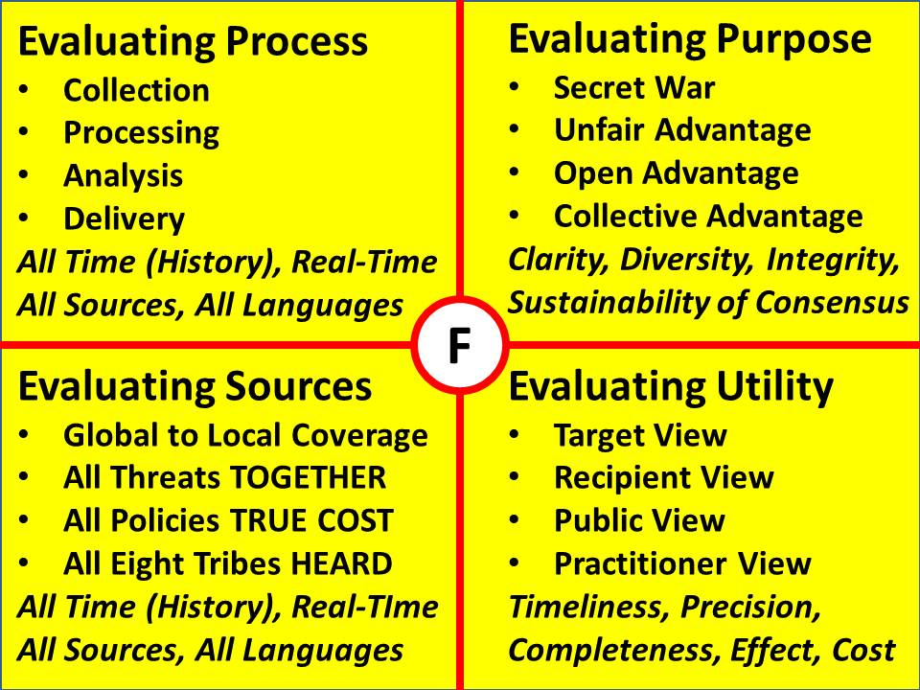
As I and others have noted over the years, a major flaw in how we do intelligence lies with the current disconnect between an intelligence community that thinks it is meeting key performance indicators and ‘doing its duty’ if the President is not complaining, and a very large government operating in a very complex world. In this context, not only do Cabinet Secretaries and their Assistant Secretaries need decision-support, but so also do their bureau and branch chiefs and their individual country or topic desk officers. I address this in more detail in two articles, “Intelligence for the President – AND Everyone Else” (Counterpunch, 1-3 March 2009), and “Fixing the White House & National Intelligence,” (International Journal of Intelligence and Counterintelligence, Spring 2010).
Secret agencies know how to do intelligence
If intelligence is defined as secrets for the President, and the primacy responsibility is “keep the money moving,” then I have to agree. The US IC is the absolute best pork pie in the country, in large part because it is secret and therefore above the law and beyond the reach of all forms of accountability. The economic effect of this translates into more and more money producing less and less decision-support, only spending, fraud, and kickbacks for Congressional patrons. The General Accountability Office (GAO) and the Office of Management and Budget (OMB) are not allowed to actually audit the US IC. Indeed, even the agency directors cannot audit their own agencies. As General Mike Hayden, the Director of the NSA as it broke new ground in violating the US Constitution said (as I recollect), “Anytime I want to look at a special compartment, the only guy that can talk to me about it is the guy that will lose his job and his budget if I cut there.” As have all those before him, he settled for keeping the money moving, and breaking new ground in spending on mass surveillance (collection without tangible processing or analysis).
If intelligence is defined as decision-support, then the US IC is a complete failure. My first book, ON INTELLIGENCE: Spies and Secrecy in an Open World (AFCEA, 2000), honored with a Foreword by Senator David Boren (D-OK), failed the US IC across four domains: strategic, operational, tactical, and technical. They have not improved in the quarter century that my generation of reformers has been striving to alarm the public. Although General Mike Flynn came back from Afghanistan with some deep thoughts I agreed with (as published in Fixing Intel: A Blueprint for Making Intelligence Relevant in Afghanistan, 2010) he was promptly assimilated by the Director of National Intelligence (DNI) and then posted to the Defense Intelligence Agency (DIA) which does not, to the best of my knowledge, do any of the following:
a. Develop requirements and manage all-source collection and all-source production consonant with a holistic analytic model that integrates the ten top-level threats to humanity, across the twelve core policy areas, in relation to every country and province around the world.
b. Produce deep broad intelligence essential to defining a strategy for how best to train, equip, and organize our military forces.
c. Produce timely diverse intelligence (decision-support) essential to force structure acquisition, not just in terms of the threat (including the many we ignore, such as Chinese submarines using German diesel engines), but in terms of designs, materials, industry partners, supply chain vulnerability, and so on. Somewhere in here we should have counterintelligence against treasonous flag officers and their civilian counterparts.
d. Produce timely culturally accurate intelligence (decision-support) for complex operations – for example, predicting that the Bi-Lateral Security Agreement (BSA) would not be signed.
Today the US IC still has the same old tired intelligence cycle, the same stovepipes, and the same kludge process of developing “products” that are thrown at consumers who generally do not actually read those products. Below is the holistic process I would demand if I were DNI:
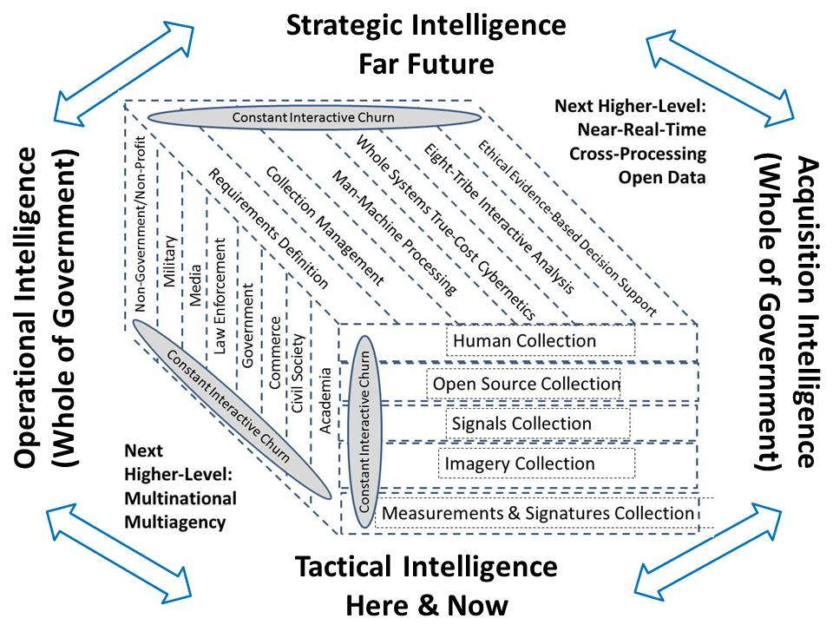

Secret technical collection is worth every penny
If we start with the reality that most of what NSA collects – as much as 95% -- never gets processed. And we should add to that reality that the NSA has not stopped a single terrorist act within the USA. In fairness to NSA, I have to note that most terrorist arrests in the USA are a result of FBI stings and entrapment. The educationally sub-normal Muslim child living with his Mom stands out. The Boston Bombing continues to demand investigation at multiple levels. Moving on to imagery, we should be concerned that we still do not have 1:50,000 combat charts (military maps with contour lines and cultural features) for 80% of the world. In Somalia we are still obliged to use Soviet 1:100,000 charts. The vaunted shuttle mission came back with the digital equivalent of Swiss cheese. When Bosnia and Kosovo were a designated combat zone, seven laptops with digital maps were the best the National Geospatial Agency (NGA) could do – some of these realities are beyond parody and well into tragedy.
The market value of the intelligence community’s secret technical collection is not more than 20% of what the government and taxpayer pay for it, and this is a generous assessment. We are long past due the mandatory termination of all technical collection programs that collect wantonly without proportional and productive processing. Absent tangible results documented by testimonials from real people on the front lines of our bureaucracy or our fighting forces, these technical collection programs must be terminated in the public interest.
Secret technical collection has also, in its wanton waste, gutted Human Intelligence (HUMINT), distorted Open Source Intelligence (OSINT), and in combination with a security architecture that costs $15 billion a year and wants to migrate to “constant surveillance” of every cleared employee, destroyed any possibility of our analysts being both capable and connected. Below is a depiction of what I would emphasize if I had the power to radically reduce wasted resources while modestly augmenting what we really need. 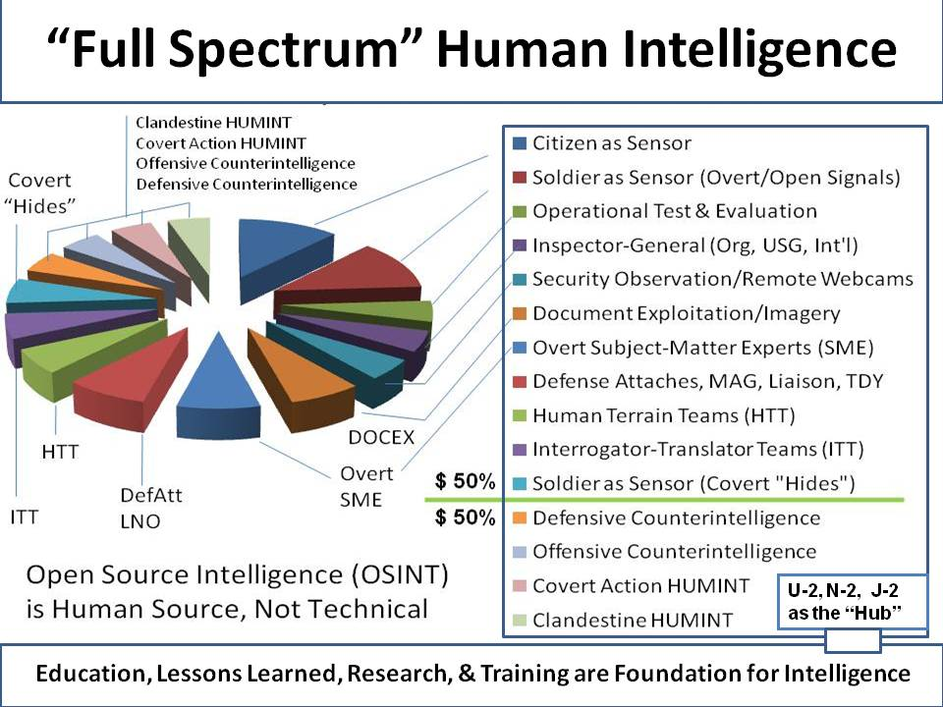
Government does not need intelligence
The entire Planning, Programming, and Budgeting System (PPBS) is fact-independent. No one does decision-support memoranda. No one has any idea what the true cost is over the entire life cycle of any program. To take one small example from the national intelligence community, the NSA data center in Utah, a water-stressed state with water hours for its citizens, is now known to require 1.7 million gallons of fresh water every single day, to cool its computers. I do not make this stuff up – the poor thinking that sits behind such a data-point sums up, at least for me, the absolute lack of intelligence with integrity that permeates our entire government.
Below is a graphic showing where intelligence (decision-support) must be applied if we are to properly govern the Republic Of, By, and For We the People (as opposed to the 1% of the elite that bankrolls the entire electoral system). After we get our own house in order – not before – we can be helpful to the rest of the world and influence how others spend money. Right now we have no business at all messing about in our uninformed, incoherent, and all too often corrupt manner. At the same time, the value of ethical evidence-based decision-support to creating an affordable, sustainable prosperous world at peace cannot be understated.
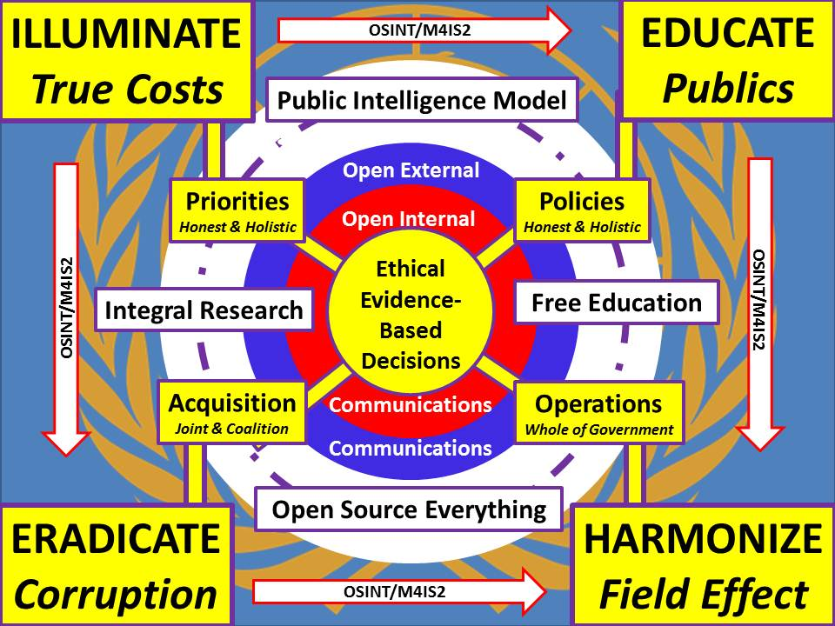
With just $2 billion a year for an Open Source Agency (OSA) that also funds Multinational Decision Support Centers (MDSC) for each theater – including multinational clandestine stations as an off-shoot; I can immediately do three times more than the secret world, at every level, across every mission area. And that’s just in the first 180 days.
Congress does not need intelligence
Acknowledging that most Congressional votes are made on a party-line basis and without benefit of the Member understanding much about the matter at hand, I have to protest, as a citizen, the present situation. As much as I like the Congressional Research Service (CRS) and the GAO, neither of them is in the intelligence business. What we have now are two branches of government that have no strategy, make policy on the basis of who pays to be heard, and have absolutely no clue how to train, equip, and organize a Whole of Government in order to create a prosperous nation at peace. As Chuck Spinney, who made the cover of TIME in the 1980’s with similar arguments (“the plans/reality mismatch”) to my own, but speaking to defense overall, likes to say, what we have now is amateur hour. To that I would add corrupt amateur hour. What is done every day, ostensibly in our name and certainly at our expense, is reprehensibly uninformed, incoherent, and antithetical to the public interest.
Britt Snider – one of two individuals to serve on both the Church Commission and the Aspin-Brown Commission (the other is Loch Johnson) – has written ably on how Congress needs intelligence and I agree. At this time secret intelligence is limited to the two intelligence committees and often to the “Gang of Four” (chair and ranking minority member for Senate and House intelligence committees) and nothing at all for everyone else. In my view, and one of the reasons I have been championing an Open Source Agency (OSA) as a new executive agency that would also support Congress, is this need for shared intelligence between Congress and the executive agencies that Congress oversees – a common foundation of best truths.
We the People have a right to expect ethical informed decisions from Congress. If ethical evidence-based decision-support is not provided to Congress, we will never overcome the current political grid-lock that substitutes ideology for intelligence and money for integrity.
Below is a graphic that captures the ten high level threats to humanity as identified by LtGen Brent Scowcroft, USAF (Ret) and the other members of the United National High Level Panel on Threats, Challenges, and Change. They reported out in December 2004. Poverty is the top threat not just around the world but right here in the USA, followed by infectious disease and environmental degradation. My vision calls for migrating national intelligence away from spies and lies and through an evolution, illustrated below, that first creates a multinational information-sharing and sense-making intelligence network focuses on all ten threats together; and then morphs into a global network of Smart Nations, each harvesting all that can be known ethically, creating a global intelligence commons one could call the World Brain.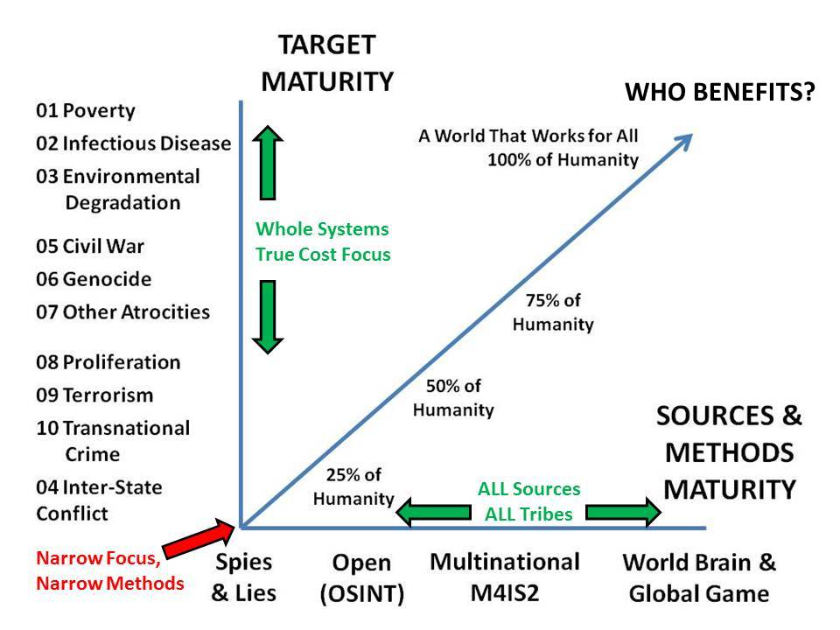
The public does not need intelligence
My second book, THE NEW CRAFT OF INTELLIGENCE: Personal, Public, & Political, was honored with a Foreword by Senator Pat Roberts (R-KS). Its subtitle was Citizen's Action Handbook for Fighting Terrorism, Genocide, Disease, Toxic Bombs, & Corruption. I have been a spy. I have been the senior civilian responsible for creating a new national all-source analysis capability. I have spent 20 years trying to get governments to understand that intelligence is an essential foundation for good governance. I have finally come full circle to embrace the wisdom of Thomas Jefferson – “A Nation’s best defense is an educated citizenry,” and the insight of Norman Cousins – “Governments are not built to perceive large truths. ... They have to be instructed by their people in great truths.”
In 1992, writing in Whole Earth Review, I called for an open source intelligence community focused primarily on the public need for intelligence. In 1995, writing in Government Information Quarterly I outlined how we might create a Smart Nation. For a quarter century now I have championed public intelligence in the public interest. We do this with an Open Source Agency (OSA). We are long overdue for intelligence with integrity at all levels of governance. This new organization would help all eight tribes of information come together as a Smart Nation, by nurturing all of the Opens. This is how we create Intelligence Of, By, and For We the People. Not secret, not toxic, not expensive, and not wasted.
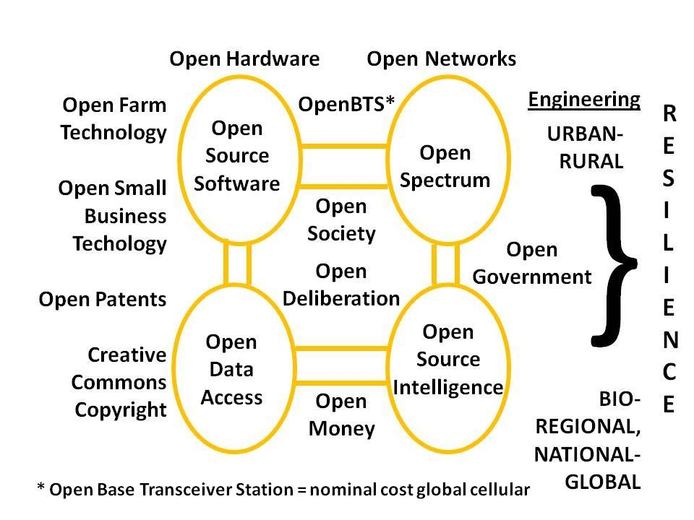
My vision empowers the public, and assures intelligence with integrity as the foundation for public governance. In my view, today, if citizens do not demand an Open Source Agency (OSA) and the introduction of intelligence with integrity in support of every decision made in our name, then both Congress and the Executive will continue to betray the public trust and the Republic will continue to decline. Intelligence is decision-support. You have to want it. St.

On intelligence generally, and the CIA specifically, see my hundreds of Amazon reviews, all sorted at Worth a Look: Book Reviews on Intelligence (Most). For a starting point on the CIA-nurtured Nazi hydra, see my review at Amazon of Glen Yeadon, The Nazi Hydra in America: Suppressed History of a Century (Progressive Press, 2008).
The story as reported is also commented upon at Mini-Me: FBI Spends a Lot of Money on a Retarded Teenager Trying to Stage a Phony Terrorism Plot — We Do Not Make This Stuff Up!

