Loughborough University in London
Concept for Creating the World’s First Open Source Hub

Overview
As Loughborough University in London (LUIL) begins its final year of installation preparatory to receiving students in September 2015, a number of established and emergent capabilities are converging to very good effect. This proposal directly enhances four of the six themes of LUIL, and supports the other two.
In the year when the UK Government announced its switch to open source, and industry observers declared 2014 to be “the year” in which open source has gone mainstream in the US, the time seems right for a Loughborough Open Source Hub that combines Open Source Everything (OSE) and Multinational, Multiagency, Multidisciplinary, Multidomain Information-Sharing and Sense-Making (M4IS2). Both an Open Source Consortium and a new Open Source Foundation exist and are based in London, offering immediate structured access to potential capability partners.
The first term of art, OSE, predominantly technical, embraces the practical value of an “all in” approach to open source information technology and knowledge management including embedded intelligence and distributed human intelligence, while pressing forward across all scientific disciplines and engineering practices to create open source solutions across all government and industry domains. OSE has the potential to create an affordable, inter-operable, and local to global World Brain that radically enhances teaching, research, and enterprise opportunity, while setting new standards for sustainable commercial production across all policy areas from agriculture to water management.
The second term of art, M4IS2, predominantly human, enables staff and students to approach every inquiry with the intent of accessing all relevant information regardless of its location, more often than not being offline or unpublished. This new form demands that all information in all languages and mediums be accessed, integrated, visualized, and hence considered in support of any moral, intellectual, governance, or business challenge. No organization in the world has ever implemented this concept.
Funding prospects for research include four groups: government, enterprises, media, and the City of London/E.J. Rothchilds. The funding concept for education calls for 64 funded scholarship students a year, eight each from each of the eight information networks (academic, civil society, commerce, government, law enforcement, media, military, and non-government/non-profit).
The Open Source Hub could enhance the rank of the university; broaden the local to global impact of its research (including successful bids for research tenders); enhance the relevance of the whole of the university to the community and the government; and increase earned revenue. Our strategic intent is to leapfrog past Cambridge and Oxford by becoming the first university in the 21st Century to be Whole, Local to Global across all policy domains, and Open Source – the first to be competent at open source everything solutions (particularly in information technology) combined with constant holistic analytics and true cost economics, manifested in various innovative new enterprises centered on LUIL.
Table of Contents
Overview 1
Commission 4
Six Themes of LUIL – the Open Source Everything Impact 5
Education for Life – Along with Decision-Support & Research 6
What Is Open Source? 9
Why Start with Open Source? 10
2014 – The Year Open Source Went Mainstream 11
Who Owns or Knows What We Need to Know? 12
What Is an Open Source Analytic Workstation? 13
What Is Big Data & Why Does It Matter? 15
Where Does Open Source Geospatial Play In All This? 17
What Is True Cost Economics & Why Now? 18
Anonymity, Identity, Privacy & Rights 19
A Killer App Loughborough Can Patent 20
Science, Technology, Engineering, & Mathematics (STEM) 21
How Might the Open Source Hub be Organized? 22
Six Bubbles – Creating the Working World Brain 25
A Potential New School and New Institute 27
PhD in OSE/M4IS2 –Revenue, Design, Content, Outcome 29
Emerging Economic Concepts 34
Potential Financial Partners 38
Practical Steps for LUIL Leadership 42
Appendices 43
Appendix 1: 2014 Headlines for “Open Source” London (Recent News Only) 43
Appendix 2: Top Ten Open Source Projects in UK (2013) 44
Appendix 3: Open Source Consortium Members 45
Appendix 4: Integrated & Non-Integrated Analytic Suite Examples 46
Appendix 5: Representative Open Source Softwares 49
Appendix 6: A Special Note on Plagiarism 50
Appendix 7: Revenue Models for Digital Non-Profit Offerings 51
Appendix 8: Short Biographies of Three Key People 52

Table of Figures
Figure 1: Grand Strategic Design for Integral Education 6
Figure 2: Open Source Everything (OSE) 9
Figure 3: Four Quadrants of Emergent Organizational Intelligence 10
Figure 4: Fragmented Web of Science 11
Figure 5: Eight Immature Information Communities 12
Figure 6: Essential Elements of an Open Source Analytic Workstation 13
Figure 7: Computing Paradigm Shift Demanding Open Source Response 15
Figure 8: Open Source Geospatial Human in the Loop in Near Real Time 17
Figure 9: Representative True Cost Information for a Single Product 18
Figure 10: The LoBo True Cost "App" 20
Figure 11: Selected STEM Job Growth Areas (USA) 21
Figure 12: Major Technical and Human Analytic Segments -- All Failing 23
Figure 13: Preliminary Holistic Analytic Model 24
Figure 14: Digital Online Elements of the World Brain 25
Figure 15: Data-Driven Disintermediation of Needs and Gifts 26
Figure 16: School of Future-Oriented Hybrid Governance, World Brain, Global Game 27
Figure 17: Specific Companies in the Collaborative Economy 37
Figure 18: The Herring Triangle of Shared and Selective Services 39

Commission
This endeavor to define the concept, scope, and practical first steps for creating the world’s first Open Source Hub within Loughborough University but in daily service to the larger community, the United Kingdom, and the world, has been commissioned by Dr. Rob Dover FHEA, Director, The Glendonbrook Institute for Enterprise Development, and Associate Dean (Enterprise) of the Loughborough University in London (LUIL) and the School of Business and Economics.
The Requirements Brief is replicated below (emphasis added):
Loughborough University in London is a transformative project that seeks to complement and add to the internationally recognised research that is conducted in the East Midlands. The London geography and that this campus is in ‘start-up’ mode allows us the opportunity to explore activities and ventures that are genuinely at the outside edge of what Loughborough has been involved with up to now.
The ‘big-data’ revolution more widely, and the potential for an open source revolution in diplomatic, government and security circles, allows us to consider what impact the university can make in terms of providing a research hinterland for the public understanding of such activity, and in terms of policy-impact work to inform the transformation we anticipate in government.
As an eminent and founding figure in the open source movement, we are commissioning you to tell us the following:
- What is the teaching, research and enterprise opportunity here?
- How would this activity complement the proposed diplomacy activity in LUIL, the wider LUIL activity (with its London location), and resonate with the activities on main campus? For these latter two considerations, we are looking for those activities which strongly resonate with existing activities, rather than where a case has to be made.
- We are interested in how this activity might help us reach our internationalisation ambitions – e.g. meaningful relationships with non-UK universities.
- What practical steps would the LUIL senior management team need to take to realise this hub and this activity?
We do not seek to be prescriptive about the length of report, nor the particular features and functions employed within. We are looking for ‘best truth’. We would ask – however – that following this work that we are given the opportunity to explore operationalising this ‘hub’ before the detailing is disseminated any further.
The work is provided to the University on a non-disclosure, non-publicity basis. While the ideas remain those of the originator, Loughborough University has first option with respect to taking action on the ideas in time to influence faculty, staff and students to be present at the opening in September 2015.

Six Themes of LUIL – the Open Source Everything Impact
LUIL has six themes. On this page we relate all that follows in this proposal to each of the six themes.
Business, Innovation and Entrepreneurship. The Open Source Everything (OSE) proposition changes everything about business, and in the process, opens the way for widely diverse innovation and entrepreneurship. There is no other university that is integrating intelligence (decision-support), open source everything as a design and innovation approach, and a focus – through holistic analytics and true cost economics – on the five billion poor (whose annual aggregate income is four times that of the one billion rich).
Design Management. This may well be the greatest beneficiary of the OSE approach, as it will allow LUIL to become the world’s first university to fully integrate into its design curriculum a Global (Serious) Game with true cost economic information deeply divergent from the current corrupt design practices that are ill-informed, along with a multidisciplinary approach to each of the ten high-level threats to humanity, each of the twelve core policy areas, and each of the eight demographics defining the future.
Digital Technologies. This program can be radically enhanced by the proposal, expanding to include attention to all open source technologies, dark fiber, an open source analytic tool-kit, open source geospatial modeling and data visualization, and new approaches to exoscale “big data.”
Media and Creative Industries. The traditional media is in free-fall but the emergent digital media lacks structure and purpose. An opportunity exists to move beyond the “cutesy” aspect of digital effect, and to focus on how an open source everything approach, and respect for holistic analytics and true cost economics, and cause a revolution in media and creative industries. At a minimum the OSE program will create new niches within industry that provide the public and government as well as small businesses with better information; at best a Global (Serious) Game will allow everyone to play themselves, impacting on every issue at every level, armed with better information that MI-5 and MI-6 combined.
Sports Management. This is the least likely of the six themes to benefit, but with a little effort, some advances can be made here as well. No one has sought to extend the “Moneyball” effect from a single US baseball team to an entire sport – striving to win the next World Cup in soccer (football) would be a more interesting project, applying the principles of “Moneyball” enhanced by a global program of big data collection and visualization. Also possible here is a new perspective rooted in true cost economics.
Virtual Engineering / Digital Manufacturing. This already very exciting program focused on 3D visualization, analytics, and various collaboration tools would rise to a new level and establish a new global standard if it fully integrated an Open Source Everything (OSE) approach to engineering and manufacturing. There are already maker and hacker spaces in London but they have no “home base.” Imagine LUIL as the hub for every hacker, every open source coder, every 3D printer, in the world.

Education for Life – Along with Decision-Support & Research
Before discussing the minutia of an Open Source Hub, I thought it would be beneficial to begin with a high-level view of what 21st Century education might become – education for life, with decision-support (intelligence) and research as tightly integrated monetizable offerings, all three being available to the individual or the client organization, for life.
Below is a graphic twenty-five years in gestation.
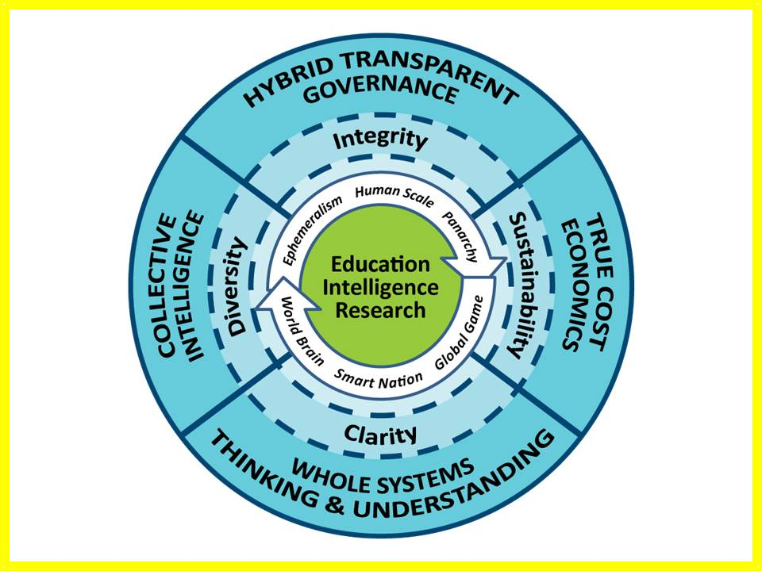
Figure 1: Grand Strategic Design for Integral Education
This vision integrates all forms of knowledge with particular emphasis on the integration – for life – of education -- teaching, intelligence (decision-support to government and business), and research. This restores the primacy of the human being, both as an individual and in community so as to do more with less (ephemeralism as defined by Buckminster Fuller). The implementing bodies are a Global Game that fully integrates true cost economics across all disciplines, industries, products, services, and behaviors; a Smart Nation in which all eight information communities are transparent to one another and fully engaged in sharing information and sense-making; and a World Brain that enables all minds to access all information in all languages all the time. The four core values are clarity, diversity, integrity, and sustainability, each manifested as shown in the outer ring above.
These past years I have seen selected universities and entrepreneurial enterprises experimenting with a mix of educational internships, applied research grants, and mixed investigative teams of student, journalist, activist, scientist, and accountant. I believe we are on the verge of a break-out in which education becomes ubiquitous and persistent, at the same time that applied education – decision-support (answer a specific question for government or business or any organization including labor, activists, and non-profits) and research (open-ended inquiries) become more closely integrated with the traditional form of education in isolation – the ivory tower.
Financially I believe this means that the costs of education – the earnings for the university – must be diversified and stretched out for each individual, such that education plays a more active role in helping individuals earn money over time, a fraction of which comes back to the university over their lifetime.
Culturally and physically I believe this means that the traditional university form – years in residence – can and should persist, but with a much greater inter-weaving of on-going education at nights, on week-ends, and during breaks in the traditional program when residences, dining facilities, and classrooms can be monetized with an entirely new transient population.
Intellectually and morally this reinstates the university as the center – the hub – for society, commerce, and governance, assuring that a majority of the individuals in any given community are afforded the opportunity to continue learning – both free and for fee – over the course of their lifetime.
Put in a more mercenary fashion, and adopting the approach of some medical and scientific career paths, traditional educational degrees will have expiration dates and require annual, repetitive renewal through refresher training and structured engagement with new knowledge relevant to the individual, their employer, and the community at large.
An Open Source Hub is a means of providing affordable, inter-operable, scalable education for life.
Here are four broad implementation ideas.
01 Education & Skill Training for life “one cell call at a time.” This is a mix of free daily prompts to the hand-held device with elementary education or new knowledge, clear answers to any question anytime, and on-demand short videos for any skill element in any trade or profession. Pearson Education is a conceivable business partner.
02 Citizen & Executive Decision Support (Commercial Intelligence) “on demand.” Commercial intelligence (CI) or decision-support (DS) requires mastery of multi-disciplinary sources and methods, as well as mastery of constantly changing information technologies. For the majority of businesses in any economy, it is neither intellectually nor technically feasible to establish “in-house” capacity. The demand for CI or DS is easily in the multi-billion per year range, and is certain to grow as “true cost economics” becomes a vital factor in whether an enterprise can remain competitive before an informed public. Furthermore, and this is very important, no one, anywhere, does true cost economics as a service.
It is possible to double the value of the university to its students and staff. We can also double the revenue that the University can raise with existing assets augmented by a 5% innovation factor.
This in turn has three general tracks that can be calibrated to address eight customer groups (academic, civil society including labor and religion, commerce especially small business, government especially local, law enforcement, media, military, and non-government or non-profit):
A. Citizen Intelligence. Later in this report I illustrate how we can monetize an educational service that scans a product bar code and return red, yellow, or green markers related to the true cost (virtual water, child labor, toxins, etcetera) or any product. At the same time the hand-held and social media data banks make it possible to “recruit” or commission any citizen at any location for “eyes on” reporting. That can be monetized and is also a comprehensive research program.
B. Commercial Intelligence. Other than my friend Mats Bjore, CEO of InfoSphere AB and co-owner of SILOBREAKER (an integrated analytic toolkit) I am unimpressed with the industry. The focus on competitors and regulatory environments is out of date. What we should be focusing on is what works for specific localities, and how to deliver it within green parameter. A World Brain Institute and a Global Game could turn the Open Source Hub into a “must have” partner for any government, any bank, any corporation, any non-profit, world-wide. Medard Gabel, co-creator with Buckminster Fuller of the analog World Game has created the preliminary architecture for a comprehensive EarthGame™. This could provide a first to market advantage for every element of the university and its ecology of associated business partners.
C. Hybrid Intelligence. There is an immediate market, local to global, for decision-support to hybrid governance of agriculture, education, energy, health, and water, to name just a few policy areas where the gap between those with power and those with knowledge is now catastrophic. A London-based School of Future-Oriented Hybrid Governance could develop new educational constructs, educate cadres of customers, and serve as a consulting enterprise as well.
03 Multidisciplinary Research Over Time and Space. The Center approach is not working. To achieve true multidisciplinary research one must be able to identify all credible voices – both published and unpublished – in all languages, far back in time as well as the most recent. An Open Source Hub that includes an Open Cloud as well as an Open Analytics suite of tools for local to global information-sharing and sense-making makes its sponsor the incontestable center of global knowledge. Further on in this report I provide specific implementation concepts including the ideas of a School of Future-Oriented Hybrid Governance inclusive of a World Brain Institute and Global (Serious) Game.
04 Open Source Everything Platform for Universities, Small Businesses, and Others. Some say that universities generally – and those in the UK particularly – have been very slow to update their information technology capacity as the industry has followed Moore’s Law over time; and also especially poor at adapting to the era of the Internet, with web sites that often defy even their most ardent suitors. The creation of a platform and process for education, intelligence, and research that could be leased to other universities while creating the first truly national – and then international – web of science and social science, humanities, philosophy, ethics, linking all of this to real world community governments, small businesses, departments of government, and non-governmental/non-profit entities, offers substantial revenue potential as well as innovation potential.

What Is Open Source?
Open Source is not, as many assume, simply a legal and technical concept referring primarily to software and increasingly also to hardware, denoting that the software or hardware is freely available and open to both redistribution and modification without substantive encumbrance.
Open Source Everything (OSE) is a meme, a mind-set, and a philosophy of education, intelligence (decision-support), and research. The below diagram is representative.
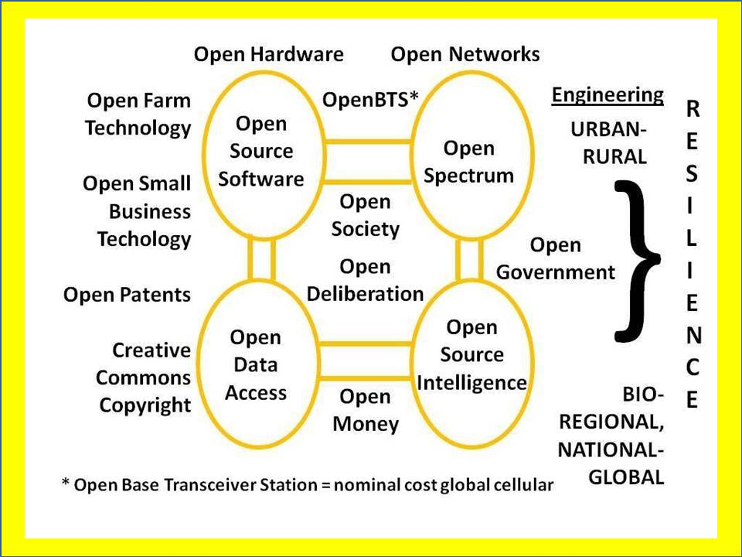
Figure 2: Open Source Everything (OSE)
In commercial terms, OSE is a means of harvesting the Cognitive Surplus of a broadly distributed, self-motivated network. Of particular note is that OSE is the only technical approach that is affordable, inter-operable across all boundaries, and scalable toward the 6 billion comprising humanity today.
OSE is the ethical, intellectual, commercial, and legal underpinning for the emergent new economy that is collaborative, ethical, inclusive, and sharing in nature.
The essence of financial profit within this new economy lies in a mix of free education combined with licensing, services, and the monetization of transactions. OSE can be licensed in multiple forms using Creative Commons designations, such that the code, to use a software example, is open to modification and redistribution, but cannot be used to collect financial remuneration without engaging the originator. As is generally the case with complex constructs, there is a two-way advantage, in that the originator has the best grasp of the creation and can more efficiently help apply it commercially.
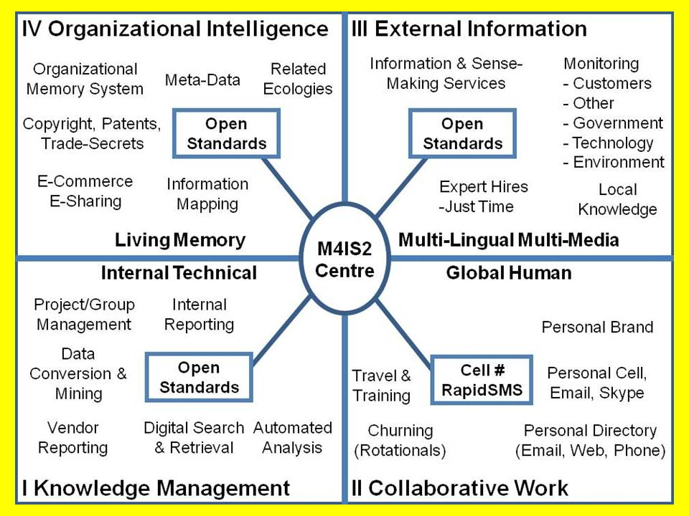
Figure 3: Four Quadrants of Emergent Organizational Intelligence
- Knowledge Management focuses on making sense of what we can document.
- Collaborative Work harvests human understanding in near real time.
- External outreach and research strives to discovery needed information.
- Organizational Intelligence is a living memory
OSE is also the underpinning for local to global information-sharing and sense-making, allowing for the efficient harvesting and harnessing of cultural, historical, and linguistically specific information across all boundaries, human, financial, and technical. The term of art for the human aspect is Multinational, Multiagency, Multidisciplinary, Multidomain Information-Sharing and Sense-Making (M4IS2). In combination with OSE, a predominantly technical term of art, the two define a virtual World Brain in which all minds eventually are connected to all information in all languages and domains, all the time.

Why Start with Open Source?
The acme of skill for any university in the 21st Century is to be able to first research, and then educate, in a holistic multidisciplinary fashion. No one does this now. Although there are many universities with various forms of Center, some displaying the name Multidisciplinary, none of these are real for the simple reason that they are not structured to actually engage in multidisciplinary research such that all relevant databases and all relevant communities of ethnocentric knowledge are integrated. They are also not able to process massive amounts of “big data,” at the same time that most data does not lend itself to machine-speed processing rooted in geospatial and calendar constructs.
The fragmentation of our academic world cannot be over-stated. Below is a depiction of the scientific disciplines and sub-disciplines alone. The situation is much worse in the less rigorous social sciences and humanities.
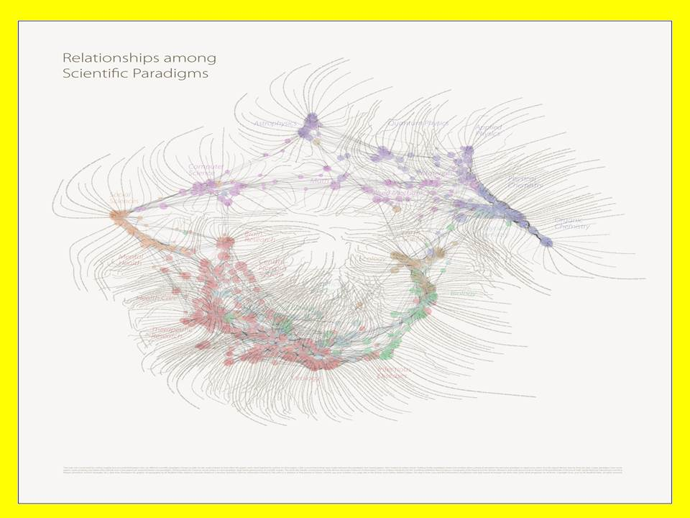
Figure 4: Fragmented Web of Science
In order to begin a very long-term endeavor to stop the persistent fragmentation of the academy, while also better integrating commercial, government, and non-profit research data, there is no alternative but that of putting forward a globally-accessible open source software and hardware solution.

2014 – The Year Open Source Went Mainstream
In 2014 Wired observed that open source hardware was joining open source software in the mainstream, i.e. as something to be purchased by large corporations. Here are some data points:
- $60 billion saved collectively by US businesses per year due to open source software
- 50% of all purchases of software will be open source in 5 years
- 2 million open source projects in 2014 – twice the number in 2012
- 80% increase in open source venture investment in US from 2011 ($307M) to 2012 ($553M)
- $2 billion estimated open source software sales in 2013
- 1.47 million open source-related software jobs in US by 2018
- 41.6% of people plan to deploy an open source solution in 1-2 years

Who Owns or Knows What We Need to Know?
Who owns or knows what we need to know? This has changed over time. Long ago it was the clergy, then a few universities. With the Industrial Era came enormous investments of capital in private sector laboratories and research centers. Since World War II government has grown as a massive bureaucracy and keeper of statistics and other forms of information. In recent years there has been a proliferation of non-governmental or non-profit organizations, some intellectual in nature (think tanks), others activist.
Below is an illustration of eight information networks that an Open Source Hub would seek to engage as both providers of information to be shared and made sense of – and as clients for our teaching, research, and enterprise development offerings.
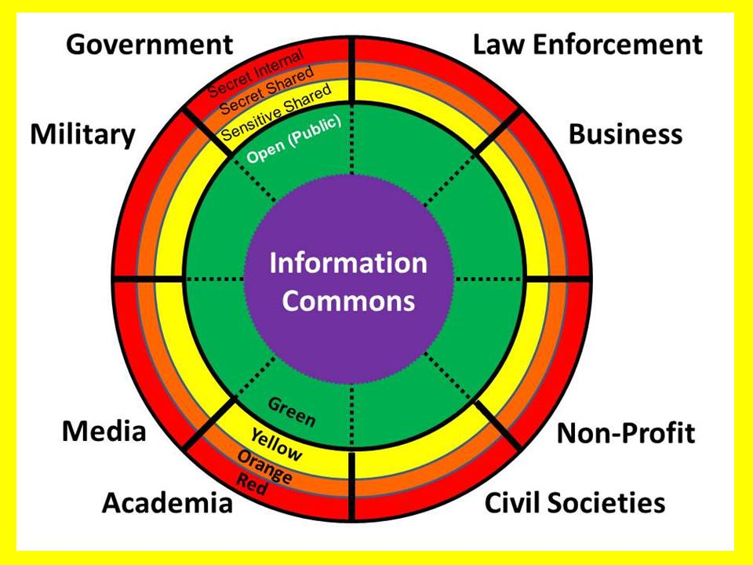
Figure 5: Eight Immature Information Communities
Beginning with case studies in support of The London Institute of Diplomacy and International Governance and The Glendonbrook Institute for Enterprise Development, the Open Source Hub would strive to rapidly aggregate existing open source softwares and hardwares, identify gaps, and then inspire the development (often at no cost) of gap-fillers; while also serving as a curator for identifying all relevant data sets and clusters of human expertise, ultimately creating a virtual knowledge cathedral (the technical architecture) with an embedded distributed knowledge bazaar (the humans with knowledge).
I have a specific vision and intent with respect to mobilizing and monetizing India from a London base.

What Is an Open Source Analytic Workstation?
A number of governments have recognized that Open Data by itself does not alter the accessibility of government data if citizens must still purchase proprietary software and hardware to access that data. Although eighteen functionalities are known to be needed for a common analytic workstation (illustrated below), these do not exist today in one unified proprietary installation, less so in open source. This may be a very fine challenge project with which to attract funding and publicity early on.
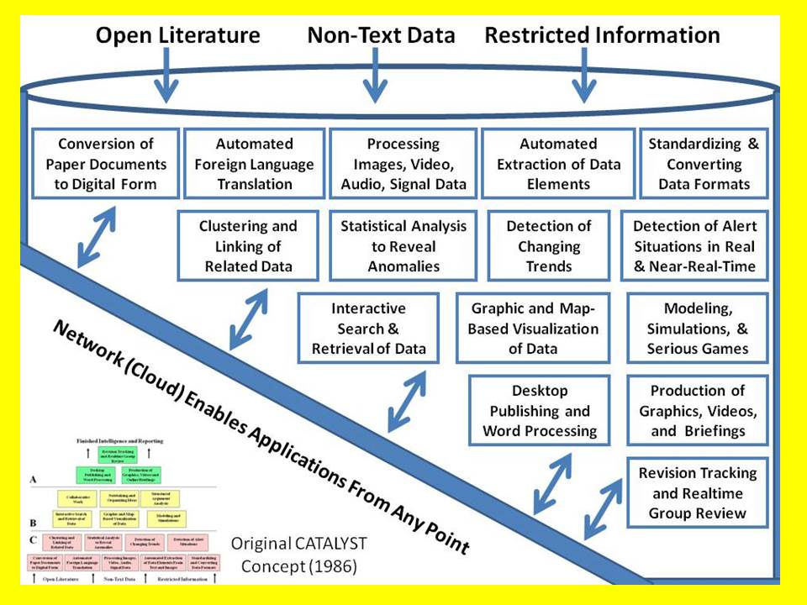
Figure 6: Essential Elements of an Open Source Analytic Workstation
There are some very positive developments at the intersection of open source hardware and software coming together in relatively low cost laptops as well as routers (for free citizen-owned mesh networks) and hand-held cellular devices, also able to operate within community owned networks.
We should think in terms of two different beneficiaries for our endeavor
- Global cities from Calcutta to Lagos to Singapore to the City of London and Metropolitan London as well as smaller communities across the United Kingdom and the Commonwealth. In this arena we address Smart Cities, Bio-City, Future City initiatives, with two huge differences from existing initiatives:

  - True cost economics will be pervasive in our analytic process
  - Individuals at the household level will have a full voice and full access

- Rural communities around the world that lack cellular and Internet access now. In this arena we can build on existing initiatives in which entire communities lacking cellular access can be connected locally with the simple installation of one $10,000 device, and internationally with a single Internet connection to that device (running wire – satellite is an option as well). Two organizations pioneering in this area and immediately available to join a larger technical information-sharing consortium are Geeks Without Borders (gwob.org) and the Rhizomatica Project in Mexico (Peter Bloom, Maka Munoz).
The first is a “big data” challenge where we bring to bear knowledge that most lack with respect to dark fiber, exoscale on demand processing power, geospatial coding, and a host of other issues that are simply not considered by smaller scale projects with narrower focus.
The second is a human outreach challenge, seeking to first connect and then empower individual who are now “off the grid.” Most interestingly, Bloom and Munoz have found that even those who are off the grid at home tend to own a cell phone that they use when they visit their regional city. An open networks that is Subscriber Identity Module (SIM) agnostic – and able to leverage open spectrum – can radically change lives for the better almost immediately, while creating an information-generation and information-sharing vortex that is diametrically opposite the challenge represented by the City of London, Metropolitan London, and other jurisdictions across the UK and world-wide.

What Is Big Data & Why Does It Matter?
We must begin with the fact that less than 1% of all big data is actually analyzed.
Yoda: Mary Meeker’s Internet Report 2014 — Explosion in Hand-Helds and Data — Less Than 1% of Data Analyzed
Then let’s add to that the reality that most legacy databases were created in by-gone eras, are non-standard, tend to be heavy, and cannot be ported electronically (the pipes are in the 10MB to 100MB range), and also cannot be accessed for simultaneous processing at most data centers because they lack the excess processing capacity.
Yoda: Exoscale by 2020? No Way, Jose! Four Socko Graphics and Bottom Line Upfront — Human Brain Still a Million Times More Power Efficient
Add to this the reality that relational databases were never designed for an era of big data, and the carriers have all been lazy about investing in dark fiber (slow speeds, choked feeds) and you have digital grid-lock. 21st Century multidisciplinary big data requires a soup to nuts design make-over.
Below is a single graphic illuminating the tsunami of change coming to communications and computing -- this is nothing less than an opportunity for an Open Source Hub able to mobilize the full human, financial, and technical resources of a great university and everyone else that it can engage.
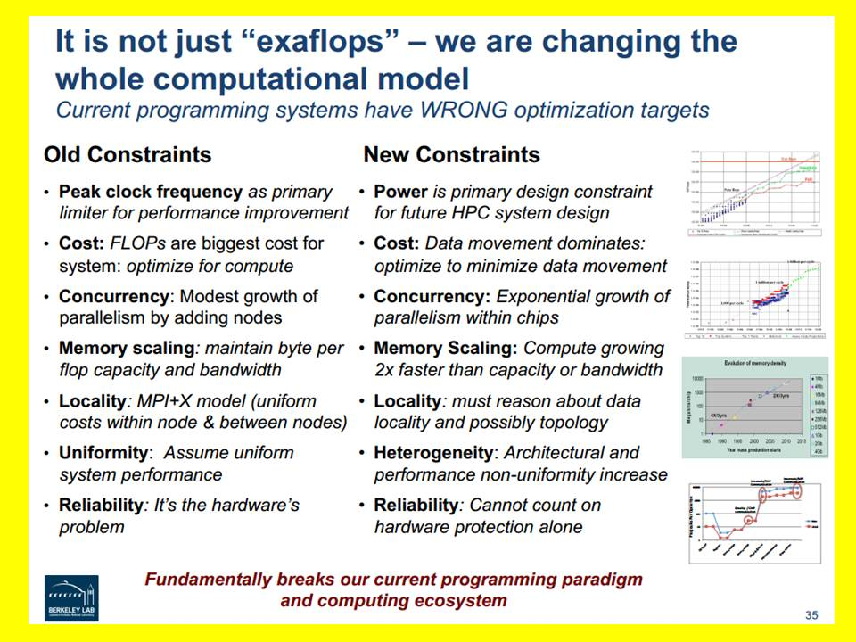
Figure 7: Computing Paradigm Shift Demanding Open Source Response
Now imagine Loughborough as the hub for an entirely new World Brain created from scratch.
Additional references on Big Data and its shortfalls:
Berto Jongman: Big Data Bandwidth Needs for Internet of Things Will Overwhelm Industrial Era Data Centers
Berto Jongman: Eight (Nine!) Problems with Big Data
John Danaher: Rule by Algorithm? Big Data and the Threat of Algocracy
Robert Steele: Why Big Data is Stillborn (for Now) + Comments from EIN Technical Council
Stephen E. Arnold: Big Data 2013 Wrapup - Stephen E. Arnold: Big Data – Can the Trend Deliver?
Stephen E. Arnold: Caution Advised on Big Data - Stephen E. Arnold: Hadoop Open Source & Big Data
Stephen E. Arnold: Human Creativity Key for Big Data Design & Exploitation
Stephen E. Arnold: Open Source Big Data Tool Combines MapR with Elasticsearch
Stephen E. Arnold: Search Big Data Flim-Flam
Yoda: Tutorial – How GoogleEarth and “Tiling” Work to Enable All-Source Near-Real-Time Big Data Sparse Matrix Compression & Tailored Exploitation

This section particularly – as well as the balance of the paper – would benefit from a deep discussion with Dr. Tom Jackson and others familiar with Loughborough University and the larger UK digital world.

Where Does Open Source Geospatial Play In All This?
A major short-fall within the digital world is the lack of structure. Apart from the distinction between the shallow web (the 2% that Google and other common digital search services can see) and the deep web (not to be confused with the dark or illegal web), one confronts vast quantities of unstructured data, much of it in varying formats, lacking pagination, editorial discipline, or even the basics of provenance.
One helpful means to begin enhancing the value of digital information as open access is expanded, is to strive to give every datum a combination of date and time identity, and geospatial attribute. The objective is to eventually be able to ask of the platform “show me everything we have in digital form (or digital pointers to analog form) for this particular location across this period of time.”
If we are to get to an affordable, inter-operable, globally scalable geospatial foundation for a World Brain, in which a massive sparse matrix of all information in all languages and forms can be associated with specific geospatial locations or paths over time and space, then open source software and open source hardware are going to be essential.
There are existing organizations and projects, most notable among them being the Open Source Geospatial Foundation and CrisisMappers the Humanitarian Technology Network. Between the two I prefer the second because it is practical, applied, and integrates various forms of open rather than focusing exclusively on software; it also integrates humans in all forms. The two (the first provides OpenStreetMap, among other open source softwares) work well together, as shown below.
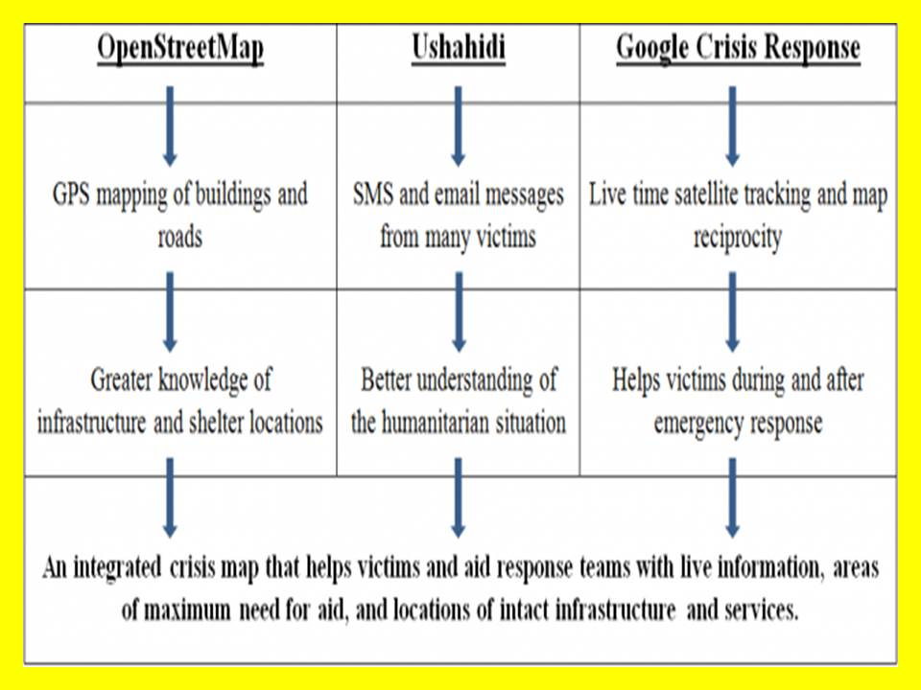
Figure 8: Open Source Geospatial Human in the Loop in Near Real Time
Eventually all data will have date and time tags as well as geospatial attributes, allowing for machine speed precision retrieval and visualization. At the same time, as situations develop where traditional government and corporate and academic resources are lacking, near-real-time situational awareness and the inventorying of specific aspects can be done by combining human observations, volunteer analysts, and a combination of open source softwares and hardwares.

What Is True Cost Economics & Why Now?
True cost economics, sometimes also called the “triple bottom line,” seeks to integrate not just the well-understood financial costs established by contract and convention, but also the less well defined social and ecological costs.
Below is a depiction of the true costs of a single cotton T-Shirt.
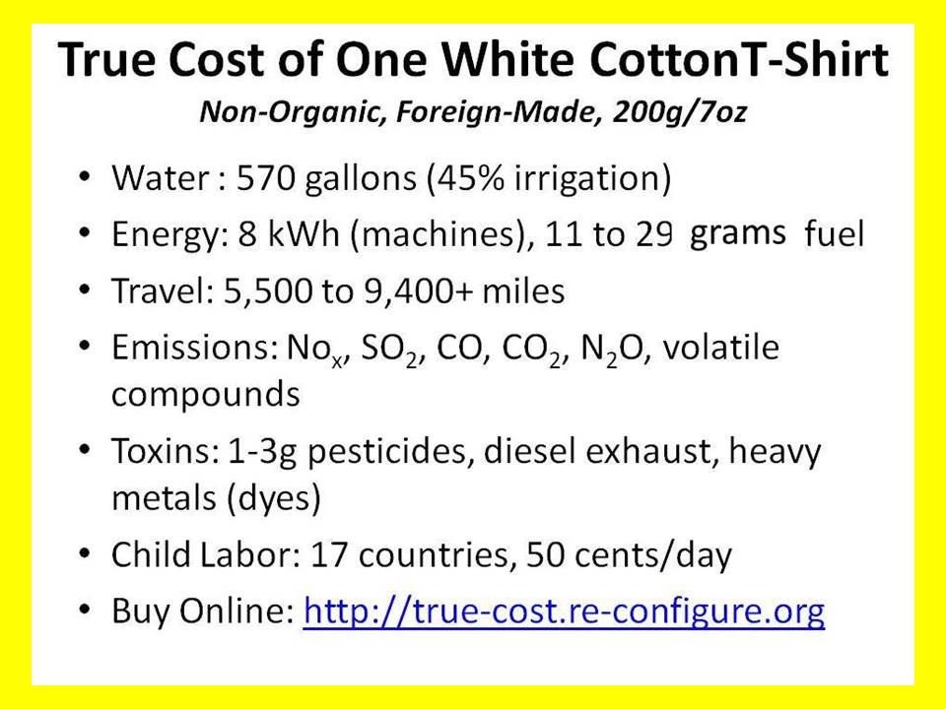
Figure 9: Representative True Cost Information for a Single Product
When fully developed, the practice of true cost economics will be multidisciplinary in nature, as individual scientific and social discipline and sub-disciplines develop new means to calculate with precision the inputs such as energy and water that each of their objects of observation consume, and the outputs in the form of toxins.
I anticipate a very vibrant and self-funding opportunity in the development of True Cost workshops, conferences, and online courses that include a platform where individuals can earn credit by contributing to the documentation and validation of true costs for specific products, services, policies, and behaviors.

Anonymity, Identity, Privacy & Rights
An Open Source Everything Hub brings together technologies (hard and soft), data in all its forms, and people. In planning for a diversity of persons to be engaged with full integrity, there are four technical challenges that must be mentioned for future consideration.
Anonymity. One could say that facts demand identity, while opinions merit anonymity. The digital era has radically altered both the possibilities and the expectations. Others more clever than I must address this requirement, I raise it only because in attending Hackers on Planet Earth (HOPE) this past week-end, I realized that in my obsession with Open Source Everything, I was neglecting some hugely important ethical, legal, and practical matters.
Identity. Whether dealing online with one’s personal banking, or accessing sensitive information intended for one’s “eyes only,” or participating in a forum intended only for a select group of law enforcement officers authorized to examine a specific delicate issue area that includes sensitive information not to be made public, the absolute validation of individual identify appears to be very important. Related to this are matters of tracking, archival of individual access to exploratory resources (see Anonymity), and so on.
Privacy. For myself privacy in the digital era centers on the right to avoid unreasonable search and seizure. I do not wish for the government to have access to everything I have purchased online; neither do I wish to commercial interests to know such that they bombard me with advertising. Of course I wish to be free of all uninvited attention, including “war dialers” that reach my unlisted number. We are entering a new era and I am personally not satisfied that the full intelligence and integrity of a major university has been applied toward these terms and how to implement them in a new form of ubiquitous World Brain intended to provide “opt in” access to all information in all languages all the time less love letters and other matters meriting reliable privacy.
Rights. As we come to the end of the Industrial Era when so many commons rights have been criminalized, we are finding that the transition lends itself to re-examining rights. Open Spectrum for example, is now being claimed by some communities, as the equivalent of local land rights – ownership held in common by the community, not to be restricted or assigned by any external body and certainly not a government telecommunications authority. The art and science of the digitally possible offer a fresh opportunity to examine rights – including patent rights – and processes.
References
UK's Drip law: cynical, misleading and an affront to democracy
Demonstrating the lack of knowledgeable leadership and the failure to engage in democratic debate, this 'data retention' surveillance law seeds distrust

A Killer App Loughborough Can Patent
This application, designed to display on any cell phone, could start a non-violent revolution that changes the marketplace overnight. This is simply one among many tools and techniques that could be developed to first research the facts across chosen industries and later across all industries (a massive undertaken that could invite other universities into a True Cost Research Consortium), and to then teach and inform via various means.
In this one instance, imagine developing an online process by which students at all grade levels can investigate the true cost of any product, service, policy, or behavior and earn academic credits or other forms of credit.
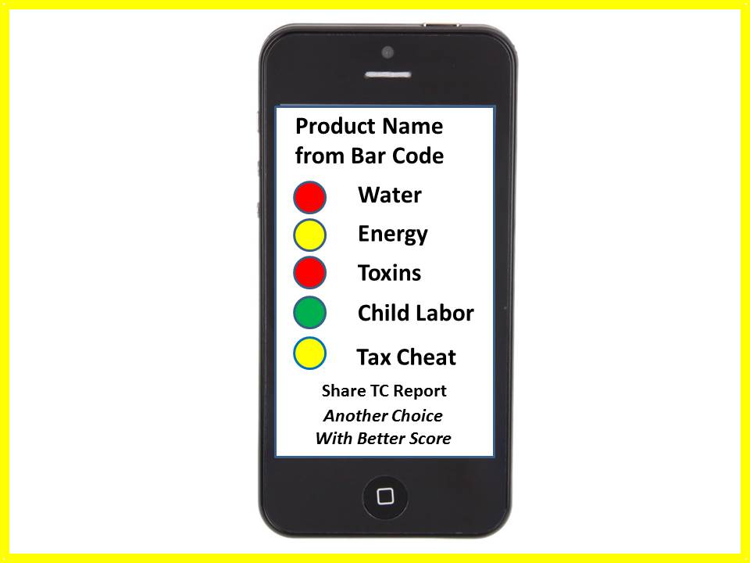
Figure 10: The LoBo True Cost "App"
All of this would of course be open source – including the cell phone (OpenBTS)—and very educational. Additional screens could show alternative products meeting all true cost expectations, and also means of promulgating both the negative finding and the positive alternatives.
For the government, new standards could be created that ensure that true costs are included in both the contract request for proposal statements of work, and in the contract selection technical and financial qualifications and evaluations plans.
For commercial clients, each existing or proposed product, project, service, or behavior could be evaluated in terms of both true costs and projected financial savings.

Science, Technology, Engineering, & Mathematics (STEM)
Western universities generally appear to be falling short in educating a sufficiency of students in science, technology, engineering, & mathematics (STEM), at the same time that Asian universities are emphasizing these domains.
Below is a graphic from the USA on anticipating job growth in relation to STEM.
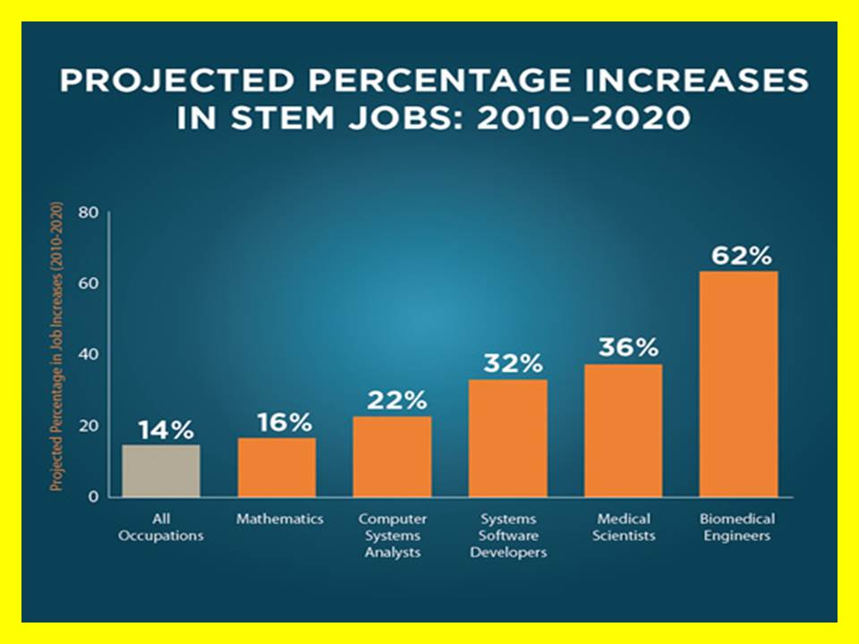
Figure 11: Selected STEM Job Growth Areas (USA)
A major aspect of the Open Source Everything Hub and its varied institutional, data, technology, and outreach elements is to radically redirect education so as to address the STEM challenge.
- Scientific education will be made more multidisciplinary, demand mastery of holistic analytics, and provide a complete understanding of true cost economics.
- Technology and engineering education will be aggressively redirected toward open sources and methods, with the desired result that Loughborough University be the premier university in the world for Open Source Everything (OSE), while LUIL becomes the most respected producer of enterprise-related education, intelligence, and research.
- Mathematics must be expanded to properly address computational mathematics and create multiple research activities that leave the University at the head of the pack with respect to algorithm development that is rooted in holistic analytics and true cost economics.

How Might the Open Source Hub be Organized?
In the most general terms, the Open Source Hub would be comprised of a small full-time cadre and a very large distributed network of adjunct staff and faculty as well as students. In a romantic sense it might be considered the prospective new soul of the organization, invisible and intangible in and of itself, but over time creating an institutional mind-set and the means for migrating from a collection of separate schools and departments toward a new blended network in which each piece retains its own unique capabilities and identity, but the whole achieves integral consciousness – Harold Wilensky would call it Organizational Intelligence.
Internal to the University, the intent is to leverage every mind and every datum such that the University becomes ever more powerful at attracting students, gaining international recognition for faculty, and winning research contracts.
External to the University, the intent is to become a globally recognized hub for three forms of 21st Century power:
- Knowing who knows down to the local level everywhere in every language
- Nurturing the ecology of open source across both the information and manufacturing domains
- Defining the new standard in holistic analytics and true cost economics
This power would be applied first to the needs of the London endeavor then to the interdisciplinary research challenges identified by the University:
- Changing Environments and Infrastructure
- Communication, Culture and Citizenship
- Enabling Technologies
- Energy
- Health and Wellbeing
- Secure and Resilient Societies
Over time, certainly not in the first year but perhaps beginning in the second year, the Open Source Hub could begin to help all elements of the University and its extended alumni and patrons of research to consider how to apply the open source mind-set to the ten high-level threats to humanity, the twelve core policies, and the eight demographic powers, doing so at multiple levels of granularity:
- Local (Town & City)
- County (Leicestershire)
- National
- Regional
- Global
Below is an illustration of the major elements
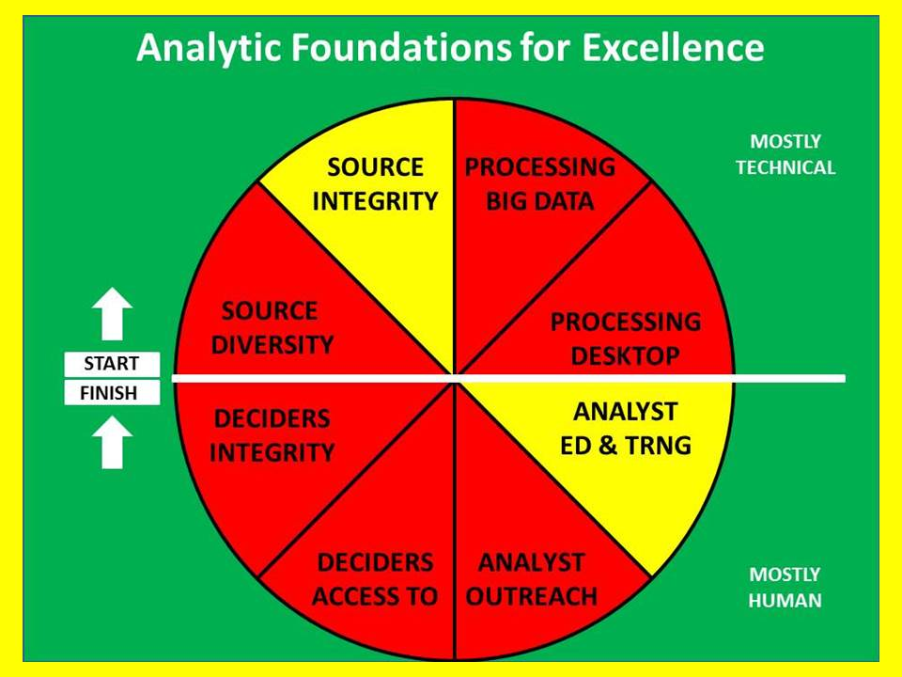
Figure 12: Major Technical and Human Analytic Segments -- All Failing
This proposal to create an Open Source Everything Hub centered at LUIL but being a major factor in the future of the larger University and the United Kingdom as a whole is nothing less than a revolution in analytic affairs. The combination of OSE as the technical aspect and M4IS2 as the human aspect can be seen as influencing the eight major technical and human aspects of how we “do” analysis, ultimately improving each of these eight aspects radically.
The Open Source Hub and its implementation vehicles described in the concluding pages of this proposal aspire to substantially improve:
- Source Diversity – all languages, all mediums, all disciplines
- Source Integrity – proper provenance and validation across the board
- Processing Big Data – needs dark fiber speeds and feeds, exoscale processing power
- Processing Desktop – create the Open Source Everything analytic workstation
- Analyst Education & Training –OSE & M4IS2 integrated into one department at a time
- Analyst Outreach – for the first time, every student & faculty have global reach in detail
- Access to Deciders – LUIL becomes the “gold card” for access to deciders
What this all boils down to is this: Loughborough University is a great university, just behind Oxford and Cambridge in traditionalist terms. It could be the best university, in 21st Century terms, when it comes to integrated useful knowledge.
A depiction of the threats, policies, and demographic challengers is offered below along with a proposed emphasis on poverty, disease, and ecology as threat domains meriting additional emphasis.
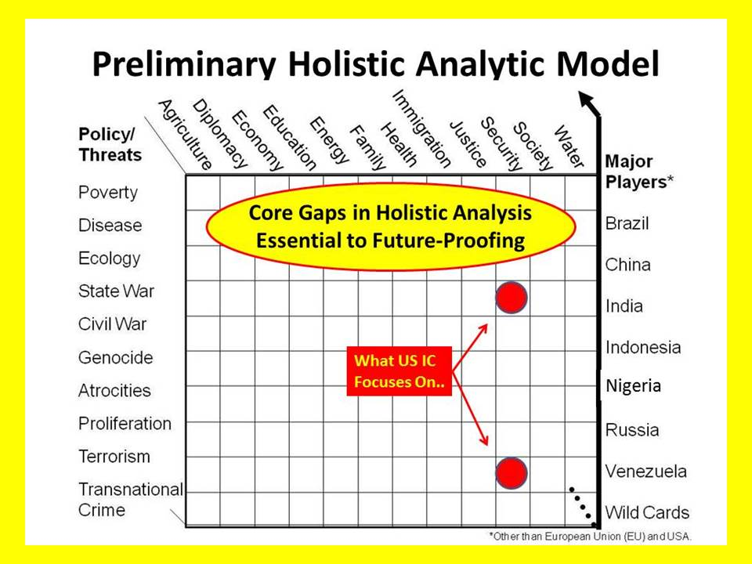
Figure 13: Preliminary Holistic Analytic Model
What the Open Source Hub would strive to avoid is the replication of any existing capability or expertise. It is more of an igniter than fuel or the engine itself.
It is a platform for empowering and connecting distributed human intelligence in all its forms.
For example, as open source softwares become available for integration into the university information technology ecology, the Centre for Information Management would be the authority on evaluating, integrating, and educating while also taking the lead in seeking funding for research to address gaps.
Preliminary reactions and additional guidance from within LUIL and the larger university are essential before venturing detailed propositions on staff. In general terms, if this proposal is accepted for action, a very rapid sequence of events (as outlined at the end of this document in “Practical Steps for LUIL Leadership” (page 35) will be pursued with internal and external inputs leading to 1) the crafting of a proof of concept phase and the manpower requires therein; 2) an interim development phase and associated manpower requirements; and 3) mature phase and anticipated manpower requirements.

Six Bubbles – Creating the Working World Brain
In 2006 24 individuals convened under the auspices of the Earth Intelligence Network (a US non-profit). Their charter: to design a means for restoring public agency by providing the public with a combination of local to global information and local to global technologies such that absolute democracy could be enjoyed – every person able to vote on every issue of concern to them, securely. Below is the high-level depiction of their vision.
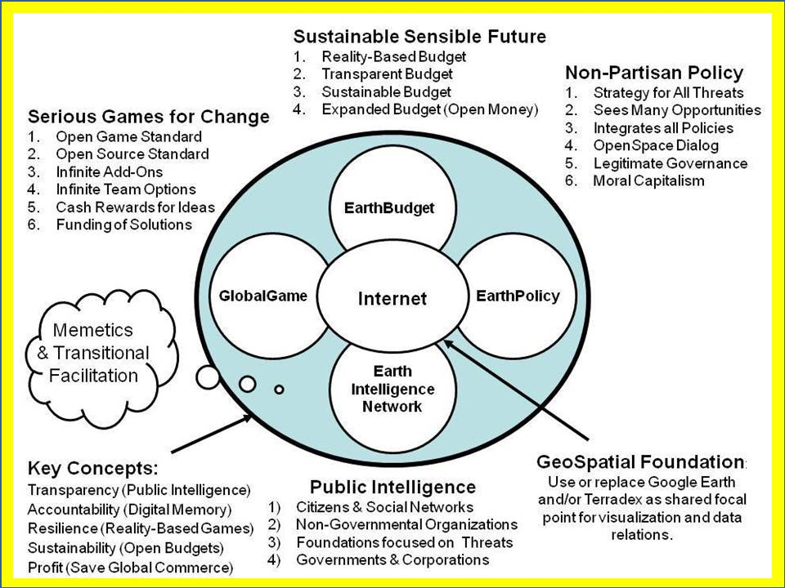
Figure 14: Digital Online Elements of the World Brain
By creating an open cloud of sufficient diversity and potency, it should be possible to enable distributed parties to curate their own particular collections of information, while also enabling near-real-time pattern analysis, anomaly detection, and other public analytic values. By placing all possible budgets online, corruption will be discouraged, waste made tangibly visible, and specific line items more easily challenged by an attentive public.
There are at least four forms of corruption that the platform will enable diverse stakeholders to address:
01 The corruption of omission – by making true cost economics integral to public consideration of every project, a non-violent influence on good governance will become readily available at all levels.
02 The corruption of process – by placing all allocations and costs online and visible to the public, the current situation, in which a billion Euros is outsourced sequentially to a series of third parties, each of whom takes 20% for “overhead” such that less than 100 million Euros are actually obligated or seen at the end-user level, will become less likely to occur in the future. On the next page is an illustration of a data-driven global range of needs and gifts table that will help disintermediate international assistance.
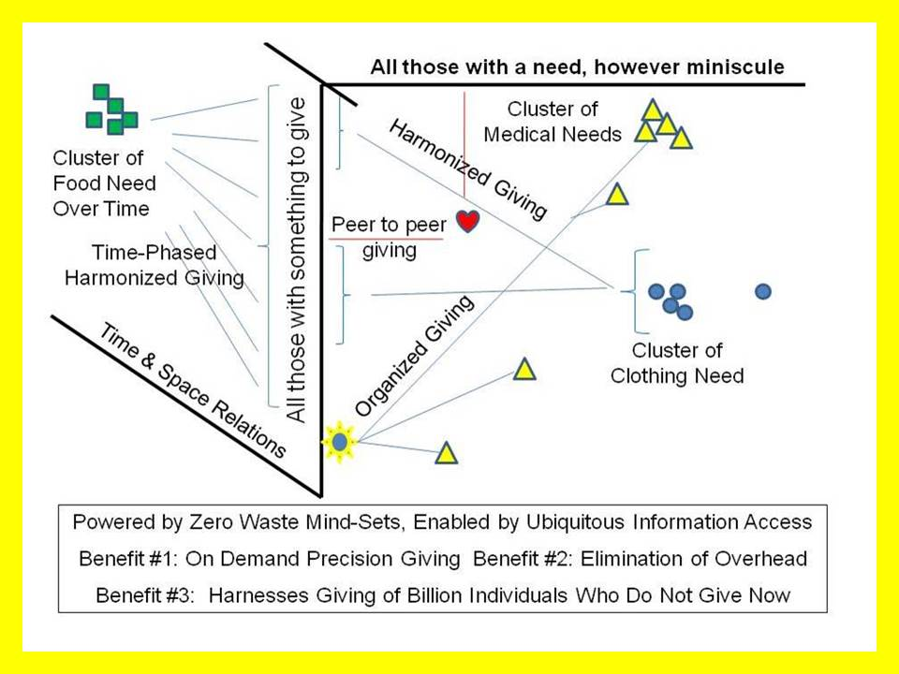
Figure 15: Data-Driven Disintermediation of Needs and Gifts
This particular approach to eradicating corruption through pre-emption is particularly well-suited to a combined effort with CrisisMappers and the entire Humanitarian Information Technologies networks (many of them, over-lapping, all lacking an integrative “home base” for information-sharing and persistent sense-making).
03 The corruption of theft – in particular cases where a government contracting organization is amenable to full transparency, contracts can be written that require full disclosure online of all costs in near-real-time basis.
04 The corruption of ignorance – this foundational form of corruption is addressed by all three of the above remediation efforts, and by a much larger endeavor to provide educational inspiration at all levels, making the platform useful to schools, local councils, activist citizens, aggrieved victims, and so on.

A Potential New School and New Institute
Two new organizations are envisioned. The first, a School for Future-Oriented Hybrid Governance, would bring together cadres from all eight of the information networks in annual classes at three levels: junior, mid-career, and senior. The second, a World Brain Institute, would administer the four World-Brain digital addresses shown below. Three of them are owned by myself and are available for sale or lease. The fourth can only be acquired by a US-based educational institution that also has a legal name including the World Brain.
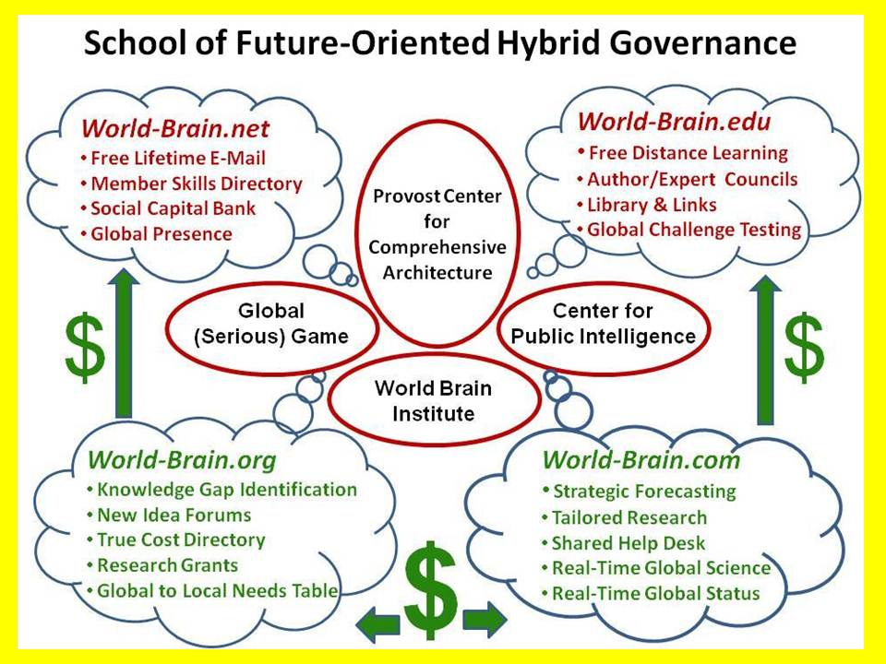
Figure 16: School of Future-Oriented Hybrid Governance, World Brain, Global Game
School of Future-Oriented Hybrid Governance. This is envisioned as a new residential school at the main campus of Loughborough University, with an extension program for non-resident students at LUIL, as well as a very robust program of faculty and student exchange, joint investigations, shared online databases, and other forms of outreach to universities, governments, corporations and non-governmental organizations around the world. Although proposed as contingent on earmarked funding, the School could nevertheless be started as a virtual entity from existing human, physical, and financial resources. A new building is envisioned with twelve wings – one each for each of the eight information networks or tribes as well as the four Centers shown above:
1) the Provost Centre for Comprehensive Architecture where all of the schools and departments might form an intellectual, data-sharing, and methods council – the new high table of academia;
2) the Global (Serious) Game as the interactive manifestation of the Open Source Everything Hub applied to real world challenges using real world information;
3) the World Brain Institute as the local to global proponent for extending the platform to every organization world-wide, while empowering individuals via the four online domains.
a) World-Brain.Net strives to register as many as wish to in a manner that both validates their identities when such validation is essential to the process and they opt-in; while also providing them with reliable anonymity & privacy, as well as means of reserving rights related to any knowledge or data they share. This is not a revenue producer, but this creates a first to market and barrier to entry for all others, capturing billions of human minds that can be monetized through the other three online networks.
b) World-Brain.Edu strives to be the platform for persistent pervasive free online education for life, while also serving as a foundation for any individuals and organizations who wish to organize localized face to face and both physical and online human to human educational options. This will take testing and tutoring as well as team learning to entirely new levels of excellence and effectiveness.
c) World-Brain.Org is a revenue-producer and makes LUIL and the larger University the hub for M4IS2 world-wide at all levels of practice from local to global. From knowledge gap identification to research funding and new forms of co-investment (including the harnessing of cognitive surplus and crowd-sourcing) to new forms of quality control that eradicate plagiarism and optimize Creative Commons credit and compensation, this aspect seeks to double or triple the return on investment of the existing research base while cleansing it of waste from redundancy and corruption related to plagiarism and poor sources and methods.
d) World-Brain.Com is a revenue producer implementing the Herring Triangle (Figure 18 on page 32) with its local to global online structured and validate information commons (displacing the erratic and shallow archipelago of unreliable and biased sources today), its local to global distributed network of help desks (reference librarians without borders augmented by information brokers, private investigators, investigative journalist, citizen activists, and so many others), and of course as a central registry for commercial intelligence with each source having a validated record of past performance.
4) the Center for Public Intelligence as the model that can be replicated at any level anywhere by anyone using free open source software and hardware that in turn enables localized free open cloud to open spectrum public agency.
The value of the whole is found in its clarity, diversity, integrity – and the sustainability it enables.

PhD in OSE/M4IS2 –Revenue, Design, Content, Outcome
Organizations are all well and good, but in the end a great university must offer substance in a process that yields a tangible outcome – graduates in demand because of what they know and how they use what they know. Central to the design of a PhD to be offered by the School of Future-Oriented Hybrid Governance is the concept of eight information networks – each of the eight networks must provide members of the oversight board as well as varied mentoring networks; there must be practitioner involvement in the design and teaching of the course and the testing of the students; and finally, the student must exit the program not only being in great demand within their chosen network, but so versatile and skilled at leveraging the other seven networks they are destined for rapid advancement.
Revenue
I recommend this be a scholarship play – leveraging a stellar oversight and advisory board, we seek to obtain funding from each of the eight information networks (major players, industry associations, lobbyists) for eight students from each, ideally a total of 64 paid students a year beginning in year one.
Below is a table showing proposed student loads across the first four years of the proposed program. This group could readily integrate the diplomatic and international governance prospects as a sub-set, if desired. These numbers are at the low end of what is possible with a distributed international program in which universities in Calcutta, Lago, and Singapore, among others, are “fleeted up” as full nodes of a global program. A loss rate is not shown, we should of course strive for zero net loss from year to year. Our goal is to take a student with a Class A degree to a PhD in four years of full-time effort with a constant student population for the School of roughly 250 at various stages of classroom, practice, and independent research such that the on-site population is held to a smaller manageable number.
School of Future-Oriented Hybrid Governance Student Load Years One to Four
 | Low  2015-2016 | High  2015-2016 | Low  2016-2017 | High  2016-2017 | Low  2017-2018 | High  2017-2018 | Low  2019-2020 | High  2019-2020
Year One | 32 | 64
Year Two |  |  | 32 | 64
Year Three |  |  |  |  | 32 | 64
Year Four |  |  |  |  |  |  | 32 | 64
Total | 32 | 64 | 64 | 128 | 96 | 192 | 138 | 256

Oversight & Advisory Board
Information Network | UK Leader | Asia/South Leader | US Leader
Academic
Civil Society
Commerce
Government
Law Enforcement
Media
Military
Non-Government
A similar body would be formed for each class, and would be responsible for mentoring that class through to graduation, with a new body recruited for each class in secession. The mentors would be practitioners and would be fully engaged in finalizing the course design, devising scheduled apprenticeships and practical challenges within their respective industry, and hosting events at which students are “roasted” by a diversity of professionals, keeping their minds firmly focused on the future.
Course Intent
Political Science is the study of governance, and has up to this point been largely a passive observer of the process. Despite the enormous foresight of some individual political scientists – Richard Falk and Edgar Morin come to mind – Political Science as a discipline (an element of the humanities) has been slow to recognize emerging threats, challenges, and processes of change at the same time that the Sciences have advanced in often dangerous directions with great costs to society and the Earth. Political Science has done little to help the public understand, mobilize, and engage.
In my view, the time has come for Political Science to become a normative discipline that is the proponent for both Multinational, Multiagency, Multidisciplinary, Multidomain Information-Sharing and Sense-Making (the human solution) and the adoption of Open Source Everything (the technical solution). International Relations, Public Administration (radically advanced into a new sub-discipline of Public Hybrid Governance), and a variety of other primary university disciplines would converge in this School. Neither parastatals nor narrow public-private partnerships encompass the larger human-centric data-driven vision that this project seeks to actualize.
This PhD degree proposal is tentatively bracketed on the one hand by technopolitics or digital activism, striving to study, design, test, and then promulgate a theory and practice of grassroots multi-stakeholder decision-support and decision-making (two completely different processes) – and by Smart Nations, Smart Cities, Smart Enterprises on the other – helping achieve emphemeralism (doing more with less) while also radically enhancing the prospects of creating prosperity and peace for all. Three "what if" questions are proposed for consideration by the Open Source Everything Steering Group (a university-wide body assuring that all schools and departments are part of the program).
WHAT IF Political Science were to make the evolving craft of intelligence (decision-support) its central focus, such that a new norm is established in which politics is evaluated in relation to its ability to engage in deep multi-cultural history and holistic analytics that are public in nature and inclusive of all eight tribes of public hybrid governance (academic, civil society, commerce, government, law enforcement, media, military, non-government/non-profit)?
WHAT IF Political Science enhanced its scientific credentials by embracing Whole Systems True Cost Economics as a foundational multi-disciplinary science with data indexed geospatially and in time? This would create a more grounded landscape of financial, social, and ecological opportunity and threat -- a basis for being a normative discipline.
WHAT IF Political Science recognized that in the Age of Information no discipline can be credible without the ability to collect, process, analyze, and share information affordably, inter-operably, and universally, which is to say, in an Open Source Everything fashion? This restores agency to the public – we put the public back into politics, but this time we connect all minds with all information in all languages.
The value proposition for the University and the community is that in today’s world, if the both the public and individual enterprises across each of the eight information networks can be provided with free information tools and access to all relevant information, everything about politics – about political economy in particular -- changes. At a practical individual PhD student level, this is a three-part challenge that many students aided by staff, will conquer: a) create an “application” for decision-support that anyone can use; b) create a model for assuring that true cost economic metrics are considered within the decision-support application; and c) leverage existing open source information technology and encourage development of needed new open source information technology applications to empower citizens and enterprises of every size with tools for thinking, communicating, and mobilizing effectively not just on one issue at a time, but on all issues all of the time.
Course Design
Track 1: Holistic Analytics. Every discipline has its means of teaching sources and methods, how to think, how to investigate hypotheses, how to validate and present findings. Track 1 would devise an integrated multi-disciplinary course of instruction drawing on the best that various disciplines have to offer, in order to produce a PhD level lead investigation in their chosen discipline who is fully familiar with alternative investigative schema across multiple disciplines, and able to credibly organize, oversee, evaluate, and exploit very large scale inquiries and projects that depend on evidence-based decision-support across the most complex combinations of challenges and circumstances. The graduate will be superior to any other graduate produced anywhere else, by virtue of being a master of M4IS2.
Among the many skills that we wish to make standards in an LUIL graduate from this new program are:
a) Citation Analytics. A new standard for literature reviews must be established, one that not only finds and evaluates best in class contributors in all languages and disciplines, but learns to go beyond the published literature to identify best in class practitioners at the field and practitioner level. A major university-wide value of this sub-track, particularly since it have some structure from the leadership of the university, the departments, and the School of Future-Oriented Hybrid Governance, is that within a short time LUIL will have a better grasp of who knows what about anything, than any other comparable university in the world including Oxford and Cambridge – and LUIL’s knowledge will be integrated and open – accessible – to all.
b) Time & Space Analytics. There is a growing body of thought that suggests we have been too dismissive of indigenous practices and wisdom prior to 1491, and still today in many areas where tribal practices and communal ownership are still flourishing. At the same time, geospatial analytics is in its infancy, but with some very promising advances being made both in the laboratory and in the field, the latter with open source humanitarian technologies and crowd-sourcing. A major university-wide value of this sub-track will be the development of new open standards and methods for integrating information across all of the disciplines in near real time and over great spans of time.
c) True Cost Analytics. The Earth and our children as well as future generations have no voice in politics and economics today. We are far past due for a radical change in the narrative at all levels, such that the true cost of every product, service, policy, and behavior can be researched, taught, and appreciated. A major university-wide value of this sub-track will be the development of a university-wide capability – unique around the world – to determine trues costs for all processes and products, discipline by discipline. I anticipate some extraordinary cross-fertilizations to occur, inspiring of innovation.
Track 2: True Cost Economics. Although the concept is well established – and its pioneering economist, Dr. Herman Daly, is available to serve as an Emeritus member of the oversight board and mentoring network, no one, anywhere, is known to have gone “all in” on actually doing true cost economics across any single discipline, much less all disciplines. A major university-wide value of this track is the immediate establishment of the university as the “world bank” for validated data about the true cost of any product, service, policy, or behavior.
Track 3: Open Source Everything. Business schools are now beginning to teach their students how to code and lead code projects. Although they still do not teach the process of intelligence (decision-support), this shift toward assuring business school graduates are moderately capable of engaging with information technology is important (but utterly shallow). We can do better. All business processes and products – not only those dealing with information – are in urgent need of ephemeralism. Open Source Everything is how we help them achieve this goal. At a minimum the graduate will fully understand how to integrate all of the opens having to do with communications and computing. Ideally – and assuredly in their chosen network and practice sub-set, they will understand how to apply the Open Source Everything mind-set and method to any given set of business products and processes.
Track 4: Hybrid Governance (Threats, Policies, Demographics).
If there were one word lacking in the vocabulary of most US college graduates today, that word is “context.” In the face of massive ignorance, obfuscation, and as often as not outright lies from the pinnacles of all eight information networks, our young adults entering the white collar workforce are sadly disadvantaged. They are ready for a life in cubicles that are no longer available for occupation. They are not ready to make their own way, to be entrepreneurial on their own or their employer’s behalf. Below I summarize the context as I have derived it from reading in 98 categories of non-fiction:
Key Negative Trends Relevant to the Proposed Program
- Collapse of complex societies. Catastrophe from disaster for lack of resilience and lack of adaptation as well as corrupton.
- Acts of Man creating Acts of God. Natural disasters (as well as industrial disasters) will be more frequent and more severe as we cement wetlands, do fracking, and generally mess up the Earth.
- Acceleration of Earth’s Demise. Changes that used to take 10,000 years now take three years – this is particularly grave with respect to the loss of clean water; absent Real-Time Science and Real-Time Public Policy (online, deliberative, rooted in evidence-based decision-support), we die as a species.
- Shock Capitalism. We continue to loot the Earth and the mis-serve the largest populations, turning the USA and the UK into Third World countries – the UAE (Dubai) is the new Switzerland while Asia devises new alternative international economic governance models that could shut out of the South.
- Political Corruption ascendant. 44 dictators (42 of them beloved by the US Government), two-party tyrannies blocking all others from the high table of politics, and very corrupt elites in small towns and districts, have abdicated all responsibility for pursuing the public interest.
Key Negative Trends Relevant to the Proposed Program
- Wealth of networks. The fortune is indeed at the bottom of the pyramid (capitalism focused on five billion poor with four trillion a year economy instead of one billion rich with one trillion a year economy), infinite wealth created through sharing information and achieving ephemeralism (doing more with less), peace through connectivity.
- GreenMind. Biomimicry, beneficial bacteria, green chemistry all coming to the fore – even more positively, true cost economics (including social costs) ready to become the new gold standard for holistic analytics and transparent multidisciplinary public policy.
- Moral capitalism. Natural capitalism, green to gold, cradle to cradle, home rule, eat local, end of corporate personality, end of absentee landlords (and an end to the fencing of the commons and the crminalization of public rights rooted in history) all coming forward. Inclusive Capitalism, Collaborative Capitalism are book-ends for finally doing the right thing instead of the wrong things righter.
- Democratization of information. True costs at the point of sale will change markets overnight.
- Left Hand of God. Faith-based dialog and diplomacy have been neglected despite there being clear case studies of the effectiveness of embracing religion as a force for good in relation to diplomacy, commerce, and science. We must end our support for all dictators, and be true to our putative respect for democracy, freedom, and human rights.
- Peer to Peer People Power. From the Tao of Democracy to Citizen Wisdom Councils (the Danish lead the way) to Blessed Unrest to Clock of the Long Now, with Occupy as a side show that lost its way, the power of the public – what Vaclav Havel called The Power of the Powerless – is not to be denied. It is a force for good. As Elinor Ostrom shows so clearly (earning a Nobel Prize for the work) in Governing the Commons: The Evolution of Institutions for Collective Action, the best governance really is Of, By, and For We the People.
At the highest educational level, in addition to understanding broad multidisciplinary contextual trends such as noted above, one should be familiar with the ten high-level threats to humanity, the twelve core policies (and their true costs), and the eight demographics that will determine the future without regard to UK or US policies or desires. They are listed below.
High-Level Threats, Policies, & Demographics
01 Poverty  02 Infectious Disease  03 Environmental Degradation  04 Inter-State Conflict  05 Civil War  06 Genocide  07 Other Atrocities  08 Proliferation  09 Terrorism  10 Transnational Crime | 01 Agriculture  02 Diplomacy  03 Economy  04 Education  05 Energy  06 Family  07 Health  08 Immigration  09 Justice  10 Security  11 Society  12 Water | 01 Brazil  02 China  03 India  04 Indonesia  05 Iran  06 Russia  07 Venezuela  08 Wild Card, such as  - Malaysia  - Nigeria  - Turkey  - South Africa
The high-level threats – validated and prioritized by the United Nations High-Level Panel on Threats, Challenges, and Change – are well-suited to be a foundation for multidisciplinary studies, consulting, and research, and of course enterprise innovation. No one else is forcing the issue of how we must change the manner in which we do diplomacy, commerce, education, enterprise, and peace-keeping if we are to be relevant, in a timely manner, to the five billion poor.
A simple example: the one billion rich (with one quarter of the annual aggregate income of the five billion poor) buy refrigerators that cost thousands of dollars and demand a centralized electronic grid to support them. At the most basic level, an African refrigerator costs $2 and is a pair of ceramic jars, one inside the other with an air gap, that when buried in the ground keep meat fresh for five days.
We are on the verge of a design revolution – the ephemeralism revolution – in which new combinations of renewable energy, virtual and open source design, and digital manufacturing, as well as new forms of entrepreneurial innovation in governance, commerce, and all other forms of human endeavor, will literally change the world for the better over 20 years. LUIL can be the hub for this global revolution.
The policies are those that tend to be prominent during every national election cycle, hence they are the recurring fundamental ones. All policies – all forms of behavior and investment – demand a new approach that applies the open source everything mind-set and engineering form. Policies examined with holistic analytics rooted in true cost economics is how we advance the multidisciplinary endeavor.
The demographics are straight-forward. These are the countries that will define the future irrespective of what pontifications and platitudes our political and financial masters may wish to profer. If we are to be serious about preserving the English-speaking people, as Winston Churchill has so famously recorded their history, we need to engage these demographic power, both by attracting their students, returning them home to be leaders, and by devising the very best science and engineering and ethical humanities concepts for going forward that anyone can create. This is what will catapult LUIL to greatness.

Emerging Economic Concepts
Below are contextual overviews of four emergent economies in ascending order of utility to this paper.
Inclusive Economy
The “inclusive economy” is a new term derived from a conference on “inclusive capitalism” sponsored by the Rothschilds in London and featuring H.R.H. The Prince of Wales as a welcoming speaker. As covered by the media, the conference is described as being organized and attended by individuals who among them have US$30 trillion under management.
Because of the wealth of this group, and the gap between what this group seeks to do and the larger reality that the Open Source Hub can illuminate, this could be the single fastest route to a Euro 100 million commitment that places the Hub in service to the City of London but enables it to be built – and to maintain its independence – in a stunningly rapid fashion.
Ethical Economy
The Ethical Economy seeks to make values and social considerations central to the prioritization and production process. Adam Arvidsson and Nicolai Peitersen in The Ethical Economy: Rebuilding Value After the Crisis articulate a tangible response to the collapse of multiple national economies occasioned by what Matt Taibbi in Griftopia–Bubble Machines, Vampire Squids, and the Long Con That Is Breaking America describes as “a highly complicated merger of crime and policy, of stealing and government.” Here is the complete quotation from page 32:
What has taken place over the last generation is a highly complicated merger of crime and policy, of stealing and government. Far from taking care of the rest of us, the financial leaders of America and their political servants have seemingly reached the cynical conclusion that our society is not work saving and have taken on a new mission that involved not creating wealth for us all, but simply absconding with whatever wealth remains in our hollowed out economy. They don’t feed us, we feed them.
This paper and its proposals seek to make the university central to restoring the integrity of society, commerce, and governance through the deliberate use of Open Source Everything (OSE) and a concurrent reintegration of design, philosophy, the sciences, and the humanities made manifest through resilient sustainable engineering (as shown in Figure 1 on page 5).
The ethical economy reinstates the human – and human values – as central to the prioritization and productivity of human enterprises.
Transparency – and the truth – are fundamentals within an ethical economy. In such an economy information asymmetries between buyers and sellers are minimized if not eliminated altogether.
In such an economy high-speed trading that takes advantage of incoming orders to “beat them to the punch” is made illegal. In such an economy derivatives that disconnect tangible value from financial value are either made illegal or so exposed they lose all credibility as offerings.
The Ethical Economy is a newer manifestation of the older concept of “triple bottom line” in which social and ecological values are co-equal with financial values generally lacking in true cost economic considerations. Most interestingly, because the Ethical Economy calls for the reinstatement of public ownership of the “value regime,” it opens the way for a reinstatement of the university as a hub for values articulation and as a binding element influential in reinstating public values in governance and commerce.
Because it is centered on values and values often take generations to gestate, this approach is considered time-consuming and not likely to yield immediate tangible returns – but it must certainly be embraced and nurtured over time.
Collaborative Economy
The collaborative economy is defined by Jeremiah Owyang as the convergence of three ideas: the sharing economy, the maker movement, and the “co-innovation” movement. In relation to a research university focused on community service and enterprise outreach, this translates into an opportunity to fully integrate design, information management, engineering, and each of the disciplines in turn.
Design translates into convenience. Information management can change the marketplace by changing public understanding of the true cost of specific products, services, policies, or behaviors. Engineering can radically reduce cost by rejecting the last fifty years in which the Americans have substituted “cost plus government specification” engineering for the more brilliant engineering that optimizes design to radically reduce costs across an entire life cycle and across different mission areas. The simplified designs and shared components characteristic of the Global Village Construction Set are a real-world achievement worthy of emulation across many disciplines.
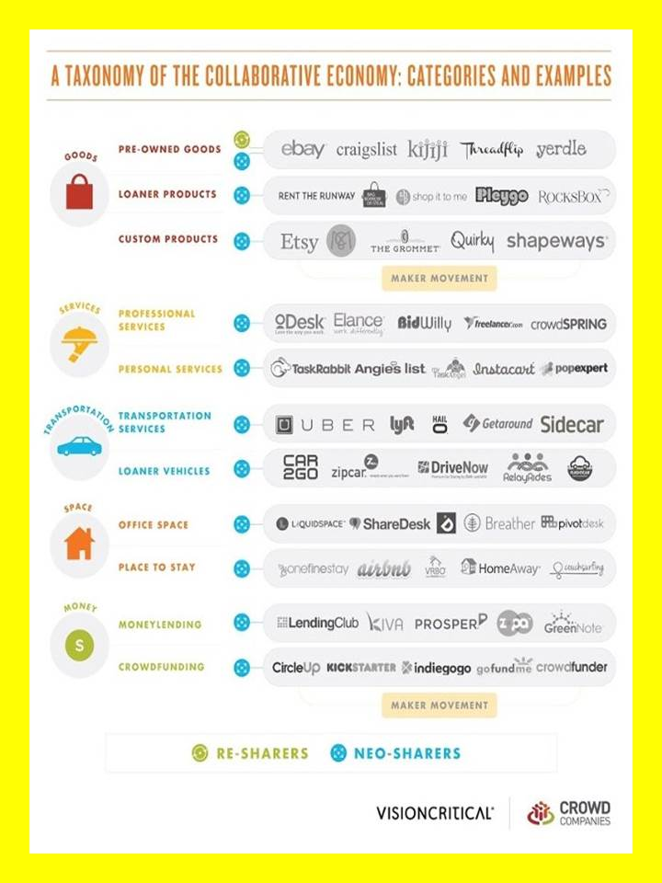
Figure 17: Specific Companies in the Collaborative Economy

Potential Financial Partners
There are at least four major potential financial partners for this endeavor. These are a starting point:
Government -- Focus on Some, Value to All
While the UK government – and local governments – are surely not as wasteful as the US Government, there is probably a 30% waste factor that can be found in government if holistic analytics, true cost economics, and big data mining are brought together. Since governments tend to be stove-piped, some immediate benefits can be gained simply by getting information shared across government boundaries, both among Cabinet agencies at the national level, and among agencies at all levels from local to national. In relation to information technology and public intelligence (decision-support) there appear to be virtually unlimited opportunities for offering government an affordable, inter-operable, and scalable open source everything approach helpful to every mission area at every location.
A few elements of government merit some special attention as immediate beneficiaries and patrons:
- Diplomats within the Foreign and Commonwealth Office as well as civil servants in the Department for International Development represent one recommended area of focus.

- The Department for Business, Innovation and Skills and the Department for Communities and Local Government are an especially enticing prospect for innovation in open source information solutions and new methods for introducing broad understanding and exploitation of holistic analytics and true cost economics.

- The Ministry of Defence – and most particularly those at the top planning for a much-changed future and those at the bottom emerging from the military cocoon to face prospects of unemployment and homelessness – merits very special attention. The Open University is an example to be refused – we can and should develop a new form that takes each individual from the military, measures them for a bespoke education, and assures their psychological, moral, intellectual, physical, and social health going forward as path-finders and innovators in the 21st Century business environment that the Open Source Everything Hub will help Loughborough University and LUIL define for a century into the future.
Across the government as a whole, taking every department as a potential beneficiary, a combination of open source information technology solutions, and an initial focus on inventorying energy and water as elements in every decision, offer promise.
I recommend we seek 20% of the desired funding from this group. It is a very important client from an influence perspective – it is essential that the government see the value of ethical evidence-based decision-support, and begin making decisions that are fully informed in a multidisciplinary manner that is future-oriented and deeply rooted in historical understanding and geospatial perspective.

Enterprises – Open Source In, Entrepreneurship & Innovation Out
Apart from the IT world – both those that seek to develop open source technologies and those that seek to buy them, there is a very lucrative and as yet not fully developed marketplace for a mix of continuing education, mission area decision-support, and directed research intent on finding new opportunities for profit.
I recommend we seek 20% of the desired funding from this group. There is particular advantage to be gained from fully integrating true cost economics analytics – particularly with respect to energy and water usage and toxin generation – and in creating business ecologies where benefits are compounded across an industry and among industries, not simply reserved to a single company. We are entering an era where the greatest profit is the shared profit, not the singular profit.
A major possible advantage to be offered to participating enterprises is a new form of direct communications with their varied stakeholders. Traditional advertising across the media appears to be in sharp decline at the same time that the public is losing confidence in the media a source of useful information. There may be new information sharing ecologies that can be nurtured in which enterprises gain audience from their association with a trusted provider of information and decision-support.
There is clearly a growing need for trusted information platforms that are devoid of vested interests, that undertake appropriate due diligence, that don’t treat the general public like half-wits, and that present media in dynamic and engaging ways. No-one is filling that space.
Below is a representation of four levels of decision-support and how they might be shared across a given industry or across varied industries with shared interests at some inflection point.
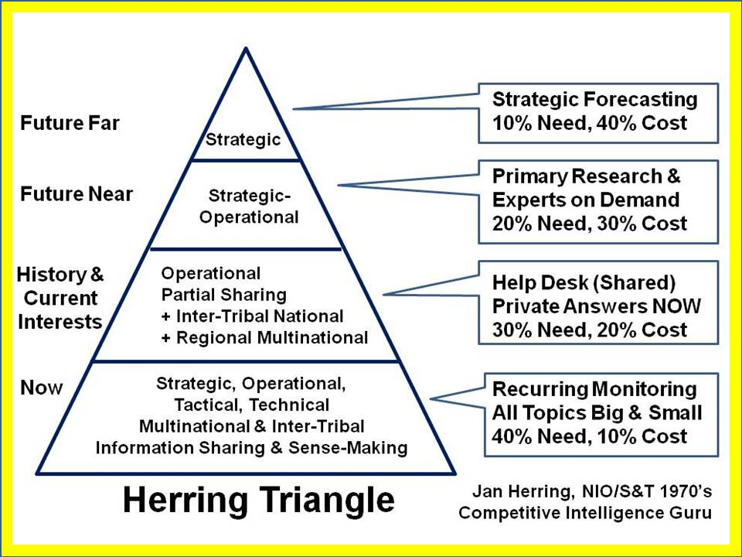
Figure 18: The Herring Triangle of Shared and Selective Services
The Open Source Everything Hub, apart from creating cost-effective solutions, can also be a trusted service of common concern, with education, intelligence (decision-support), and research all benefitting from the local to global operation of these four levels of information and intelligence and planning.
Media, Publishers, and Other Universities – The Guardian in Particular
Rupert Murdoch’s recent offer of US$80 billion for TIME Warner was rejected. I mention this only to observe that there is money available and the news industry is in some turmoil. I actually reached the editorial level of TIME Magazine in the 1990’s with a proposition that they become a public intelligence agency, able to provide citizens and organizations with structured access to trusted information across all policy, financial, and other topics. The idea was rejected in part because there was fear of the potential expense to do it right, and in part because it seemed to demand that TIME cover all topics all the time.
The mainstream media, including some of the biggest sellers, i.e. Daily Mail, have lost not only trust, but credibility, namely because not only does the validity of their content vary from stretching the trust to abject lies, but there’s now so much tittle tattle and celebrity focused gossip, that the mainstream audience has a love/hate relationship with the media. People want ‘news’ and they want ‘promotions’, but they are smart enough to increasingly understand that a fair percentage of what is printed is cobblers.
On the high end, The Guardian, the Financial Times, and their counter-part newspapers in India strike me as a very promising set of potential media partners. I recommend we seek 20% of the desired funding from a mix of media, book publishers (e.g. Routledge), and professional associations thinking about how to become more timely and relevant outside of their web sites and professional journals.
City of London – E.L. Rothschild in Particular
The City of London – not to be confused with Metropolitan London – is still the center of the Western financial world. It is under siege, not only from government and corporate leaders who feel betrayed by the LIBOR scandal and the hubris of playing with the global economy absent any ethical standards at all, but also from a new alternative international financial order led by China and Russia and including Brazil, India, South Africa, and probably Malaysia and Turkey as well. The single best indicator – and point of access for seeking funding from this group of potential investors is the Inclusive Capitalism initiative.
I recommend we seek 40% of the funding from this group, but be prepared to advance ideas for much larger amounts to be placed in escrow for a multi-year fund with many chairs and projects – on the order of Euro 1-3 billion.
References
Conference on Inclusive Capitalism: Building Value, Renewing Trust
On 27 May 2014 global business leaders gathered at the Mansion House and Guildhall in London to attend the Conference on Inclusive Capitalism: Building Value, Renewing Trust. The Conference was hosted by the Lord Mayor of the City of London and E.L. Rothschild and organized by The Inclusive Capitalism Initiative and the Financial Times.
Speakers Page
It would be most interesting for the leadership of LUIU to contemplate how many among the listed speakers might be engaged in to preliminary conversation about the Open Source Everything Hub, with a view to having their earnest support upon an official advance toward E. L. Rothschild and the Lord Mayor.
A speech by HRH The Prince of Wales at the Inclusive Capitalism: Building Value, Renewing Trust conference
The key to forging such a new approach has to be, I would have thought, a fundamental transformation of global Capitalism. It seems to me that the transformation I have long had in mind is reflected in the substance of your meeting today and the question of how to create a shift in focus away from the present attention on the short-term and towards a focus on the long-term. And with it, an authentic moral commitment to acting as true custodians of the Earth and architects of the well-being of current and future generations. Many of you here today are pioneers in this process and you have shown that this commitment does not have to incur a financial cost. Indeed, as my Accounting for Sustainability Project has demonstrated only too clearly, it is only by adopting a broader sense of value that our finances will be sustained and we can find new sources of profit.

Practical Steps for LUIL Leadership
I list below some specific practical steps – including fund-raising – that the LUIL senior management team can take commencing in August 2014, just over one year prior to the formal opening of LUIL.
In general terms the steps fall into three categories: outreach (both internal to the University and externally across the community, both face to face and via publishing), fund-raising, and implementation planning. This initiative is conceptualized as a full-time fast-paced endeavour intended to raise funds for and to establish new capabilities within LUIL in time to influence its recruitment for the first year of teaching and research commencing September 2015.
Short biographies of each of those named below are provided in Appendix 8.
Date | Practical Step | Comment
2014 AUG | Open Source Everything Steering Group | University-wide, all schools/departments
 | - Dover forms and chairs initial group to assure all stakeholders are engaged & satisfied.
2014 SEP | University Planning Document | With eye on raising Euro 100 million
- Steele drafts in interactive engagement with Dover and via Dover, other stakeholders
- UK Leads receive preliminary commissions to contribute to the planning.
- Dover considers LUIL floor space and rented real estate options and costs.
2014 SEP | London Challenge: Open Source Everything
- Dover, Steele, & UK Leads 2 events a day with focus on City of London, IT world
- Selected others for a culminating black tie event that makes international news
2014 SEP | Legal (Patent) Brainstorming Workshop | Protect the investment, create legal entity
 | - Hybrid approach needed – some things patented, some not, top legal minds needed.
2014 SEP | Form Preliminary Coalition | Edutopia, Pearson, AP+, Guardian
- Prestigious “name” will be needed to rapidly engage substantive allies in discussion.
- EduTopia founded by George Lucan, secures right to use of Yoda in conference name
- Pearson may have infrastructure in place to create multidisciplinary tutors/consultants
- AP or Reuters or AFP or all three could join a graduate student alliance to cover world
- Guardian could be primary means for educating public and raising business awareness
2014 OCT | Create implementation plan | Bodies, budgets, locations, activities
- Steele in full-time mode on location, working with all stakeholder
- UK Leads on design, Jackson on IT feasibility, time and cost calculation
- Deliberate global speaking and outreach travel schedule, enlisting various others
2014 OCT | Methodical fund-raising approaches | Start with Inclusive Capitalism crowd
 | - Dover shepherds “names” in campaign to secure Euro 100M placed into escrow
2014 OCT | Draft educational offerings | Certificate, MA, PhD
- Steele has already designed a new PhD in Political Science
- Integrates hybrid governance, holistic analytics, true cost economics, public ethics
2014 NOV | Secure Royal endorsement, raise funds | Euro 2.5 million minimum cash in hand
 | - Selected big names could be most helpful.
2014 DEC | YodaCon: first new global conference | By invitation, a virtual global council
 | - 100 from each of the eight information networks, 1/3 UK-India, 1/3 Arab, 1/3 All Others
2015 JAN | Announce new initiatives, open registration | YR 1 Certificate, YR 2 MS, YR 4 PhD

Appendices

Appendix 1: 2014 Headlines for “Open Source” London (Recent News Only)
2014-07-15 Basho Appoints Executive Team to Lead Enterprise Focus
“With the phenomenal growth in unstructured data and adoption of cloud technologies in the last few years, we are exceptionally positioned to capitalize on this trend with our open source solutions,” said Dave McCrory, CTO, Basho. “Our goal is to build a team of proven leaders that can help bring a data platform that encompasses scalable key value data store, cloud object store and distributed search to enterprises, and help support our global customers through this growth.
2014-07-14 Dark Wallet's Developer Envisions 'Startup Governments' Run on Bitcoin
2014-07-14 Slovak architect turns billboards into homes for the homeless
2014-07-10 Cloud-Based Virtual Call Center Company NewVoiceMedia Raises $50M
[Think of this combined with Pearson Education’s global network of tutors in all subjects.]
2014-07-07 From Pen and Paper to 3-D, Look Who's Challenging Google Maps
2014-07-10 Red Hat Pushes VMware Integration with New OpenStack Release
2014-07-03 How the "Brainwriter" is overshadowing Google Glass and Oculus Rift at London event
Not Impossible Labs just revealed the Brainwriter, designed to read and write brain waves for fully paralyzed people so they can draw and communicate, and it's now on display in London.
2014-06-19 The open source revolution is coming and it will conquer the 1% - ex CIA spy
The man who trained more than 66 countries in open source methods calls for re-invention of intelligence to re-engineer Earth
2014-05-22 Leading technology companies form open source foundation ‘prpl’ supporting ‘datacenter to device’ portability - Non-profit prpl foundation to support MIPS architecture; open to others
Broadcom, Cavium, Ikanos, Imagination, Ineda Systems, Ingenic Semiconductor, Lantiq, Nevales Networks, PMC, Qualcomm Incorporated and others join to create prpl
· prpl to deliver substantial open source resource for advanced MIPS CPU semiconductor devices
· Initial key targets include enabling next-generation ‘datacenter to device’ (IoT); truly portable software; virtualized architectures
Press Release Web Site Hardware Aspects

Appendix 2: Top Ten Open Source Projects in UK (2013)
Top 10 open source projects v3 Staff, 29 March 2013
01 Linux becomes the Swiss army knife of operating systems. Offerings such as Ubuntu rival Windows for ease of use and are still free to download and install, while Red Hat's Enterprise Linux has carved out a niche as a reliable corporate workstation platform
02 Apache serves up the world. The Apache Software Foundation is a non-profit body comprising a community of developers maintaining over 100 open source projects.
03 MySQL democratizes the relational database
04 Firefox rises from the ashes of Netscape
05 Webkit provides the core of many browsers
06 Android changes the face of the mobile market
07 Hadoop delivers distributed data analysis
08 OpenStack empowers anyone to build a private cloud
09 OpenOffice.org / LibreOffice - free application suites For businesses users wanting an open source alternative to Microsoft office
10 Eclipse offers an open, extensible development platform. Primarily an alternative to Microsoft's Visual Studio suite, Eclipse provides developers with a development environment that is not tied to any single programming language or vendor.

Appendix 3: Open Source Consortium Members
The Open Source Consortium in London is a trade association for companies devoted to Open Standards and Free & Open Software. A list of their present members is below (as of 10 July 2014).
2nd Quadrant | PostgreSQL RDBMS | Oxford
Basho Technologies | Riak, a distributed database  Riak CS, an object storage system | London
Blue Fountain Systems Ltd | Software developer, training, installation | Liverpool
Birmingham Open Source Solutions | FLOSS stacks | Birmingham
Canonical Ltd | Ubuntu engineering, online, professional services | London
Catalyst IT Europe Ltd | Moodle, TotaraLMS, Mahara, Drupal and Koha ILS, others | Brighton
Charter Software Ltd | Linux/Open Source and financial firmware | Cornwall
Code Enigma | Drupal applications for large organizations | London
credativ Ltd | Debian developers, > 40 open source consultants | Rugby
Embecosm | electronic hardware modeling | Lymington
Enterprise Management Consulting Ltd | business-ready open source IT solutions | London
Flax | open-source search software | Cambridge
Fry-IT | Education, Healthcare, Charity and Mobile Operator OS | London
Inviqa | open source web development experts | London
LinuxIT | Linux systems management | Bristol
OpusVL | virtual office management systems, | Rugby
OSSCube UK | PHP and open source databases | London
parliament hill computers | system management; Internet services | Watford
PretaGov | CMS SaaS for Government websites | UK
Rackspace | Dedicated hosting services with 9 centers - OpenStack | London
RISE Computers | digital equality, community and inclusion | Southhampton
SalesAgility | SugarCRM projects | Stirling
ScraperWiki | write scripts to get, clean and analyze data sets | Liverpool
Seath Solutions Ltd | Open Source ERP software | Cambridge
SUSE | enterprise Linux solutions | Bracknell
Tactix4 | software development, data quality, data integration | Plymouth
TDM | eLearning and eBusiness software | Bewdley
The Learning Machine Ltd | Open ICT Systems and Office applications | Tamworth
Transitiv Technologies | Linux, Unix and Open Source software | Wolverhampton
Walsall Council | providing or commissioning hundreds of public services | West Midlands
Zedcore Systems Ltd | document management, online recruitment and systems integration | Sheffield

Appendix 4: Integrated & Non-Integrated Analytic Suite Examples
This needs development with Dr. Dr. Dave Warner (PhD, MD), leader of the Defense Advanced Research Projects Agency (DARPA) STRONG ANGEL effort, and more recently, UnityNet in Afghanistan.
The closest anyone has come to creating an integrated analytic center that I know of if the US. Special Operations Command (USSOCOM), within the Open Source Branch (J-23) that I helped create from 1997-2006. Below is an extract from one of my memoranda.
Below are several groups of tools that are intended to serve the all-source intelligence analyst and to some extent the intelligence user. Each grouping was made with different needs in mind, and so they are not direct competitors. Clearly, some tools could easily swap in and out of the different groups. None of the groups is highly integrated, though there are often pairs of applications that are undergoing integration. None of these groups (except for some in the DARPA group) handle truly massive ingest and semantic markup, and thus the AONS TeraText can serve as the shared repository, while all these tools sets can work on extractions from the repository and do on the analysts desktop (or via portal).
This is a dated list. Extraordinary new capabilities are available now, while critical gaps continue to persist. Our task would be to create an integrate best in class to date, and then rapidly address the gaps all the while striving to reverse engineer or otherwise see to it that everything ends up open source.
Collection
Copernic Pro (Internet search and download engine), Teleport Pro (Internet spider), Convera Spider (Spider -- downloads all or selected parts of a website), Inxight StarTree / Crawler (Internet web site relationship mapper)

Process
Copernic Summarizer (Summarizes individual files), SummIT! (Specialty summarizer embedded within Retrievalware and Semio), Convera Retrievalware (Data indexing and free text search engine), Inxight ThingFinder (Categorizing entity extractor, allows for determination of relationships between known entities and unknown people, places, things, etc.), Semio Taxonomy (Automatically put data into pre-determined taxonomies for methodological retrieval), Apptek Machine Translation, Database (Ibase / Ibridge) ((database for analyst notebook)), Inxight Categorizer (Smart categorizer)

Analyze
Convera Retrievalware (Data indexing and free text search engine), Inxight ThingFinder (Categorizing entity extractor, allows for predetermination or relationships between known entities and
unknown people, places, things, etc.), Semio Taxonomy (Automatically put data into pre-determined taxonomies for methodological retrieval)

Visualize
Webtas (Allows you to put data into a timeline with corresponding map information), Analyst Notebook (De-facto standard product for link product development), Spire (Visualization application with "terrain" map view of data, MapInfo (Mapping package), ARCView / ArcIMS (Mapping package), Propeller (data linages (primarily communications focused), Intranet Brain (Web site mapping), EnFish Onespace (Indexing engine for analyst pc's

RDEC, simplest of various versions

- Request for HTC (holistic target characterization)
  - IWS
- Refine request, problem decomposition
  - IWS, Groove, Compendium, CIM (which can operate as a tool inside Groove)
- Data call
  - IWS, (and perhaps Smart Discovery against data inside ProtoJ)
- Populate HTC, identify gaps, and COA precursors
  - Analyst Notebook, ArcGIS and other family tools
  - iBase and other family tools, NetViz, Starlight, Target, Smart Discovery
  - XML Spy, Oracle, SQL Server, GeoRover
- Deliver HTC
  - IWS
- Military Planning
  - IWPC (external, used by CoCom planners)

Additional tools evaluated for RDEC and of interest to all-source analysts
I*Map, VizServer, Crystal Reports, Intelligenxia, Iowa, Alaska, Nebraska, Idaho (all from national labs), Inspire, DCTS, Visual Links, Objectivity, PathFinder, NetOwl, Comotion, ION, IOPC, Sensor Harvest, SEAS, GeoRover, Athena, LSI, Trellis, SIAM, MapPoint, Centrifuge, Fetch, Clementine, Clear Forest

- Candidate Visualization Tools and Techniques
  - Oculus – display of complex time and space relationships.
  - Questerra – web-based workbench for threat assessment, disaster analysis, and others. Scalable, secure, multiple data formats.
  - AT&T Suite of tools (GraphViz, XGOBI, Xgvis) – interactive tools for highly dimensional network data displays and analysis
  - DaVinci – Directed digraph visualization tool
  - Mage – kinemage graphics (3D interactive scientific data display)
  - NewsMap – dynamic display based on filtered news feeds from Google.
  - Dimension5 – 3D and 2D visual analysis tool for data mining, charts, reports, etc.
  - PV-WAVE – array-based programming language for developing customized visualizations for patterns, trending, anomalies, etc.
  - TouchGraph – visualization of interrelated information networks.
  - Others

- Candidate Data Fusion Tools and Techniques
  - Digital Harbor – platform for fusing multiple back-end applications into a common, user-facing composite application
  - SAFE – NASA Ames tool for collaborative project management and data fusion
  - Paryon – agent-based programming environment for distributed data collection and feed forward of findings.
  - Xythos – webDAV based file server
  - Others

Below are summaries of the technologies developed for STRONG ANGEL and UnityNet, followed by a list of open source technologies used by the CrisisMappers.
STRONG ANGEL (Experimental, 1990’s)
Software: VSee, Groove, GeoFusion, UNM Mapserver, MapLab, ZMapServer, Zope, ZWiki, Plone, Python, Skype, Vonage, Apache, Squid, APRS, findU.com

Hardware: Vonage, TigerTrack, SignalLink, DVC-80

Sites::
http://www.gpstracker.com/
http://www.aprs.net/
http://www.hamradio.com/
http://web.usna.navy.mil/~bruninga/aprs.html
http://www.tigertronics.com/index.htm
http://www.homepages.hetnet.nl/~pe1dnn/#PocketAPRS
http://www.kantronics.com/kpc3+.htm
http://www.elcom.gr/sv2agw/pepro.htm
http://www.mixw.net/
http://www.ui-view.com/
http://www.findu.com/cgi-bin/wxpage.cgi?KG6VAD-1
http://www.findu.com/cgi.html

Unity Net (Afghanistan 2013-2014)
Can be fleshed out by Dr. Dave Warner (PhD, MD).
CrisisMappers (2014, Bleeding Edge)
A long list of affiliated organizations, many of them software and hardware providers, is available, but no longer updated from 2012, here. Below are just a few listings centered on Open:

Appendix 5: Representative Open Source Softwares
Data mining
- Environment for Developing KDD-Applications Supported by Index-Structures (ELKI) — data mining software framework written in Java with a focus on clustering and outlier detection methods.
- SCaViS — Java-based data analysis framework
- Konstanz Information Miner (KNIME)
- OpenNN — Open source neural networks software library written in the C++ programming language.
- Orange (software) — data visualization and data mining for novice and experts, through visual programming or Python scripting. Extensions for bioinformatics and text mining.
- RapidMiner — data mining software written in Java, fully integrating Weka, featuring 350+ operators for preprocessing, machine learning, visualization, etc.
- Scriptella ETL — ETL (Extract-Transform-Load) and script execution tool. Supports integration with J2EE and Spring. Provides connectors to CSV, LDAP, XML, JDBC/ODBC and other data sources.
- Weka — data mining software written in Java featuring machine learning operators for classification, regression, and clustering.
- JasperSoft — data mining with programmable abstraction layer.
Data Visualization Components
- ParaView plotting and visualization functions developed by Sandia National Laboratory, capable of massively parallel flow visualization utilizing multiple computer processors
- VTK is a toolkit for 3D computer graphics, image processing and visualization.
ETLs (Extract Transform Load)
- CloverETL (Community Edition)
- Konstanz Information Miner (KNIME)
- Pentaho
- SpagoBI
- Talend
File Systems
- OpenAFS — a distributed file system supporting a very wide variety of operating systems
- Tahoe-LAFS — a distributed file system/Cloud storage system with integrated privacy and security features
- CephFS — a distributed file system included in the Ceph storage platform.

Appendix 6: A Special Note on Plagiarism
Plagiarism is a major problem in academia - and increasingly in the wider research and development community across industry and government. Recent scandals in the UK suggest that there may be a tangible reputation and financial value to any platform and process that can virtually guarantee to eradicate plagiarism and offer only validated replicable results worthy of investment.
While softwares exist to scan for plagiarism, they are limited to what can be found in the shallow web (the 2% Google scans, not seeing the deep web of PDFs without persistent URLs and so on.) While the very best institutions tend to spot plagiarism, many of the less well-resourced institutions don’t seem to have the capacity to always keep atop of the problem.
Further driving the problem is a general lack of understanding of the issue in broader society, for example the significance of citing original authors in order to assure that the meta-data (e.g. citation analytics) properly represent the “map” of disciplines, sub-disciplines, centers of excellence, and specific individuals who are making contributions worthy of research grants, student disciples, and other forms of value-added investment.
Plagiarism is not just an academic problem – it is a problem within industrial research circles, and between industry and academia. For government, it is a problem of validity – to what extent can one rely on putatively authentic studies that are allegedly peer-reviewed, but perhaps only cursorily so?
Traditionally Journals helped stem plagiarism, as their peer reviewers would spot copycat works. However, peer review standards at some titles have dropped, and more generally there is less rigor. In the medical industry, journals are now considered totally unreliable, as ghost-written works and fabricated results have become the norm to the point that trust has been lost. This has implications for treatments, rates of disease, and other consequences of a mal-informed medical profession.
Worse still, we recently had several peer review scandals break, meaning academic confidence in the peer review process is at an all-time low. On the bright side, this could be a major opportunity.
If the platform could integrate software and wider infrastructure such that helps prevent plagiarism and in so doing maintain rigor in its content vetting process, this could well be of interest to both the sponsoring organizations, and the larger community around the world with special benefits immediately accruing to academia, commerce, and government.
The opposite of plagiarism and unethical competition for scarce resources is an open source everything approach in which shared information and shared insights, all properly attributed, lead to greater progress, attracting more funds for investment (the basis of the investment being assured reliability of the evidence-based decision support) and ultimately a stronger, broader community of inquiry.
Plagiarism and peer-review scandals represent a crisis of culture. Open Source Everything is potentially a healing solution that is also profitable for investors and very satisfying for all validated participants.

Appendix 7: Revenue Models for Digital Non-Profit Offerings
It is never too early to start thinking about financial sustainability. If this preliminary proposal is accepted for further development, the juxtaposition of potential stakeholders, the specifics of software and substance, and revenue models, will comprise the essence of the next stage of deliberation.
There are various references available. One in particular is focused on academic and non-profit elements seeking to offer digitally-related tools and content.
The best revenue models and funding sources for your digital resources
Supporting those actively managing digital projects and seeking to develop funding models for continued investment
“This report updates Sustainability and Revenue Models for Online Academic Resources (2008) in two major ways: first, by expanding the list of revenue models covered in order to take into account emerging models, including highlighting those methods that are compatible with open access. Second, the report places the notion of ‘revenue generation’ in the context of the fuller range of funding activities we have observed in higher education and the cultural sector.
The report distinguishes between direct beneficiaries and indirect beneficiaries. It also distinguishes between direct financial remuneration, donations of goods and services, and human voluntary effort.
Value Revenue Model
Content Subscription
Purchase/perpetual access/pay per use
Licensing: e.g. offering content to publishers for re-use
Freemium: Charge for added value for special formats
Freemium: Charge for added value for greater functionality, service, tools
Tools & Services Licensing or customizing software
Author (or contributor) pays
Consulting and other services
Audience Advertising
Corporate sponsorships
Mission Membership
Philanthropy (grants, donations, endowments)
Host institution support
For each of the revenue models, the reference itemizes benefits, disadvantages, attributable costs, and key questions to ask if one is considering that particular model.
This first paper should lead to a strong expression of interest by the LUIL leadership and ideally also the leadership of the larger university. Then, as a first practical step an Open Source Everything Steering Group will be formed. It is that group that will formulate a plan integrating revenue calculations.

Appendix 8: Short Biographies of Three Key People
Dr. Rob Dover (UK). PhD, MA, BA, Postgraduate Certificate in Academic Practice; Senior Lecturer in International Relations and Director of the Glendonbrook Institute for Enterprise Development and Associate Dean (Enterprise) at Loughborough University in London. Elected member of University Senate, of the University’s Human Resources Committee (and associated sub-committees) and a member of the University Enterprise Committee.
Mr. Robert Steele (US). MPA(Hons), MA, Naval War College (distinction), CEO (pro bono), Earth Intelligence Network, an accredited US 501c3 (non-profit, educational). Former spy, honorary hacker, #1 Amazon reviewer for non-fiction reading in 98 categories. Former CEO of Open Source Solutions Network, Inc. (1993-2010). Author or editor of nine books on intelligence (decision-support) and information operations, as well as many articles and chapter. Senior civilian founder of the Marine Corps Intelligence Activity and study director for the first global study, Planning and Programming Factors for Expeditionary Operations in the Third World (MCCDC, 1990). Creator of four strategic analytic models for predicting revolution (1976), cultural analysis (1979), global expeditionary operations (1988), and world brain operations (2006).
Dr. Tom Jackson (UK). BSc(Hons), PhD, FBCS, Professor of Information and Knowledge Management, Director Centre for Information Management, School of Business and Economics, Loughborough University. His research areas are Electronic Communication and Information Retrieval, and Applied and Theory based Knowledge Management, including his Natural Language Processing Email Knowledge Extraction system (EKE) that has the world’s best f-ranking measure. He works closely with both private and public sector organizations throughout the world and over the last few years he has won over £5.2M of funding and won a number of prizes for his research, notably in the area of mobile terminals for local law enforcement.

These are illustrated in Figure 13 on page 24 and itemized with sources on page 32.
Academic, civil society, commerce, government, law enforcement, media, military, non-government/non-profit.
Although the Creative Commons license is well established among those favoring open source practices, it is not well-defended in the Courts – a new international legal consortium would be helpful to advancing in this area.
Provided directly from Richard Klavans, founder of Maps of Science.
Klint Finley, “The Almost Completely Open Source Laptop Goes on Sale,” WIRED (2 April 2014)
Barbara Jurin, “InfoGraphic: 2014 – The Year of Open Source?,” GoGrid (8 April 2014)
Think Penguin (www.thinkpenguin.com) is in the forefront on completely open source devices able to draw on a vast array of free downloadable open source programs. There are gaps – for a relatively modest investment – on the order of $200,000 according to CEO Christopher Wald, further advances can be made on the hardware side, while our Open Source Hub recruits and guides tens of thousands in address some of the analytic needs and true cost economic data processing needs (e.g. a global sparse matrix that is geospatially rooted).
Dark Fiber is very high-seed global Internet access available directly from the fiber provider, by-passing the largely inefficient and over-priced carriers.
This refers to an actual ability to process petabyte and larger amounts of information in near real time.
Keyhole Markup Language (KML) as developed by Silicon Graphics and purchased by Google for use in GoogleEarth is the standard now. An open source alternative that also applies to non-geospatial information, enabling a sparse matrix rooted in a geospatial foundation, is needed.
Stephen E. Arnold, CEO of Arnold IT, was before his recent retirement among the top information technology analysts relied upon by Bear Sterns and other major Wall Street investment banks.
As researched over the course of a year by JZ Liszkiewicz, then Executive Director of the Earth Intelligence Network. Cf. Graphic: True Cost of a Cotton T-Shirt.
With 5% of net earnings assigned to the originator of this idea.
Harold Wilensky, Organizational Intelligence: Knowledge and Policy in Government and Industry (Basic Books, 1967); my review: Foundation Work.
As shown in Figure 13 on page 23.
OSE: Open Source Everything
M4IS2: Multinational, Multiagency, Multidisciplinary, Multidomain Information-Sharing and Sense-Making
Among a handful of works relevant to this great work I count Will Durant’s 1916 doctoral thesis, now available as Philosophy and the Social Problem, Annotated Edition (Promethean Press, 2008); my review: So VERY Relevant Today--Absent Philosophy, No Amount of Money Will Suffice. Also of recent interest to me has been Curtis L. Bonk, The World Is Open: How Web Technology Is Revolutionizing Education (Jossey-Bass, 2011); my review: 6 STAR Wake Up Call for All Educators. I have posted a slide show of a number of books relevant to this proposal, Robert Steele: Online Review Books on Education, Intelligence, Research.
This may have changes as the US Government has given up control over the Internet Assigned Numbers Authority that controls the original domain name extensions.
Academic, civil society, commerce, government, law enforcement, media, military, non-government/non-profit.
Massive Open Online Courses (MOOC) are ineffective – they have a 4% completion rate, are too structured and static, and hence are generally not responsive to real-world needs for on-demand learning appropriate to specific instances. They also neglect the learning that is available from the other seven information networks. Entirely new forms of learning, testing, and certification must be devised. No one else is doing this at scale.
M4IS2: Multinational, Multiagency, Multidisciplinary, Multidomain Information-Sharing and Sense-Making.
Threats from A More Secure World: Our Shared Responsibility (United Nations, 2014); policies from Earth Intelligence Network (2006); demographics from fact as selected by Earth Intelligence Network (2006).
“Conference on Inclusive Capitalism: Building Value, Renewing Trust,” an Inclusive Capitalism Initiative of the City of London and E. L. Rothschild. For a critical review, see Carol Hanisch, “Inclusive Capitalism? What an Oxymoron!,” CounterPunch, 25 June 2014.
Cf. “Ethical Economy,” P2P Foundation, 2013.
Ariel Schwartz, “The Collaborative Economy Is Exploding, And Brands That Ignore It Are Out Of Luck,” FastCoExist.com, 3 March 2014.
Ms. Melissa Sterry contributed comments generally, and this and the next segment specifically.
Mr. Jan Herring was the first US National Intelligence Officer for Science & Technology (NIO S&T), and is widely regarded as the father of competitive intelligence in the USA, and Dr. Stevan Dedijer is regarded for Europe. Central to his concept is the proposition that across many industries, everyone needs a great deal of the same information, and small businesses that cannot afford major expenditures in international information can be brought along by larger corporations willing to share basic information, with the entire ecology being stronger.
There are a number of references to the end of the dollar as the reserve currency, the creation of a new Chinese alternative to SWIFT, a new international development bank managed by the BRICs, and even a new Internet among the BRICS. Here is just one reference: Berto Jongman: New World Order (Banks) Facing Challenge from New New World Order (BRICS+)
Academic, civil society, commerce, government, law enforcement, media, military, non-government/non-profit.
Inspired by and based on contributed words from Ms. Melissa Sterry, design maven and futurist.

