Rebuilding National Intelligence – A 12-Step Plan
Why Barack Obama, Joe Biden, John Kerry, and Chuck Hagel Need to THINK….now.
Robert David STEELE Vivas
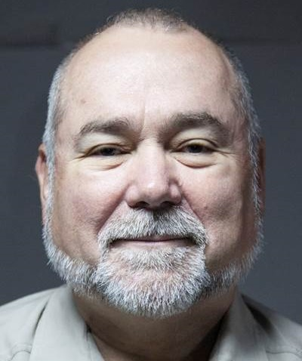 | Robert Steele is a former spy – one of the first to chase terrorists in the 1980’s – who has become known for his global proponency of Open Source Everything (OSE). Raised abroad by a father born in New York and a mother born in Colombia, he spent four years on active duty as a Marine Corps infantry officer and S-1/Adjutant (personnel and security management), followed by sixteen years in the Reserve (as a Service-level military intelligence officer) after he joined the CIA’s clandestine service (9 years including three back to back overseas tours and 3 headquarters tours in counterintelligence, advanced information technology, and satellite plans & programs). In 1988 he left CIA to accept a Marine Corps invitation to be the senior civilian creator of the Marine Corps Intelligence Activity (MCIA). In 1993 he resigned from the Marine Corps to create Open Source Solutions, Inc., going on to train over 7,500 mid-career officers across US defense intelligence, special operations, and the member nations of the North Atlantic Treaty Organization (NATO) and Partnership for Peace (PfP). He has testified to multiple Presidential and Congressional Commissions including the Moynihan Commission and the Aspin-Brown Commission, published nine books and many articles and chapters on intelligence reform, and generally been the single individual persisting in the view that the US Government should be devising strategy, policy, acquisition, and operations on the basis of ethical evidence-based decision-support. In 2012 he was a candidate for the Reform Party presidential nomination; his platform can still be viewed at We the People Reform Coalition. He is a member of Hackers on Planet Earth (HOPE) and of the Silicon Valley Hackers Conference founded by Stewart Brand. In passing he has become the #1 Amazon reviewer for non-fiction, reading in 98 categories. He curates Phi Beta Iota the Public Intelligence Blog with over 800 contributors going back to 1992. His motto is “the truth at any cost lowers all other costs.”

As we begin the final two and a half years (less 7 days) of the Obama-Biden Administration, a great deal is going wrong all at once. Strategically, we are imploding around the world, with the Ukraine and Syria being but two examples of what happens when you wage war on the basis of lies – we have learned nothing from Iraq or Afghanistan just as we learned nothing from Viet-Nam, El Salvador, Nicaragua, or Honduras – or decades of Mexican government support for illegal immigration. On the policy front we wax and wane between the incoherent (Middle East) and the insane (armed pivot to Asia). In the acquisition and contracting world we are beyond broken – the Navy cannot design ships, the Air Force cannot build a sustainable aircraft that fights as it should, and the various Cabinet departments – as well as their Congressional oversight committees – are all pursuing budget share without regard to the debt, the deficit, or the growing public outrage over a government that lies to it, spies on it, and is generally out of cash, out of credibility, and out of capacity.
I trace this collapse of America’s viability as a world power to the failure of national intelligence and the loss of national integrity. In this overview of the present state of the country’s intelligence services, I begin with context, offer an agency-by-agency catalog of malfeasance – the tip of the iceberg – and conclude with my own 12-point prescription for what Joe Biden, John Kerry and Chuck Hagel could do to help Barack Obama leave office with at least some semblance of a legacy.
My extensive endnotes offer many links to prior work by myself and others on this topic of national intelligence. Virtually all serious work about intelligence reform has been ignored for the simple reason that such work focuses on creating a prosperous America at peace for the 99% instead of a world at war profitable only to the 1%.
I am told the President wants Hispanics and women nominated for the highest professional offices. I am Hispanic, I am America’s “top gun” for getting intelligence right, and I am under-unemployed and immediately available. Hopefully someone with a great deal of money will point this article out to the President and suggest he give some thought to what role this Hispanic – and intelligence with integrity – might play for him.
Context – Where We Went Wrong
National intelligence is a sub-set of the military-industrial-congressional complex that was created during World War II and then refused to go away. In the years following our touted victory over fascism we imported thousands of Nazis and facilitated the escape to Argentina of thousands more along with vast stores of stolen wealth; we also created a secret covert action fund (the Black Lily Trust) undeclared to Congress or the public, a fund that we used to restore fascists to power in Germany, Italy, and Japan. We also turned Harry Truman’s 1947 idea for a Central Intelligence Agency (CIA) focused on integrating already known information, into a clandestine and covert action hydra that today specializes in waves of indiscriminate assassination by drone, rendition and torture, and not-so-secret support to 40 of 42 dictators that are “best pals” to a government that, as recent history has shown, works for the banks, not for the public. Connecting the dots, we have a federal government owned by banks, managed on their behalf by politicians whose principal foreign policy objective appears to be the cultivation of dictators and the subversion of democracy, all abetting the agenda of the 1% -- the banks – instead of the 99% -- the public. This policy, by the by, is responsible for the flood of illegal immigrants compounding the 22.4% unemployment rate in the USA.
As an afterthought to the CIA, in 1952 the National Security Agency (NSA) was created – as an executive organ without a legislative charter – to advance monitoring of foreign signals (Signals Intelligence or SIGINT) beyond what the military services already did. The National Reconnaissance Office (NRO) followed in 1961, to fund satellites capable of taking high-resolution images of Soviet targets (Imagery Intelligence or IMINT). Also created in 1961 was the Defense Intelligence Agency (DIA), intended by then Secretary of Defense McNamara to be a coherent single point of reference for decision-support to defense strategy, defense policy, defense acquisition, and defense operations. The two technical collection agencies, being vastly more expensive than Human Intelligence (HUMINT) or Open Source Intelligence (OSINT) became the darlings of Congress, where a 5% kick-back paid to the appropriate Political Action Committee (PAC) is the standard expectation for any outlay authorized and approved by Congress that is more often than not inconsistent with the public interest. DIA, “led” in the past by flag officers unwilling to alienate the Services, was simply ignored and became a dumping ground, as did the National Geospatial Agency (NGA), for unpromotable mid-grade military officers.
On the counterintelligence front during all those years, we allowed J. Edgar Hoover to use the Federal Bureau of Investigation (FBI) as a personal tool for blackmailing elites both political and financial, while going through the motions of counter-intelligence and counter-espionage. Hoover gave his sacred mission no more than lip service, because he gained more personally by leaving traitors in power than by keeping government honest. Today, we have information suggesting that the NSA has replaced the FBI as the primary means of collecting lurid information with which to blackmail elites, while also collecting insider trading information with which to create off-budget windfalls. Meanwhile the NRO and the NGA have been far out-stripped by faster, better, cheaper commercial technology.
In 2004 we created the position of a Director of National Intelligence (DNI) and abolished the historic position of Director of Central Intelligence (DCI), relegating the DCI to being merely the Director of the CIA. This was a military financial coup explicitly intended by Dick Cheney to marginalize the CIA and place all national intelligence and covert action budgets under predominantly military control. It was accompanied by a massive expansion of the Undersecretary of Defense for Intelligence USD(I), who proceeded to neglect counterintelligence, Human Intelligence (HUMINT), Open Source Intelligence (OSINT), and expert human analysis, while embracing the industrial complex focus on spending tens of billions of dollars on technical collection and arcane scientific and technical means that have yet to yield any return on investment (ROI) validated by an ethical informed professional US Intelligence Community (US IC).
Across this quarter-century of endeavor – at a cost to the US taxpayer of at least $1.25 trillion – we have a vast archipelago of very expensive contracted capabilities to collect technical information, 99% of which is not processed, while deliberately avoiding the substance of intelligence: decision-support. To this I would add two co-equal sins of intelligence: the out-sourcing of the inherently governmental function of intelligence to contractors steeped in conflicts of interest; and the startling loss of any semblance of ethics in the rush by pretentious “warriors” to do rendition, torture, mass surveillance, and assassination by drone. We have much to be ashamed of, including the fact that fraud, waste, and abuse across the larger government we are supposed to support with counterintelligence and intelligence has been on the order of 50% -- over 25 years at 3 trillion a year (one trillion a year borrowed) – that adds up to no less than $27 trillion. Indeed, it is noteworthy that the position of Inspector General for Intelligence in the Department of Defense (DoD) has been vacant for the majority of the time that Mike Vickers has been USD(I).
Context – Criminal and Practical
On page 32 of Griftopia: A Story of Bankers, Politicians, and the Most Audacious Power Grab in American History (Spiegel & Grau, 2011) author Matt Taibbi has this to say about the country’s criminal mix of politics and finance over the past quarter century:
What has taken place over the last generation is a highly complicated merger of crime and policy, of stealing and government. Far from taking care of the rest of us, the financial leaders of America and their political servants have seemingly reached the cynical conclusion that our society is not work saving and have taken on a new mission that involved not creating wealth for us all, but simply absconding with whatever wealth remains in our hollowed out economy. They don’t feed us, we feed them.
Combine this with Congressional abdication of Article 1 of the US Constitution (essentially, the balance of power provision), and a two-party tyranny that blocks Independents and the four robust small parties (Constitution, Green, Libertarian, Reform) from access to the ballot and to Congressional positions, and you have a government Of, By, and For the 1%.
I am the most published (and ignored) intelligence reformer in the English language, but because of Edward Snowden’s revelations about NSA, and a recent profile of my work in The Guardian, I am suddenly being heard, for the first time it seems, in 25 years. A quarter-century ago, in 1990, I outlined the six practical failures in US intelligence represented today by the below graphic. While the graphic is largely self-explicatory, the article upon which it is based it explains each of the six grievous short-falls in detail.
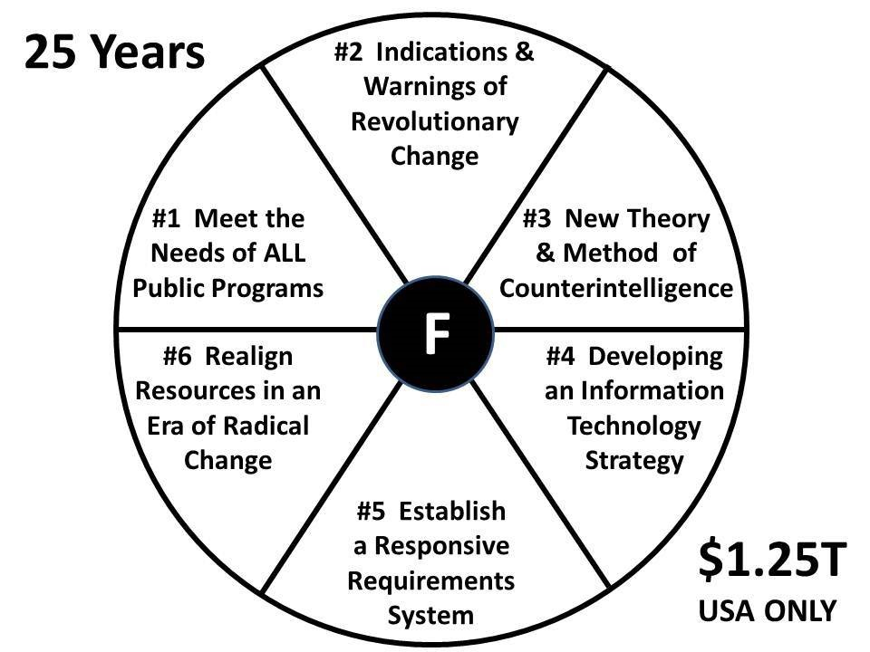
Figure 1: Six Fundamental Intelligence Failures Unaddressed in Past Quarter Century
25 years ago I nailed it – but as soon as the power brokers realized my vision meant more intelligence for less money, I was marginalized. Today, $1.25 trillion later, neither my recommendations, nor those of the Aspin-Brown Commission, have been addressed and the President is perpetuating a system of governance that is morally, intellectually, and financially bankrupt.
In 1993, speaking to the National Federation of Abstracting and Indexing Services in Washington, D.C., I offered this practical depiction – ethics and purpose aside – of what we had and what we needed:
The Intelligence Community Was Built To Do Soviet Secrets
The reality is that the intelligence community, in its designs and methods, its collection and production management decisions, and its resource allocations, has been so totally structured for a single mission, the collection of intelligence about a closed society, the only closed society that represented a strategic nuclear threat of consequence, that its capabilities do not lend themselves to re-orientation to other targets, much less to rapid and constant re-orientation among differing targets sets over time.
It is as if we had built a Cadillac and a single superhighway connecting two points–Moscow and Washington—and all of a sudden find that we need three jeeps, ten motorcycles, and a hundred bicycles in order to handle our information requirements. The Cadillac does not lend itself to off-road movement, nor does it lend itself to multiple “minor” missions.
Let me pursue this from another angle, that of cybernetics. Effective decision-making and action comes from having good feed-back loops—not only lots of feed-back loops, out to various sensors or informants or sources of information in different areas of interest, but also efficient feed-back loops, in which the time between change of circumstance, report of change, and notice of change is kept to a minimum.
Nothing has changed in a quarter century. We continue to do the wrong things with the wrong methods, ever more expensively and less responsibly.
I will not belabor the many great minds and earnest patriotic calls for change that have been published these past twenty five years. Here I will only link to a single list of 300 summary book reviews on secret government intelligence, along with my selective list of my own sharply focused intelligence reform publications over the same period.
There is nothing intelligent – or ethical – about US intelligence writ large. Intelligence is not helping the President, it is not helping the Cabinet, it is not helping the Congress, and it is most assuredly not helpful to the US banking and commercial enterprises whose communications NSA has been sabotaging or exploiting – or to the public being spied upon with indiscriminate abandon.
Agency by Agency – A Summary of Malfeasance
DNI. The DNI was created within the Intelligence Reform and Terrorism Prevention Act of 2004 (IRTPA). All four incumbents to date – each with the best of intentions – have been abject failures. The primary product of this office is not just bureaucracy, but a higher-level bureaucracy providing headroom for the incompetents that would otherwise have been forced into retirement in the aftermath of 9/11. The DNI has no financial authority of note and no influence at all over government deliberations with respect to strategy, acquisition, policy, and operations within the national security elements of the federal government, much less so across Whole of Government including predominantly domestic agencies and departments.
CIA. The CIA is supposed to do three things: produce all-source intelligence that is timely and useful to the national security leadership (they are not expected to support Congress or the larger Cabinet); conduct clandestine and covert action operations that provide the US Government (USG) with an advantage against the public and national interests of other nations; and create scientific and technical advances helpful to “close in” technical operations or advanced analytics that require humans in the loop to be effective. CIA has failed at all three.
DIA. Apart from being marginalized from its day of creation by Services intent on protecting budget share and protecting their cozy relationships with major contractors such as Lockheed (the original proponent for the Cold War), DIA has failed to keep the rest of government honest – for example, allowing Dick Cheney to lead the telling of 935 now-documented lies that took us into a multi-trillion dollar war in Iraq that has produced tens of thousands of US veteran amputees and mental cases – and failed to support the Secretary of Defense (SecDef) in his or her legitimate responsibility to keep America safe by training, equipping, and organizing a coherent effective military with global reach. In passing, Cheney’s hubris led to the liberation of the majority Shi’ite population of Iraq – in other words, Dick Cheney has done more for Iran and Shi’ites than any other person anytime in modern history.
FBI. In my view, the FBI is a combination of a theatrical agency and a protective service for elites. It has done nothing of substance against religious, ideological, and financial traitors in the Executive and Congress that routinely subvert the government decision-process at a cost to the public of blood, treasure and spirit. The FBI’s failure is deeply troubling to me, because in my past 25 years of advocacy for intelligence reform, I have learned that without counterintelligence – without the ability to clean one’s own stables – reform is simply not possible.
NGA. The NGA is a reincarnation of the Defense Mapping Agency (DMA) that morphed into the National Imagery and Mapping Agency (NIMA), and then became, ostensibly, the National Geospatial (Intelligence) Agency. It is largely a fraud that has still not resolved the long-standing gaps in 1:50,000 military combat charts with contour lines that are essential for combined arms collaboration and on the ground infantry operations. In Somalia today we are using Russian 1:100,000 charts – elsewhere around the world our combat forces are often resorting to GoogleEarth coverage because of NGA’s failure to be serious about needs at the tactical level. NGA continues to believe that the availability of digital geospatial information in their headquarters is a substitute for hard-copy maps in the hands of our troops, maps that continue to operate when hit by rocks or shot through with a bullet. NGA is also sadly ignorant about the realities of global digital “feeds and speeds,” and does not understand that prior preparation and hard-copy production of military combat charts are a necessity, not a luxury.
NRO. The NRO, once as secretive as the NSA, collapsed in the mid-1990’s when industry demanded that commercial imagery be allowed. Their demand was sensible in part because the USG could not afford to keep the satellite assembly lines open for the very limited production the NRO was authorized to fund. Today – and especially so with the newly authorized one-quarter meter resolution for commercial satellites, with small agile satellites the norm – and the blending of Google Earth with extremely timely tight resolution from micro-unmanned aerial vehicles (UAV) along with 360 degree access to all relevant Instagram photos taken by hand-held cell phones – the NRO is worse than an anachronism, it joins NSA as a second sucking chest wound in the classified intelligence budget.
NSA. As much as I prefer to respect security regulations, two people stand in history as violating their security oaths for the right reasons: Daniel Ellsberg with the Pentagon Papers, and Edward Snowden with the as-yet incomplete but clearly massive disclosure of NSA’s mass surveillance program. Although I personally protested directly to LtGen Mike Hayden when he was the Director of NSA and began doing warrantless surveillance, what really matters about Snowden is not that the information is new – many of us have been articulating concerns for decades – but rather that the information is now being “heard.” NSA has violated the public trust in every possible way – it is representative of how all the other elements of the secret world are also violating the public trust, they just have not produced their own versions of Edward Snowden yet.
USD(I). USD(I) is ostensibly the full-counterpart to the Undersecretary of Defense for Policy (USD(P)) and the Undersecretary of Defense for Acquisition (USD(A)). Both of the latter are making decisions that are completely lacking in common sense, affordability, sustainability, and military necessity, in part because USD(I) is incapable of producing intelligence with integrity. SecDef is presiding over a hollow military stretched thin by irresponsible Service-level decisions on top of empty Service planning and programming capabilities. The Navy cannot design ships – the Air Force cannot design aircraft – and the Army still thinks the weight of a system is irrelevant to its deployability and employability. DoD has lost its mind, and the blame for that falls squarely on a series of USD(I) billet holders that have chosen to invest hundreds of billions in technical collection means without regard to the actual decision-support needs of SecDef and the Services with respect to strategy, policy, acquisition, and operations.
What Is Intelligence and How Do We Evaluate It?
In my first book, ON INTELLIGENCE: Spies and Secrecy in an Open World (AFCEA 2000, OSS 2001), a book that enjoyed a Foreword by Senator David Boren (D-OK), past Chairman of the SSCI, I published the below graphic.
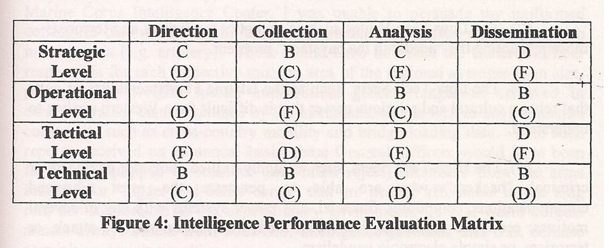
Figure 2: Scoring Secret Intelligence Against Traditional versus Emerging Threats
The first grade, without parenthesis, was my evaluation of the secret world’s performance against its existing mandate, the denied area targets of China, Cuba, Libya, North Korea, and Russia, without regard to the rest of the world – Africa was of interest only because we could more easily lure Soviet officers into drinking and indiscretions there than anywhere else.
The second grade, with parenthesis, is the grade I assigned to existing capabilities in relation to emerging threats that were generally unconventional, non-state, without rules of engagement, and so on.
Intelligence is about decision-support, the outcome of the process of intelligence. It is not about spending the most money possible on the most esoteric technical collection programs possible, knowing that you will process less than 1% of what you collect, and that you will produce, “at best,” 4% of the what a major theater (regional) commander needs to know.
The dirty little secret of both James Clapper the DNI and Mike Vickers the USD(I) is that they are all about spending money – as much money as possible – without regard to meeting the needs of the President, the Cabinet, Congress, or the public, for decision-support.
More recently I created this graphic, as I was contemplating what innovation I might inspire if selected to be the DoD Inspector General for Intelligence. Realistically, since I am the anti-thesis of the malfeasance now entrenched across the leadership of the US Intelligence Community, I will never return to this community unless I am selected by the President to clean it up. I am not holding my breath but certainly I have trained my whole life for precisely that opportunity.
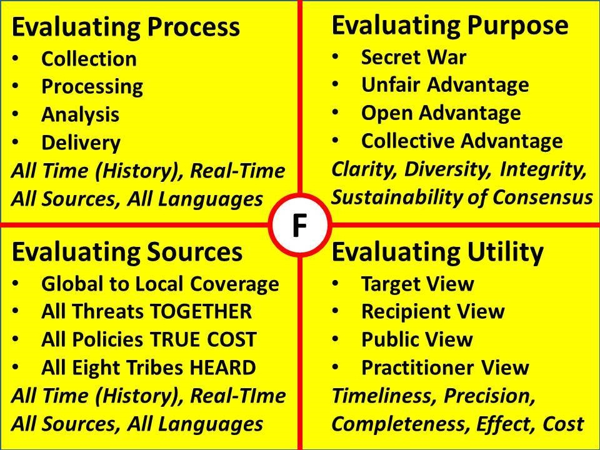
Figure 3: Four Quadrant Process for Evaluating National Intelligence
Put bluntly, we earn an “F” across the board today. Our process is skewed toward technical collection that is not processed, and dismissive of everything else – humans, open sources, holistic analytics, speaking truth to power. Our purpose is perverted – CIA killing people with drones while NSA spies mostly on Americans? Our sources suck. 90% of what CIA claims as clandestine is actually a hand-out from a counterpart foreign intelligence service and generally wildly untrue (witness Pakistan on Afghanistan), or obtained through legal traveler debriefings in the USA. We are utterly incompetent at outreach to real people everywhere. The time has come to be honest about the lack of utility of the secret intelligence community. Outside of being a secret pork pie for Congress and a financial wind-fall for the banks and the corporations that feed Congress, the secret intelligence world is largely worthless.
This may strike some as incomprehensible, so I will take the liberty of providing one more graphic. Below I show, from a collection point of view, what the secret world collects today in relation to the larger whole of available relevant information in 183 languages we do not speak – most of that information not being online.
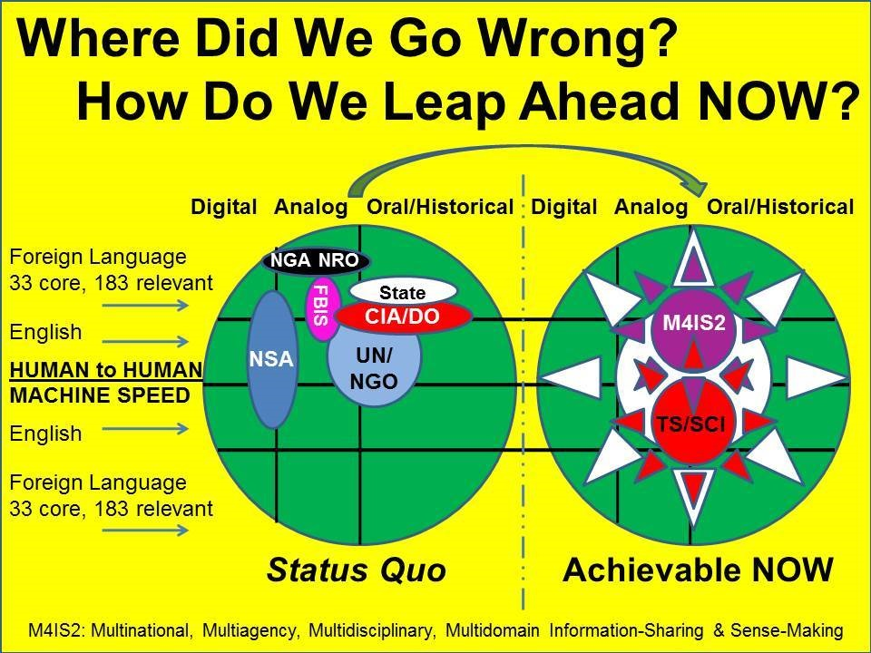
Figure 4: What US Does Against Real-World Information in All Languages & Mediums
The second half of the graphic, “Achievable Now,” is what I could create within 90 days by mandating proper respect for Open Source Everything (OSE) augmented by a Multinational Decision Support Center (MDSC). Instead of the entire US intelligence community being “top secret” and largely worthless, we need to move to a state where it is largely NOT SECRET, and very very valuable to everybody across all mission areas, from schoolhouse to statehouse to White House….with ethics prominent throughout.
All of these failures directly, and adversely, affect our capacity to interpret world affairs as well as domestic threats and challenges in a responsible manner. Our reactions to the Ukraine, where fascist criminals have replaced communist criminals, and our Secretary of State is constantly embarrassing us with a mixture of banalities and lies – one presumes they are talking points he has been given, and he is helpless precisely because he lacks an authoritative source of ethical evidence-based decision-support.
Here is one final graphic that depicts my vision for how Open Source Intelligence (OSINT) should underlie the classified disciplines while also being a discipline in its own right, and enable the provision of decision-support to EVERYBODY such that we can focus on whole of government waging peace and commerce, instead of always being on a global war footing for lack of intelligence with integrity.
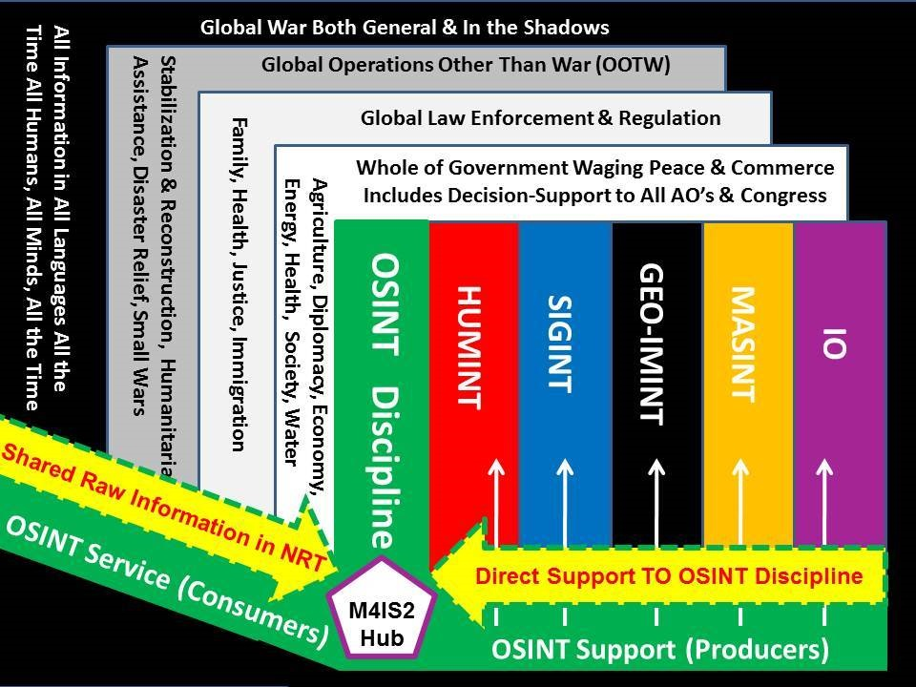
Figure 5: Intelligence for Grown-Ups – A Truly Professional Approach
Context for Reform – The Ugly, the Bad, & the Good
It was my privilege to play a small role in supporting the National Security Act of 1992 as crafted by Senator David Boren (D-OK), then Chairman of the Senate Select Committee for Intelligence (SSCI) and his counterpart, Representative David McCurdy (D-OK-04), then Chairman of the House Permanent Select Committee for Intelligence (HPSCI). I learned three things that bear on the President’s need to get a grip on reality today by sponsoring a National Security Act of 2014.
UGLY: Congress only cares about its 5% kick-backs. I happen to be a great admirer of a number of Senators, among them Pat Roberts (R-KS), past chairman of the SSCI, and of course Carl Levin (D-MI). Unfortunately, however well-intentioned a few Senators may be, the majority are in it for the money and this is not going to change absent a national strike led by Occupy, the small parties, the Independents, and the sane wings of the two-party tyranny, demanding an Electoral Reform Act.
BAD: No one cares what the SSCI and HPSCI do. All the power is held by the Senate Armed Services Committee (SASC) and the House Armed Services Committee (HASC). The center of gravity for achieving substantive reform in national intelligence, national defense, national diplomacy, and national governance is with the SASC and HASC, not the SSCI and HPSCI.
GOOD: Reform must be job and revenue neutral, state by state and district by district. I watched a perfectly good (and relatively modest) National Security Act of 1992 go down in flames because on the one hand then SecDef Dick Cheney refused to release control over the intelligence funds hidden in the defense budget, and on the other Senator John Warner (R-VA) interpreted any attempt to “right-size” the secret world as a diminution of jobs in Northern Virginia. He forced the creation of the Aspin-Brown Commission precisely to derail the National Security Act of 1992. I learned from this – if I am ever given an opportunity to unscrew the US IC, it will be on the basis of a firm promise to Congress that I will strive to do so on a job and revenue neutral basis. I have no problem with them collecting 5% kick-backs but I do have a problem with the taxpayer’s money being spent in the most useless fashion possible.
Separately I have addressed seven false premises that have blocked intelligence reform for the last quarter century. Those seven myths – unquestioned by the sycophantic mainstream media – must be destroyed in the public mind. Edward Snowden has helped do just that by producing documentary evidence of malfeasance on such a grand scale that the public is now ready to question all the lies they have been told for a quarter century about the essential value of the secret intelligence world.
What Is To Be Done?
In the closing years of the two-term Obama-Biden Administration, as Joe Biden contemplates a run for the Presidency in 2016, as Barack Obama contemplates his legacy being defined by Edward Snowden and mass surveillance of US citizens – with many more exposures to come on NSA over the next two years, it is my view that there could be nothing more salutary for the Republic than a National Security Act of 2014 called The Smart Nation Act. I have worked with a tiny handful of individuals, including Congressman Rob Simmons (R-CT-02), on this matter, and have published extensively on this precise question.
There are two options.
OPTION A: Limit The Smart Nation Act to the creation of the Open Source Agency (OSA) under diplomatic auspices with military funding, and let myself and a few others get on with doing what we wanted to do 25 years ago – launch a lifeboat to create a shared understanding between Congress, the Executive, and the public of what the publicly-knowable facts are across all mission areas.
OPTION B: Go for the whole enchilada. I am reminded that Amy Zegart, a protégé of Condi Rice, came to the conclusion in her book Flawed by Design: The Evolution of the CIA, JCS, and NSC, that the secret intelligence world is so flawed that there is no point to attempting remediation around the edges.
The President has to decide if he wants a Smart Nation – and a legacy – or not. This is an all or nothing challenge with one bit of good news: reforming national intelligence is easier than most realize – and will yield returns on redirected investment most cannot imagine with one caveat: the President has to want to change and commit to being serious about demanding ethical evidence-based decision support across Whole of Government.
I can execute either option, aided by proven patriots aching for leadership with integrity – the quality of my little black book would do Presidential Personnel proud.
If Option A is selected, a handful of DoD officers have all the planning documentation in hand and are ready to get this up and running with DoD and White House level results within 90 days and stunning impact across Whole of Government within 180 days.
With either choice, there is still time for an Obama legacy rooted in intelligence with integrity.
If Option B is selected, The Smart Nation Act would be structured as a 12-point program integrating and refining the following provisions:
01 The Smart Nation Act will strive to be job and revenue neutral, state by state, district by district.
02 Create the Open Source Agency (OSA) as recommended on pages 23 and 413 of the 9/11 Commission Report. This agency would set the gold standard for what can be known – and easily shared with Congress, the media, and the public – across both national security topics and all of the domestic and foreign topics not now covered by the classified world (roughly 200 in number, at $10 million per year each, this justifies the $2 billion a year Final Operating Capability (FOC) of the OSA.
This agency would have only one mission, that of the development of accurate and timely open source information (intelligence) in support of executive branch decision making and policy formulation with the proviso that such decision-support could be easily shared with Congress, the press, the public and of course our many multinational allies both governmental and non-governmental. This agency, approved twice by OMB, would be funded and managed by DoD under diplomatic auspices as a sister agency to the Broadcasting Board of Governors (BBG) – OSA as knowledge in, BBG as knowledge out. It would play a role in presidential direction of all nationally-funded research and contribute substantially to revitalizing US education at all levels on all topics.
This would be the first government agency to organize itself to support every Cabinet department and federal agency across all four levels of analysis (strategic, policy, acquisition, operations) as illustrated below, while giving Congress an exact copy of the decision-support being given to the Executive. For the first time in history, the oversight committees and the varied levels of the federal government being overseen, would be fully informed.
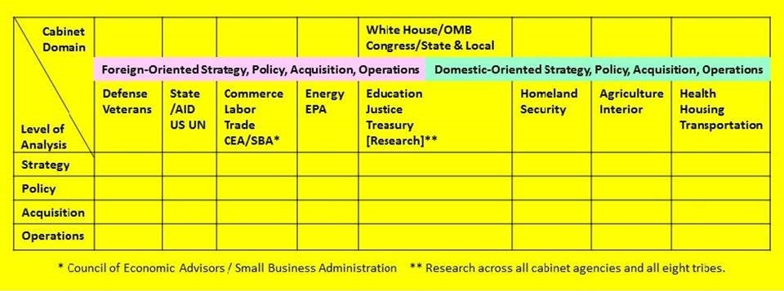
Figure 6: Organizational Concept for Open Source Agency Decision-Support Services
03 Eliminate the DNI and restore the DCI. This is essential. The vast bureaucracy of the DNI has made matters worse. At the same time, The Smart Nation Act must give the restored DCI financial control at the line item level with a strong emphasis on documenting Return on Investment (ROI). Collection that cannot be processed should not be funded. The DCI should end subsidies to foreign intelligence services and close overseas bases and collection activities that do not yield useful information for processing.
04 Activate the “M” in the Office of Management and Budget (OMB). There is no management in OMB today, only number crunching and budget share negotiation. A former DNI – all good men of great intellect and moral fiber, defeated by a bad system – would be an ideal candidate for the position of Deputy Director of OMB for Management. Their mission would be to cross-walk the total federal budget against the ten high-level threats to humanity, across all policy domains without regard to bureaucratic boundaries. I would contemplate placing the National Intelligence Council within the Executive Office of the President, perhaps as an advisory body to DD/OMB/M.
05 Redirect CIA into being the classified collection management agency. The DCI should be responsible for managing all classified collection endeavors at all levels of operation. Its new SIGINT Office would change both the collection strategy and the applied technologies to achieve a precision target capability that is within the law and helpful in supporting diplomatic, commercial, and military planning as well as warning intelligence. Similar offices for IMINT, GEOINT, and MASINT would be established, skimming the cream from the employees of the now-dysfunctional agencies to be closed down.
06 Terminate NSA, redirecting a portion of it into a national all-source processing agency. The processing center in Utah – the one consuming 1.7 million gallons of clean drinkable water every day to cool its computers – was a good idea badly executed and should be abandoned. SIGINT, IMINT, and Measurements & Signatures Intelligence (MASINT) should be managed by new Offices for each within CIA. A new processing facility should be constructed at a location that combines access to dark fiber as well as sea water for desalination and use as a coolant. New York City comes to mind.
07 Redirect DIA into being the all-source analysis agency. Easily half of DIA’s existing employees, beginning with most of the senior civilian executives, must be retired and retired quickly. DIA’s Human Relations (HR) component must be rebuilt from scratch. In fairly short order, and developing in tandem with the OSA and its combination of a School of Future-Oriented Hybrid Governance, World Brain Institute, Global (Serious) Game, and Multinational Decision-Support Center, DIA should become the hub that gives the USA as a Smart Nation an information advantage that past IC leaders have refused to contemplate in part because Presidents have failed to demand grown-up intelligence – decision-support.
08 Merge NGA and USGS while supporting the OSA in advancing open source geospatial endeavors.
09 Create a Cyber-Security Agency, terminating the Cyber-Command. This agency must do what NSA was supposed to do – work to make US commercial and public communications and computing impervious to unauthorized interception and exploitation. A Center for Computational Mathematics will be part of this new construct, to keep both Wall Street and Google honest.
10 Terminate the NRO.
11 Restructure the FBI to emphasize success against commercial espionage and policy traitors whether motivated by religion, ideology, or money.
12 End financial subsidies to foreign intelligence agencies and generally end all covert actions.
Beyond Spies and Secrecy in an Open World
A few of us, devoted patriots every one, have sought over the years to focus the White House and Congress on the reality that secrets tend to be vastly more expensive, more cumbersome, and less useful than open sources. It has taken 25 years – a quarter century – for our message to gain a small semblance of traction, and only then because the DNI has been caught lying to Congress and Edward Snowden has made it clear that NSA is an out-of-control monstrosity that neither the DNI nor USD(I) can manage.
NSA – ostensibly under the oversight of the present DNI and USD(I) – has done more to undermine US financial and commercial communications and computers than any foreign power – even China or Israel – could have imagined.
CIA, with torture, rendition, and drone assassinations, was not enough to anger the public. The NRO and NGA with waste, and the FBI and DIA with irrelevance, were not enough to anger the public. It is the NSA that has awoken the public to the deep threat represented by a secret intelligence world that is both too expensive and so terribly out of control that it can intimidate politicians and manipulate markets with insider impunity.
Creating an Open Source Agency alone – or also rebuilding national intelligence with the twelve-step program itemized above – is the beginning of a renaissance in national education, intelligence (defined as decision-support, not spies and secrecy), and research.
President Obama and Vice President Biden have an opportunity, ideally before Congress takes its summer recess on 1 August, but certainly before Congress departs to campaign before a dubious public from 3 October, to pass the National Security Act of 2014 – The Smart Nation Act.
Below is a depiction of various terms and relationships that would characterize a Smart Nation able to produce ethical evidence-based decision-support for any decision on any topic at any level without resource to spies and secrecy. The time has come to bury the cult of secrecy, and open up our minds and our government to the full potential of our Collective Intelligence.
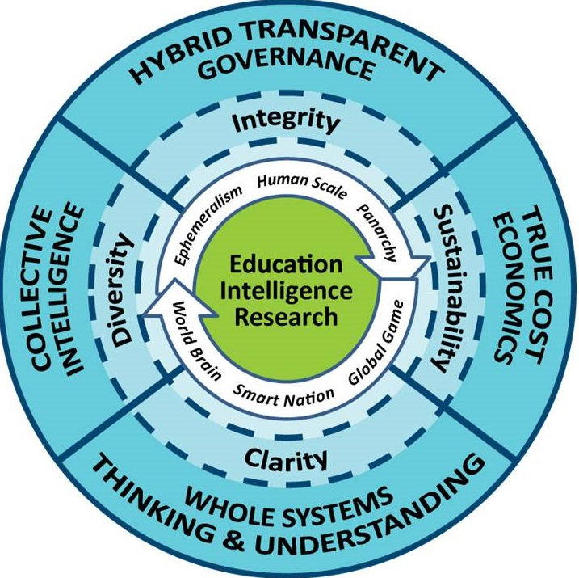
Figure 7: Abstract Concept for Creating a Smart Nation
The Obama Legacy – with Intelligence and Integrity
If President Obama were to make Intelligence Reform – ideally in combination with Electoral Reform – the centerpiece of his 2014 summer political campaign toward elections in November 2014, I know that the following are possible, apart from assuring continuing Democratic control of the Senate:
a) Ethical evidence-based foreign policy ending our support for dictators and oligarchs, stabilizing foreign publics and reducing hatred for American power while also reducing illegal immigration into America.
b) A sharply reduced defense budget (achieving the President’s now ignored mandate to reduce that budget by 30%) while also creating a 450-ship Navy, a long-haul Air Force, and an air-mobile Army –closing all of our overseas bases especially in Germany, Japan, and Korea, is a major aspects of the cost reduction, along with an end to cost plus contracting that subsidizes massive corporate overhead, profiteering, and waste.
c) A revitalized domestic economy benefiting from the one hand on a national “Manhattan Project” toward open source everything – not just in information technology but also across all of the engineering disciplines relevant to national agriculture, energy, health, justice, and water, to name just a few policy areas desperately in need of ethical evidence-based decision-support.
d) A revitalized society and policy in which transparency, truth, and trust make a come-back.
I know how to do all this. What I do not have is access to the four US leaders most likely to benefit personally from getting intelligence with integrity back into our system of governance. St.
Endnotes

See two of my articles in CounterPunch: “Intelligence for the President–and Everyone Else: How Obama Can Create a Smart Nation and a Prosperous World at Peace” (Weekend Edition March 1-3, 2009); and “On Defense Intelligence: Seven Strikes: Why Secretary of Defense Hagel Must Choose the Next Director of the Defense Intelligence Agency” (July 02, 2014).
Among the useful references on this point are Sterling and Peggy Seagrave, Gold Warriors: America's Secret Recovery of Yamashita's Gold (Verso, 2006), my review: Earth-Shattering, Faith-Shaking, Well-Documented Deceit; and Glen Yeadon, The Nazi Hydra in America: Suppressed History of a Century (Progressive Press, 2008), my review: Lacks Visualization and Genealogy, A Good Start. For a startling insight into Nazi homosexuality and the subversion of selected senior officers in the US military, see Scott Lively and Kevin Abrams, The Pink Swastika: Homosexuality in the Nazi Party (Veritas Aeterna, 2002), my review: Please Appreciate the Difference -- Much Misunderstanding Here and see especially this post, Mongoose: 2012: What's the `real' truth? Mrs. Kay Griggs Wife of USMC Col George Griggs Tell-All Interviews at Phi Beta Iota the Public Intelligence Blog.
Cf. Harry Truman, “Limit CIA Role to Intelligence,” Washington Post (22 December 1963), page A11.
Cf. “Owl: Visualization of Drone Deaths—98% ‘Collateral Damage,’” Phi Beta Iota the Public Intelligence Blog (29 March 2013).
Cf. Amrit Singh, “Open Society Institute: Globalizing Torture: CIA Secret Detention and Extraordinary Rendition,” Council on Foreign Relations (5 February 2013).
(Ambassador) Max Palmer, Breaking the Real Axis of Evil: How to Oust the World's Last Dictators by 2025 (Rowman @ Littlefield, 2005), my review: Single Most Important Work of the Century for American Moral Diplomacy.
My second book, THE NEW CRAFT OF INTELLIGENCE: Personal, Public, & Political -- Citizen's Action Handbook for Fighting Terrorism, Genocide, Disease, Toxic Bombs, & Corruption (OSS, 2002), placed emphasis on the illegal immigration pressures on the USA, Europe, and Russia (from China). Honest and fully explained unemployment statistics are provided at www.shadowstats.com.
Personal knowledge confirmed over the years by multiple Congressional staff including a senior budget director.
Cf. Google Search for < nsa blackmailing politicians >.
Cf. Google Search for < nsa insider trading >.
I am among several who were found eligible and referred for this position many months ago. In my personal view, the failure to fill this position is both an indictment of USD(I) and an indicator of the culture of impunity represented by the current USD(I) approach to intelligence as a money channel, not a professional service.
Cf. John M. Barry, The Ambition and the Power: The Fall of Jim Wright: A True Story of Washington (Viking Adult, 1989), my review: Classic Detailed Study of Both Corruption and Abusive Power; and Theresa Amato, Grand Illusion: The Myth of Voter Choice in a Two-Party Tyranny (New Press, 2009), my review: Final Detailed Review: Our Bunker Hill. Add to that Lou Dobse and Jake Bernstein, Vice: Dick Cheney and the Hijacking of the American Presidency (Pimlico; Aiorport, 2006); my review: 23 Documented High Crimes That Should Put Cheney in Irons Immediately and you have nothing less than a total collapse of democracy in the USA – we are slaves – expendable slaves – nothing more.
My nine books are free online as well as for sale at Amazon: Books By and With Robert Steele; see also Articles and Briefings as well as two online linked lists, one for my reform publications, another for selected other authors on intelligence reform.
Nafeez Ahmed, “The open source revolution is coming and it will conquer the 1% - ex CIA spy,” The Guardian (19 June 2014).
As described in “Intelligence in the 1990′s – Six Challenges“ (American Intelligence Journal, Summer 1990). The graphic was created in 2013 for my work in progress, INTELLIGENCE with INTEGRITY: Enabling Hybrid Public Governance with Open-Source Decision-Support.
The Aspin-Brown Commission is the most effective review of US intelligence operations across over 25 such reviews going back to 1947; all of its recommendations, including the recommendation that OSINT be a top priority for Director of Central Intelligence (DCI) attention and a top priority for funding, were ignored by then DCI George Tenet. The entire report, Preparing for the 21st Century: An Appraisal of U.S. Intelligence (Government Printing Office, 1996) remains a valuable starting point for those interested in creating intelligence with integrity.
Robert David Steele, “The Intelligence Community as a New Market,” Speech to the National Federation of Abstracting and Indexing Services, Washington, D.C., 23 February 1993.
The vast majority of both government and contracted employees of the US Intelligence Community – including my wife who works within CIA’s Directorate of Intelligence as a computer support and training specialist – are good people trapped in a bad system. What we are dealing with is a total failure at the leadership level, both political and professional. With the exception of LtGen Michael Flynn, I can think of no serving intelligence leader who combines a commitment to decision-support with deep integrity and practical common sense.
Ambassador John Negroponte, Vice Admiral Mike McConnell, Admiral Dennis Blair, LtGen James Clapper.
In 1992 when I was the second-ranking civilian in Marine Corps intelligence, there was only one Senior Executive, John Guenther (RIP), and my grade was that of a GS-14, more or less a LtCol equivalent. Today the Marine Corps has a number of Senior Executive civilians that I personally believe are not warranted.
Cf. Ryan Cooper, “Time to scrap the CIA: The agency does almost nothing right — and now it's a direct threat to American democracy,” The Week (14 July 2014). Among many books I have reviewed on CIA’s failures, two in particular bear mention here: Charles Faddis, Beyond Repair: The Decline and Fall of the CIA (Lyons Press, 2009), my review: First Rate Deep Current Insider View Cannot Be Denied; and Anthony Codevilla, Informing Statecraft–Intelligence for a New Century (Free Press, 1992), my review: Informing Policy is more important than stealing secrets. My larger list, Worth a Look: Book Reviews on Government Secret Intelligence, includes 71 reviews, some focused on CIA successes such as Afghanistan that can in retrospect be seen as strategic failures. My monograph, Human Intelligence: All Humans, All Minds, All the Time (US Army Strategic Studies Institute, June 2010) outlines what a properly managed full-spectrum HUMINT program should look like. This graphic – with validation by other serving and retired professionals – is an indictment of HUMINT today across these functions: 2012 USA Human Intelligence (HUMINT) Scorecard 1.1.
Cf. William Hartung, Prophets of War: Lockheed Martin and the Making of the Military-Industrial Complex (Nation Books, 2010), my review: Final Review: Boring, Limited, Not for General Audience.
Cf. Charles Lewis, 935 Lies: The Future of Truth and the Decline of America’s Moral Integrity (PublicAffairs, 2014), my review: Title Short-Changes Value -- This is One of the Most Important Books of Our Time.
My article on the seven strikes of defense intelligence is linked in Note 1. Two books among the 36 I have reviewed include A. J. Rossmiller, Still Broken–A Recruit’s Inside Account of Intelligence Failures, from Baghdad to the Pentagon (Presidio Press, 2008), my review: If the SecDef and DNI Could Read One Book, This is the One; and Jeffrey St. Clair, Grand Theft Pentagon :Tales of Corruption and Profiteering in the War on Terror (Common Courage Press, 2005), my review: Chapter and Verse But No Footnotes--a Cornerstone Read. The classic book on why defense intelligence matters is Chuck Spinney’s still acutely relevant Defense Facts of Life: The Plans/Reality Mismatch (Westview Press, 1985), my review: Core Ideas Relevant to Imminent Defense Reform.
I have reviewed 16 books on the FBI and counterintelligence. Military counterintelligence is just as broken for the same reason DIA is broken: entrenched civilians ignore and outlast uniformed leaders who are not allowed to clean house. Apart from being ineffective, the FBI is also accountable for its role, under Hoover, in the assassinations of John F. Kennedy and Martin Luther King. The persistent refusal of the CIA and the FBI to work together – or with military counterintelligence – is a leadership failure that continues to this day. Three books worthy of citation here are Sibel Edmonds, Classified Woman-The Sibel Edmonds Story: A Memoir (Sibel Edmonds, 2012), a guest review from David Swanson, Sibel Edmonds Finally Wins; my friend and former FBI Supervisory Special Agent I. C. Smith, Inside–A Top G-Man Exposes Spies, Lies, and Bureaucratic Bungling in the FBI (Thomas Nelson, 2004); my review: Not Enough on Spies, Plenty on State-Level Corruption and FBI Idiocy; and Mark Riebling, Wedge–From Pearl Harbor to 9/11–How the Secret War between the FBI and CIA Has Endangered National Security (Touchstone, 2002), my review: Pogo Lives at FBI--We Are Our Own Worst Enemies.
Col Mike Pheneger, USA, then J-2 for US Special Operations Command (USSOCOM) and I, then the second-ranking civilian in Marine Corps Intelligence and the senior civilian responsible for creating the Marine Corps Intelligence Activity (MCIA), blew the whistle on Mapping, Charting, & Geodesy (MC&G) shortfalls in 1988-1992. The official USMC findings on MC&G short-falls (roughly 90% of our countries of interest) are contained in the study I led, Planning and Programming Factors for Expeditionary Operations in the Third World (MCCDC, 1990). Although I finally succeeded, as the Marine Corps representative to the Foreign Intelligence Requirements, Capabilities, and Priorities Committee (FIRCAP), in getting MC&G added to the national intelligence responsibilities as a priority, and third world countries short-falls recognized in the FIRCAP document, the reality is that senior military commanders do not think about MC&G shortfalls – or strategic generalization such as bridge loading data and standard aviation day temperatures – and neither do the so-called intelligence leaders. One very credible study of this matter by Arnie Donahue (former OMB senior civil servant for all C4I programs) recommends that the NGA be combined with the US Geological Service (USGS) and focus on map-making for all instead of isolated (singular) geospatial displays costing hundreds of millions of dollars that are useless outside the beltway. It bears mention that USGS, while excellent in many ways, also has severe shortfalls. During the recovery from Hurricane Sandy, it was noticeably absent as first responders scrambled to blend together GoogleEarth, micro-drone images and hand-held photography from victims to establish “ground truth” for rescue and reconstruction operations.
Cf. search at Phi Beta Iota on < NGA big data >.
Security oaths are administration matters that do not have the force of law, but the various Administrations have sought to equate violations with treason. In my view, the oath we take to defend the US Constitution against all enemies, domestic and foreign, trumps all laws and all regulations. That is an ethical point of order not honored by the present or recent Attorney Generals. It was my privilege to testify to the Moynihan Commission on Secrecy, where my core point was that secrecy is used by the secret world primarily to enable lies to Congress. I have reviewed a number of books on secrecy that provide vital perspectives on this schism between the public interest and routine betrayal of the public trust. See for example, Daniel Ellsberg, Secrets–A Memoir of Vietnam and the Pentagon Papers (Viking Adult, 2002), my review: History Matters, Secrecy Permits War Crimes by Presidents; Ted Gup, Nation of Secrets–The Threat to Democracy and the American Way of Life (Doubleday, 2007), my review: Our Era's Tom Paine on Common Sense; Daniel Patrick Moynihan, Report of the Commission on Protecting and Reducing Government Secrecy (Diane Books, 2008), my review: The Single Best Examination of Secrecy Costs; Daniel Patrick Moynihan, Secrecy–The American Experience (Yale, 1998), my review: Extraordinary Contribution to National Sanity and Security; Dilip Hiro, Secrets and Lies–Operation “Iraqi Freedom” and After: A Prelude to the Fall of U.S. Power in the Middle East? (Nation Books, 2003), my review: Most Scholarly Documentation of Bush-Blair Deceit; Michael Turner, Why Secret Intelligence Fails (Potomac Books, 2005), my review: Superb for the general audience, not for professionals.
I was given a front row seat on 19 July 2014 when Ellsberg and Snowden were the keynote speakers at Hackers on Planet Earth (HOPE). The live stream of that presentation was #1 in the world. My comments, their bottom line, and the entire embedded video are at HOPEX: YouTube (1:23:26) Ellsberg – Snowden.
My indictment of USD(I) explicitly and at this time is detailed in “On Defense Intelligence: Seven Strikes,” as published in CounterPunch, Supra note 1.
Here I am citing General Tony Zinni, USMC, then Commanding General of the US Central Command (USCENTCOM) engaged at the time in two wars and over 12 joint task force actions. His exact words can be seen here, Graphic: Tony Zinni on 4% “At Best” and were first cited publicly in my seminal work, “Open Source Intelligence,” in Loch Johnson (ed.), Strategic Intelligence: The Intelligence Cycle (Praeger, 2007), Chapter 6, pp. 96-122.
Cf. Robert David Steele, “The National Security Act of 1992,” American Intelligence Journal (Winter 1992).
Robert David Steele, “Think Again: Intelligence,” Reality Sandwich (7 January 2014). A refined academic version is forthcoming, Rob Dover and Robert Steele, “Intelligence and National Strategy? Rethinking Intelligence—Seven Barriers to Reform” (Sage Publications).
In 2006 I published – and Congressman Simmons and I distributed to every Senator and every Representative, THE SMART NATION ACT: Public Intelligence in the Public Interest. Oakton, VA: OSS International Press. It is also free online as THE SMART NATION ACT__web PDF (270 pages).
A one page version of this simplified act is online at Reference: Smart Nation Act (Simplified) 2011.
Amy Zegart, Flawed by Design: The Evolution of the CIA, JCS, and NSC (Stanford, 2000); my review: Too Hard to Fix on the Margins--Fix Big or Don't Fix At All.
Graphic: 9-11 Commission Open Source Agency. Mr. Kevin Scheid, today Assistant Chief Management Officer in the Pentagon, has never received due credit for his stellar performance on the staff of the 9/11 Commission, and in later postings. He is ideally suited to be the next Deputy Undersecretary of Defense for Intelligence.
Keith Hall, former Staff Director for the Budget at the SSCI, and later the Director of the NRO, is the originator of the original $1.5 billion a year estimate (150 topics at $10 million a year each). He was interviewed by Boyd Sutton, my former boss and one of the most ethical and experienced intelligence professionals I have ever known. Boyd, assigned by George Tenet to examine short-falls in US IC capacity, authored The Challenge of Global Coverage in 1997. When Tenet was told there was a need to spend on open sources instead of secret sources, he refused to attend to the study and ordered it locked up and never spoken of again. Fortunately, an unclassified version has been published and is free online.
The first time, in 2000, by Sean O’Keefe, then Deputy Director of OMB, after being briefed by Don Gessaman, then recently retired Associate Deputy Director of OMB for National Security; the second time, in 2010, by Kathleen Peroff (Gessaman’s replacement) and other senior staff, after being briefed by Dr. Joseph Markowitz, former Chief, Community Open Source Program Office (COSPO), and myself.
Cf. 2014 Robert Steele – An Open Letter; 2013 Intelligence Future — The Third Era of Local to Global Intelligence Overview & Workshop 2.8 Adds 2 Memos to CINCEUR & CINCSOC; 2012 Integrity, Reflexivity, & Open Everything – Presentation to the Washington Academy of Sciences; and 1957+ Story Board: Peace & Prosperity Through Ethical Evidence-Based Decision-Support — Analytic Sources, Models, Tools, & Tradecraft.
The threats and policies are illustrated and sourced in the first graphic of my previous CounterPunch article, “On Defense Intelligence: Seven Strikes“ (2 July 2014). The graphic only can also be viewed in a larger context at 1976-2013: Analytic, Methodological, & Technical Models 2.1.
Dark fiber is the high-speed Internet before it gets watered down by the carriers. One exemplar provider is Allied Fiber. The Smart Nation Act would fund, via the Open Source Agency dark fiber across America to connect schoolhouses, statehouses, and global sources of information in a manner that the US IC as well as the government over all refuse to consider.
The dirty little secret of both CIA and NSA is that they are excessively reliant on foreign intelligence services for “hand-outs,” and often incapable of achieving unilateral gains in critical areas of interest. That needs to change – where warranted, unilateral capacity is essential. At the same time, instead of subsidizing bi-lateral relations, we need to fully engage multi-laterally, to include the creation of regional multinational decision-support centers reliant primarily on open sources, but having a multinational clandestine and covert action capability to one side. Covert action will remain contentious. I do not believe it warranted. For a case in favor of covert action, see Jack Devine, Good Hunting: An American Spymaster’s Story (Sarah Crichton Books, 2014), my review: Modern Bible for Covert Operations -- Joins Dulles, Helms, Colby as a Classic.
Cf. Electoral Reform at We the People Reform Coalition.
I have defined the 450-ship Navy on the basis of the findings of the Marine Corps study I led in 1989-1990, Supra Note 27. See particularly 2012 Robert Steele: Reflections on the US Military — Redirection Essential — and a Prerequisite to Creating a 450-Ship Navy, a Long-Haul Air Force, and an Air-Liftable Army. The long-haul Air Force and air-mobile Army are obvious pre-requisites to closing all of our bases overseas and returning our troops to be at home with their families and spending their money within our economy, until they are needed for a legitimate war authorized under Article 1 of the US Constitution.
My latest two books represent the ethical and professional approach I would take if the President were to consider me as a candidate for any position bearing on creating a Smart Nation: INTELLIGENCE FOR EARTH: Clarity, Diversity, Integrity, & Sustainability (Earth Intelligence Network, 2010); and THE OPEN SOURCE EVERYTHING MANIFESTO: Transparency, Truth, & Trust (North Atlantic Books/Evolver Editions, 2012).

