Revolution Now – Non-Violently – for Electoral Reform in 2015
Want an Honest Government Of, By, and For We the 99%? Here’s How.
Robert David STEELE Vivas (a Native-Born Bi-Lingual Pissed-Off Latino Activist)
I cannot stress this enough: whatever your issue, however righteous and important it might be, it will never get a fair hearing as things now stand.
The ONLY way any issue might receive a fair hearing is if we FIRST achieve Electoral Reform and restore integrity to our government.
SHORT URL: http://tinyurl.com/Rev-USA-2015
I was inspired to write this call to arms by two articles I read today, one by Chris Hedges here at OpEdNews, “The Most Dangerous Woman in America,” and the other by Barbara Hollingsworth in CNS News, “Economist Tells Congress: US May Be in ‘Worse Fiscal Shape’ Than Greece.”
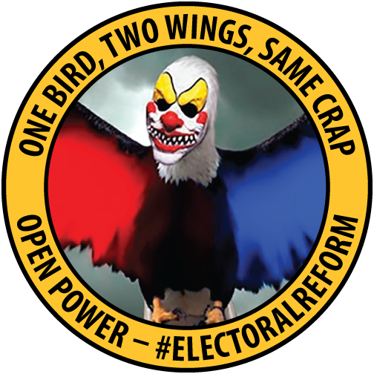
Let’s start with the short-comings of both articles. First off, Chris, whose books earn rave reviews from me and whose articles are generally featured at Phi Beta Iota the Public Intelligence Blog, is hyping one person in one election at the local level. How nice. Also very much on the margins. To suggest that this one election means anything in the face of the absolute corruption of all three branches of the federal government and the general corruption of all state and local electoral processes, is at best a cosmic joke and at worst a cruel misrepresentation. Nothing personal, I love Chris and his genius, but if we don’t stop making happy faces over isolated instances of hope we are all toast.
And then there is Laurence Kotlikoff. I know Laurence, we talked when we were both running for President ever so briefly in 2012. I like Laurence as well, and the point he is making, that we are bankrupt, is absolutely correct. What he fails to mention is that David Walker, at Comptroller General of the USA, said precisely the same thing to Congress from 2006 to 2008, when he finally resigned in disgust. Today David is running as an Independent for a Senate seat in Connecticut. For Laurence to think for one moment that anyone in Congress gives a shit about his opinion or our bankruptcy is delusional.
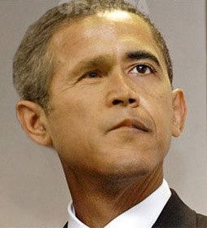
I am empathetic about this delusion, I believed for many years that if I could just wait for one more election, one more “great leader,” things would get better. Not so. I was radicalized in 2008 when I saw Barack Obama break his promise to run only on public funds and then take in close to a billion dollars, of which over $300 million have still not been accounted for to this day.
I was so outraged at the utter crap that David Plouffe and David Axelrod were spewing through their captive candidate that I wrote a quick book, free online, ELECTION 2008: Lipstick on the Pig. I was further radicalized by Theresa Amato’s 2009 book, Grand Illusion: The Myth of Voter Choice in a Two-Party Tyranny coincident with – in the same year – Chris Hedges’ Empire of Illusion: The End of Literacy and the Triumph of Spectacle. Today we know that Barack Obama is if anything vastly worse than his predecessor – what he lacks in the venality of Dick Cheney he more than compensates for in his subjugation to the military-industrial complex, big agriculture, big pharma, and of course our beloved banks too big to fail, but so big they can destroy entire economies including our own, with impunity. I credit Matt Taibbi and his first blockbuster in 2011, Griftopia: A Story of Bankers, Politicians, and the Most Audacious Power Grab in American History, with leading me to join Occupy, focus on electoral reform in earnest, and run for the Reform Party nomination for President. Here is the paragraph from Matt’s first book that most citizens have not grasped (it appears on page 32):
What has taken place over the last generation is a highly complicated merger of crime and policy, of stealing and government. Far from taking care of the rest of us, the financial leaders of America and their political servants have seemingly reached the cynical conclusion that our society is not work saving and have taken on a new mission that involved not creating wealth for us all, but simply absconding with whatever wealth remains in our hollowed out economy. They don’t feed us, we feed them.
Partly enlightened by Matt Taibbi I noticed Occupy, and in October 2011, when I saw they had an electoral reform working group, I was moved to apply for an invitation to speak to them. They gave me six minutes, a guy named Philip Small recorded it, and that video, after making the front page of Reddit and went viral. I tried – and failed – to get that working group to go to the General Assembly to propose that Occupy move indoors for the winter – specifically, into the home offices of every Senator and Representative – so as to demand the Electoral Reform Act of 2012.
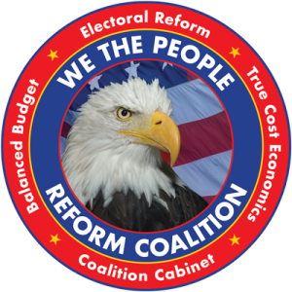
Accepting failure with Occupy, and being unemployed at the time, I applied to join the Reform Party and was accepted as a candidate for the presidential nomination. I ran for six weeks, long enough to create a website with the best ideas I could aggregate from others – and to write to every other small party presidential candidate – and one myself – inviting them to join together to push the two-party tyranny aside and open ballot access for all. Without exception they refused. This is when I realized that it is not just the Democrats and Republicans that accept the status quo, but also the Greens and Libertarians and Reforms! What I learned during this campaign – including the fact that there are eight accredited national parties that could be put on every state ballot for federal officer tomorrow if Congress were willing to make this a law – is told in my Reality Sandwich article, How I Tested the Boundaries of the Two-Party Tyranny.
That was 2012. Since then I have watched in horror as a so-called “progressive” Administration has become the most fascist in modern US history. I have read a great deal more, absorbing hundreds of books on “democracy lost” and what to do about it. That book list, freely available online as Worth a Look: Democracy Lost & Found Essay, Book Review Blurbs and Links [Updated 3 MAR 2015] is what got me to thinking in 2014 when I noticed the Economics of Happiness Conference coming up in Portland OR in February 2015 did not have a workshop focused on restoring public power over our government.
From the Conference Web Site:
Open Power: Electoral Reform & the Open Source Toolkit The progressive world is fragmented across thousands of issues and even when agreed on a major issue, such as climate change, fragmented in behavior and consequently ineffective. There are two remedies for our public impotence, and both are converging in 2015. The first is Electoral Reform. The second is Public Empowerment with a free open source toolkit that makes possible information sharing and sense-making across all boundaries. The workshop will outline the specifics of the 2015 electoral reform campaign and the specifics of the new initiative to create a proactive public intelligence network. Recommended reading before attending: http://tinyurl.com/Steele-Reform.
Robert David Steele is a former spy, honorary hacker, #1 Amazon reviewer for non-fiction (reading in 98 categories), and a former candidate for president (Reform Party). He is the author of The Open- Source Everything Manifesto: Transparency, Truth and Trust. His recent profile in The Guardian has received 58,000 likes and put Open Source Everything into the meme pool. Learn more: www.robertdavidsteele.com
Below I am going to outline the fundamentals on the first half only, Electoral Reform. If you prefer learning about this stuff via video, here are four YouTubes:
- Steele in Portland on Electoral Reform (14 Minutes)
- Steele on Alex Jones (12 Minutes, distillation from 59 Minutes)
- Steele on Alex Jones without Commercials (59 Minutes)
- Steele on Max Kaiser (13 Minutes, Start at 12:26)
Let’s start with what we have now: a two-party tyranny that has sold us all out to include eliminating any chance of our Senators and Representatives every actually representing the public interest. As the story is told in The Ambition and the Power: The Fall of Jim Wright: A True Story of Washington, Newt Gingrich not only destroyed Speaker Wright to achieve personal power himself; he destroyed bi-partisanship and stopped Congress from abiding by Article 1 of the Constitution (Congress as a balance of power against the Executive). Instead, he consolidated the control of the two political parties over their Members, and started the practice of selling all Member votes as a bloc to the highest bidders. Today we know that 42 specific billionaires “own” Congress, and that our so-called legislators neither write nor read the bills they ostensibly vote for – lobbyists do the writing, and money does the voting.
Now let’s move on to what I learned from my engagement with Occupy, my run for President, and the flood of information I received from electoral reform activists once I made Electoral Reform central to my presidential campaign – these are just the highlights:
01 As long as the two-party tyranny controls Congress and the state legislatures, no Independent, Constitution, Green, Libertarian, Reform, Justice, or Working Families Party candidate can expect to gain access to the ballot, be elected, or be effective.
02 Breaking the two-party tyranny is easier than most might imagine. We simply have to come together and make it the ONE THING that we all demand. Set aside all issues, however important. Whatever your issue is, you will not make progress on it until we first retire the two-party tyranny and restore integrity to our electoral process.
Just to drive home the point that we are in desperate straits (and I agree wit the cited opening article that places us worse off than Greece in many respects), on the next page I show a chart of all of the pre-conditions of revolution that exist today in the USA (and for that matter in the UK and many other European countries). The situation is BAD. Allowing our current dishonest government to continue will make matters WORSE.
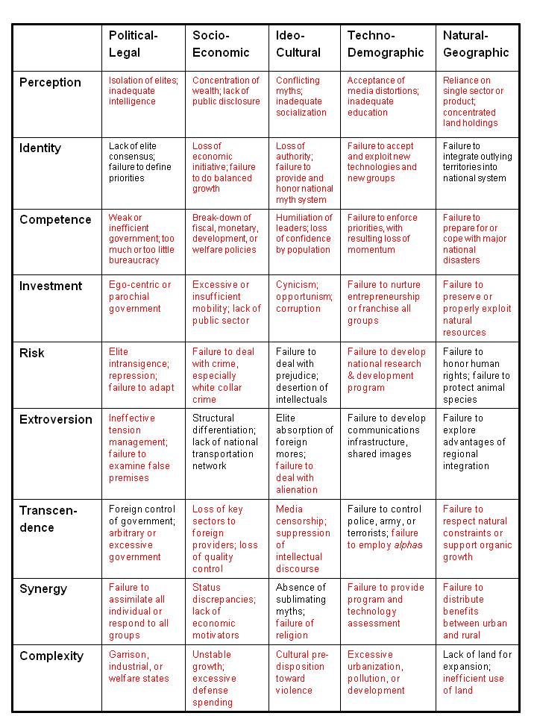

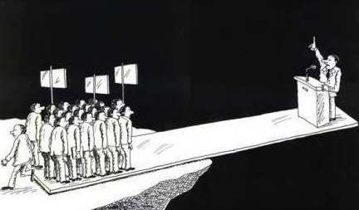
This graphic, which I have seen in various forms, captures the essence of what others have written about, for example Vaclav Havel in The Power of the Powerless: Citizens Against the State in Central-Eastern Europe and Howard Zinn, A Power Governments Cannot Suppress. We are insane to not recognize that we have the populist power to stop the two-party tyranny – and in so stopping the two-party tyranny also stop the banking and corporate and other criminal abuses that the two-party tyranny has enabled.
If you have any doubts at all on this point, spend seventeen minutes watching Eric Liu, a high school civics teacher, on the topic of why ordinary people need to understand power.
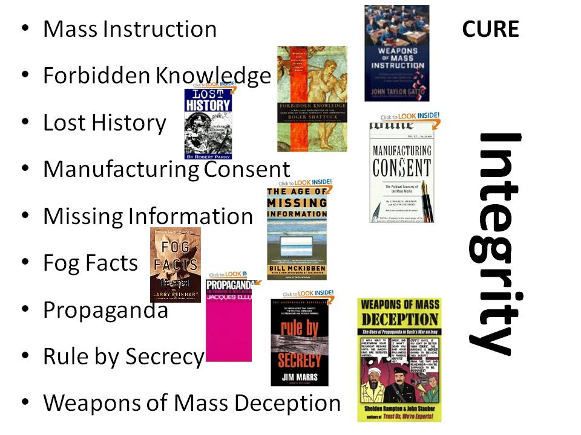
As a professional intelligence officer, the most published intelligence reformer in the English language, I have thought about this a great deal, and concluded that all of our checks and balances have failed because they were designed to fail, funded to fail, and managed to fail. Academic institutions, churches, labor unions, the media, non-profits – all hapless failures. Here to side I illustrate a few books that capture what I think of as the “big picture” of failure. We have been trained to be both obedient to authority and stupid in the face of obvious atrocities including everything that is being done in our name by the military-industrial complex, and everything that is being done at our expense against ourselves by the agriculture, education, energy, and health industries. ENOUGH! as they said in the Arab Spring. The time is right for us to EMERGE!
So what is the deal? Let’s start with our desired end state. I humbly propose that if the public embraces my vision for how to do this and what to demand in 2015, we can, in 2016:
A. Elect an Independent President, Green Vice-President, and a Coalition Cabinet committed to restoring the checks and balances called for in the US Constitution, achieving a Balanced Budget, and ending the current inequality between the 99% and the 1%.
B. Elect a sufficiency of Independent, Constitution, Green, Libertarian, Reform, Justice, and Working Family Senators and Representatives to restore the responsiveness of Congress to his home constituencies, and reinstate facts as the basis for making decisions instead of corruption.
I cannot stress this enough: whatever your issue, however righteous and important it might be, it will never get a fair hearing as things now stand. The ONLY way any issue might receive a fair hearing is if we FIRST achieve Electoral Reform and restore integrity to our government.
There are eleven international electoral reform principles that we should – but do not today – embody in the United States of America. Longer detailed accounts of each principle are online.
- Transparency: The voting public must be assured the right and ability to see and hear how elections are conducted, and to track votes by observing operations and accessing electronic or paper records to reconcile the tally and witness all aspects of elections. There must be no obscuring of data by any means, such as naming it differently to hide access; there must be strong enforcement of election laws to provide for timely, fast access to documents before chain of custody is broken or documents can be altered; there must be no acceptance of security gaps that allow for fraud capacity, all security gaps must be closed to provide true election protection to assure the safety of our democracy. This requires expedited amendment of current election laws to provide for faster access to critical documents (for example audit logs) to allow analysis in a timely manner and far tighter election security to protect the citizens’ votes. This transparency principle is embedded in all the other principles that follow and provides the foundation for integrity of our elections.

- Chain of Custody: The voting public’s ability to easily, clearly and accurately track every vote through the election process through more than one set of data; use of the two person rule (two people doing tasks at the same time as a check and balance during the chain of custody); show security access logs; allow observer access; insure that no gaps in custody exist when no visibility is permitted to the public; conduct no activity after hours when observers are sent home.

- Observer Access: The voting public has the right, as codified in CA Elections Code, to observe all aspects of elections, to ask questions and understand what they are observing (and receive accurate, understandable answers), take notes and get immediate access to supporting documents to monitor election operations. There are to be no secret documents, no secret meetings, no changes to an audit behind closed doors or after hours when observers are sent home, no secret ballot experiments, no important decisions made without public hearings, no technology that hides information beyond voter privacy (for example the Hart InterCivic, Inc. unique identifier bar codes on ballot envelopes that links the ballot to the vote and would allow insiders to track voting patterns with voters); no evasive answers to questions.

- Checks & Balances: Voters must have the protected right to have full access to, at a minimum, a second independent set of data for election tallies to verify the numbers and provide a check against electronic and paper tallies. For example, implement the Humboldt Election Transparency Project to scan ballots and tally against an electronic system.

- Enforcement of Election Laws: Put those persons with malicious intent on notice that in California there will be state oversight and enforcement of the law. Strengthen existing laws to reflect the current times. This includes: investigations, prosecutions, and also showcasing of examples of good compliance with the law. Work with the Attorney General and Secretary of State to get them to enforce laws on behalf of the citizens, not just provide legal defense on behalf of the elections officials. Establish an independent oversight commission at the state level with hearings to address the multitude of issues that are raised by citizens with officials doing nothing about the complaints. Acknowledge that counties historically will not prosecute their own people, thus, enforcement must also come from the state.

- The Voter’s right to use a paper ballot and not have the tally subject to proprietary software or software that cannot be monitored independently without many, many thousands of volunteers. Prohibit ballot shortages and forced use of DREs, touch-screens, or optical scanners - all of which have proven to be vulnerable to hacking which can alter the tally. Utilize the paper ballot, counted at the polls on election night at the precinct in the presence of multiple poll workers and observers. This method is the international gold standard as defined by the United Nations. Bring this democratic standard back to the United States.

- The Voter’s right to polls and poll workers must be protected, rather than vote by mail or forced all mail-in elections. As a country our history and tradition is based on voting at the polls with the use of poll workers to monitor the integrity of the process. This fundamental right must be upheld, with polls available and accessible to the handicapped, elderly, those without cars, and spread out geographically to make voting convenient and very localized. Reduction of the number of polls violates this principal and makes voting more difficult especially for people in our most vulnerable communities.

- The Voter’s right to photograph and videotape election operations as long as it doesn’t directly interfere with operations (i.e. film from the side rather than in front of operations to allow enough room for work to proceed) or voter privacy. Enforce reasonable distances from operations to areas where observers observe; do not allow any officials to establish cordoned-off area that restricts the ability to film, see or hear the proceedings. This is codified in the California state elections code. However, it’s not enforced and some counties ban all photography and videotaping at the door, leaving the observer with no ability to enforce the elections code correctly. Educate our judicial and enforcements systems on these rights: judges, sheriffs, county counsel, police about these rights so that they may learn to become advocates for the voters rather than enforcers of selective, and sometimes arbitrary, legal interpretation of the law.

- The Voter’s right to have full education from the elections office on how operations work, without having to know the key words to ask. Full disclosure of chain of custody and full disclosure of any broken chain of custody or other violations of these principles.

- The Voters right to full disclosure of the assumptions that underpin any numbers or assertions. For example, a claim that Vote By Mail is so much cheaper must include detailed “homework” calculations so they may be double checked by the voters for accuracy. Show the work.

- The Voter’s right to review the raw data files from where the tally originates. This is essential to prevent privatization of the elections. These files do not contain either software code (they shouldn’t, otherwise they need certification which they do not have) nor do they violate voter privacy therefore they must be immediately disclosed for analysis.
I salute Gail Work in San Mateo County and the group of California election activists with whom she worked, a group that included Eva Waskell. As all will recognize, these principles are not honored in the USA, and the two-party tyranny uses every tool it can to disenfranchise at least 60% of the voting public – and their candidates – from access to the electoral process.
Now, what is to be done?
First, we need to have a national conversation about Electoral Reform. I have aggregated eleven aspects of electoral reform that many others have suggested to me in one form or another (running for President is a great way to bring stakeholders out in the open), but these need to be discussed.
Second, we need to bring together a critical mass of past and current presidential candidates able to take the public consensus on needing an Electoral Reform Act of 2014, and turn that into a public – very publicized – DEMAND to Congress with a DEADLINE.
Third, since Congress is deaf, dumb, and blind when it comes to the public interest, and will almost certainly ignore this demand as they have ignored nine separate attempts to open ballot access to Independents and small parties in the past (Ron Paul submitted four of the nine bills), we need to be ready to OCCUPY their front lawns and home offices until they comply with our demand.
Fourth, and a happy day indeed, the Independents and the small parties need to get serious about putting forward candidates for every local, state, and federal election in 2016 and thereafter.
Below are the eleven specific recommendations that I have pulled together from across many conversations and sources. I offer them as a starting point for a national discussion, not as a pre-packaged solution calling for an up or down vote. The conversation is the essence of democracy, not the vote!
PHASE I (Implementation in Time for 2016)
1) Process. The election process shall reflect the eleven International Election Integrity Principles of Transparency, Chain of Custody, Observer Access, Checks & Balances, Enforcement of Election Laws, Right to Paper Ballot and Open Source Software, Right to Polls and Protection of Poll Workers; Right to Photograph & Videotape; Right to Full Education, Right to Full Disclosure of Numeric Calculations & Assumptions, and Right to Review Raw Data Files at Point of Origin. For the purposes of this Act, precinct-based Hand-Countable Paper Ballots (HCPB) shall be the national, state, and local standard until such time as a national referendum validates alternative solution, specifically the implementation of open source / mandatory paper ballot printing and tabulation systems
2) Ballot Access. Ballot access requirements shall be the same for every candidate, irrespective of party affiliation. Equal access includes access to debates. This shall also apply to initiatives and referenda, and to primary elections. No state shall be eligible to receive federal funding in any amount or form absent its implementation of this provision in time for 2012 and thereafter.
3) Voting for People. All national, state, and local elections must immediately begin, and by Election Day 2014 complete, the process of phasing out plurality voting and adopting a better voting system. An improved voting system should collect more information from voters using improved ballot design, and use that information to accomplish at least two of the following three goals: (1) to better satisfy more voters if all voters vote sincerely; (2) to satisfy more voters if all voters are strategic; (3) to encourage voter sincerity. Well-understood systems which satisfy two of those goals include Approval Voting, Condorcet voting, Instant Runoff Voting, and Range Voting. Newer systems which may satisfy all three goals include Majority Judgment, Simple Optionally-Delegated Approval (SODA) voting, and Proportional Representation (except closed-list forms). All ballot counting must be done using hand-marked precinct-based and Hand-Counted Paper Ballots (HCPB) Election Day must fall on a Sunday. Every citizen 18 or older, regardless of condition or transient status, must be able to vote easily. Early Voting must be universal. Which voting system can be selected on a national basis via the National Initiative for Democracy.
4) Voting for Issues. Voters in all jurisdictions -the nation, states, counties, localities, school boards, water districts, etc.- shall all have the right to propose and vote on legislation, including amendments to constitutions, charters, etc., in parallel with representatives. Improvements over existing initiative processes should be included, such as the ones incorporated in the National Initiative for Democracy and now in use in Oregon.
5) Coalition Cabinet. Presidential candidates must name prospective individuals to all Cabinet positions at least 90 days prior to Election Day, and those individuals must participate in such debates as the states might organize, and at least one national debate for each of the positions. Presidents are obligated to appoint their designated Cabinet members once elected, as the central premise of this element of the Act is to eliminate the “winner take all” nature of partisan politics.
6) Debates. Each state shall sponsor at least one presidential debate for a total of 50 debates, each state determining the questions, format, and participants. Each state shall sponsor at least one cabinet-level debate among designated individuals, e.g. the Attorney General, Secretary of Homeland Defense, etcetera. National debates shall be based on national polls that are open-ended with respect to who voters wish to see and hear participate in such debates. Candidates must participate in all debates to be eligible for free and equal access to public media.
PHASE II (Implementation in Time for 2018)
7) Representation. Enact Open Registration. Enact Proportional Representation via the Voting process (03) with full integration of the Electoral Integrity Principles (01) and full use of national referendums (04). What this means is that no voting block comprising 5% or more of the population, across the country or across any state, will lack for designated representation in the national or the respective state legislatures.
8) Districts. Gerrymandering is outlawed. It will be replaced by any combination of compact computer drawn districts using open source software and/or citizen wisdom councils selected from jury duty pools, and/or at-large districts. All gerrymanders in progress in 2011 are stopped by this Act and replaced by tightly-drawn districts. In light of the 1:1 representation provided by national referendums, no increase in the number of Representatives is necessary.
9) Funding. Qualifying candidates will receive public funding in equal amounts. Political campaign committees are made illegal and lose their public charters. For the purposes of this Act corporations are not people and may not contribute nor cause to be contributed, any campaign funds. Issue advocacy and advertising are not tax-deductible. Air time and media print space for all candidates is free and equal.
10) Legislation. All proposed legislation without exception be published on line, normally one month prior to vote but no less than 24-72 hours for emergencies, to include explicit geospatial pointers for all “earmarks” each of which must be publicly announced. Secret legislation and secret treaties are expressly forbidden.
11) Constitutional Amendment(s). Congress shall work toward a Constitutional Amendment that places Election Integrity outside the power of the government. That amendment, whose terms shall be formulated via the National Initiative for Democracy (National Ballot Initiatives). It might include but not be limited to such initiatives as:
01 Elimination of personhood for any organization
02 Affirmation of universal voter registration
03 Abolishment of the Electoral College
04 Balanced Budget
05 Termination of the Federal Reserve
07 Constraint on size and budget of the US Government
06 Re-enfranchises convicts who complete their sentences
07 Reversal of the 17th Amendment (Senate by the States)
NOTE: DC Statehood does not require an Amendment.
What about money? Sadly, this is just complicated enough so I don’t think a Kick-Starter or IndieGoGo campaign is going to do for the initial funding. I would like to be wrong about that. There are two levels of funding: the first could come from individuals such as Peter Ackerman, Michael Bloomberg, and Peter Peterson -- they funded Americans Elect (a brilliant idea badly executed that in addition lost its integrity early on) and Peter Peterson’s 2005 book, Running on Empty: How the Democratic and Republican Parties Are Bankrupting Our Future and What Americans Can Do About It was one of the first to show me that very rich people were seeing the dysfunctional nature of our dishonest government as a threat to their own wealth.
Below are a few line items adding up to $2.5 million dollars, a reasonable “ask” of the above individuals, should they agree that restoring integrity to our electoral process is much more complicated than their earlier assumption (add a viable third party candidate).
Full Time Staff, 1 per state plus 10 for a total of 60 inclusive of benefits | 600,000
150 Workshops with travel expenses for local, state, and national participants | 300,000
Political advisors, author influencers, consultants, researchers, all part-time | 600,000
Independent and small party leader engagement inclusive of travel & stipends | 300,000
New national values survey directed by Ray Paul and Sherri Ruth Anderson | 300,000
Summit hotel rooms, catering, audio-visual inclusive of press corps catering | 200,000
Outreach to youth, labor, veterans, and unemployed – roughly 2/3 of all voters | 200,000
TOTAL | 2,500,000
Now what if this idea takes off? What if all 110 million at or near the poverty level join with the 30 million unemployed electricians to CEOS and the 20 million new college graduates living again at home with their parents and the 80 million Cultural Creatives?
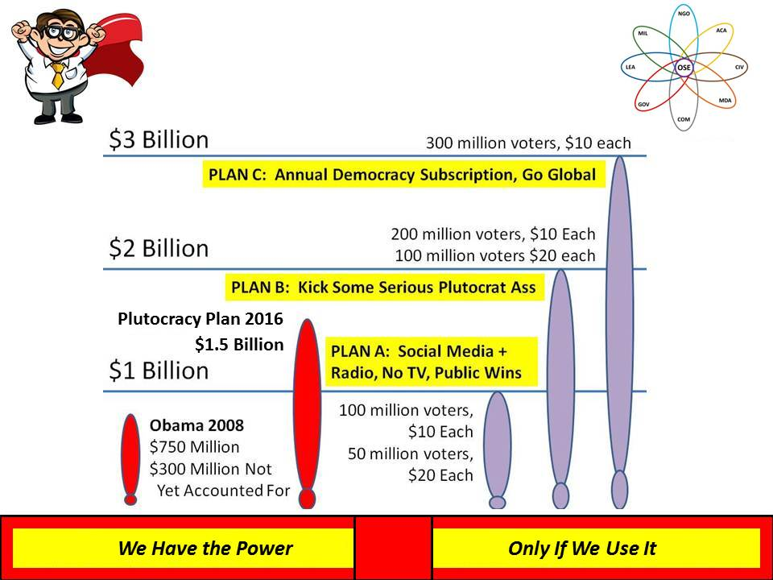
Here is my vision. Imagine just 50 million of these donating $10 this year to our Electoral Reform Fund. Then imagine 100 million of them donating $10 each. Then imagine the first 50 million coming back with another $20 each. The below graphic, inspired by Howard Dean and Joe Trippi and Zephr Teachout, is the tip of the iceberg, in my view.
Finally, a word on the elites that have blocked up from free and equal elections for so long.
A major reason I am so optimistic about the possibilities of our success is that I have observed a sharp breaking of the ranks among the elites. Ackerman, Bloomberg, and Peterson were ahead of their time. More recently Lady Lynn Rothschild (who was born in New Jersey) sponsored a conversation on “Inclusive Capitalism,” code for “stop the pitchforks. Elsewhere, in both Europe and on the West Coast of the USA, we have the “Black Sheep Billionaires” talking about Redemptive Capitalism – another term for “stop the pitchforks. What they are realizing is that the achievement of a 100% corrupt government is NOT WORKING. They are killing the golden goose of the economy, the individual worker and working families.
I also learned long ago that given a population of nine billion, and given the way the economies of the world work, there is nothing to be gained from confiscating wealth for redistribution, particularly digital wealth that is largely intangible and difficult to apply at scale.
This is why I have been focused on a non-violent revolution rooted in Truth & Reconciliation. As much as I agree with the critiques of predatory capitalism, some call it “vampire” capitalism, and as much as I agree that great harm has been done by Wall Street and the City of London, I also have to observe that We the People allowed our government to legalize these great crimes, We the People have been absent from our duty as citizens, and We the People must be ready to start fresh, without any more destruction or conflict.
My bottom line: let us come together to achieve Electoral Reform in 2015 so as to restore the integrity of the US Government in 2016. Beyond that, I pray that the grace of God might be with us all, and allow us to self-govern with integral consciousness and a commitment to the creation of a prosperous world at peace, a world where we do no further harm to the Earth, to others, or to ourselves.
I have published a book, only electronically because it has hundreds of live links to documents, graphics, and book reviews. I offer two free online sources of information, the Open Power home page and the Democracy Lost book review page. I hope this article – and those sources, are helpful. I have done all one man can do. Now it is up to the community to decide if it wants to be free and equal.
Robert David STEELE Vivas is the son of a US oil engineer and a Colombian daughter of Telmo Vivas, founder of the Escuela Remington in Cali, Colombia. He grew up all over the world and then spent many more years overseas as a Marine Corps infantry officer and CIA spy. His education includes an AB in Political Science with a thesis on multinational corporations and home/host country issues; an MA in International Relations with a thesis on predicting revolution; and an MPA (Public Administration) with a thesis on strategic information (mis)management. He is a graduate with distinction of the Naval War College as well as the Marine Corps Command and Staff College. His awakening came when he served as the senior civilian responsible for creating the Marine Corps Intelligence Command in 1988-1993. This is when he discovered that secret intelligence accesses less than 10% of the relevant information and is often wrong about any given question. He went on to champion Open Source Intelligence (OSINT), training 66 countries and over 7,500 mid-career officers in this domain. He then turned his attention to the educational and economic theme of Open Source Everything, and the political theme of Electoral Reform. He was a candidate in 2012 for the Reform Party presidential nomination, creating a small movement, We the People Reform Coalition. Today he is leading an Electoral Reform movement; his latest book, Open Power: Electoral Reform Act of 2015 – Open Source Activist Tool-Kit has been #1 in Civics at Amazon Kindle.
See Also:
OPEN POWER Electoral Reform Home Page
Worth a Look: Democracy Lost & Found Essay, Book Review Blurbs and Links [Updated 3 MAR 2015]

