After Paris: An American Grand Strategy – Evidence-Based, Affordable, Balanced, Flexible -- No Longer Ignoring Gladio, Wahhabism, or Traitors in Our Own Ranks
Robert David Steele
The Paris attacks bring home far better than any words of mine just how desperately lacking we are in both intelligence and integrity. None of the government leaders – and none of the media personalities – dare utter the obvious: these attacks are either state-sponsored attacks, or a neo-Nazi false flag operation organized by the still-strong remnants of the North Atlantic Treaty Organization (NATO) Gladio program, perhaps drawing on volunteers offered up by Turkey or Saudi Arabia. Although these attacks are also consistent with Israel's long-standing "Oded Yinon" Plan for fomenting a clash of civilization between Muslims and Christians -- it is never out of the question for any alleged ISIS attack to actually be an Israeli false-flag attack, especially if it furthers the Balkanization of the Middle East and forces France to join the war against Syria – on balance I favor the Gladio narrative – what was done to Italy is now being done to France. The role of the US in creating the Islamic State of Syria and Iraq (ISIS) cannot be ignored, nor can Russian President Vladimir Putin’s public report identifying 40 states allowing individual to provide financial support to ISIS.
The recent Democratic presidential “debate” was sophomoric. No one was willing to discuss a prior history of Western deceit and war crimes, a recent history of political betrayal of the public trust and gross mis-judgment, and our long tolerance of Saudi Arabian export of Wahhabist terrorism and Israeli genocide against the Palestinians and plain ignorance. The Republican presidential candidates are no better – they will hold the Middle Eastern powers blameless and call for more spending on a military that is already too hollow and too expensive. We will never hear the truth from either wing of the two-party tyranny. We are our own worst enemy.
President Barack Obama is absolutely correct in refusing to put boots on the ground in Syria -- it was boots on the ground in Iraq, and the dismantling of the Iraqi army, that enabled Saudi Arabia to create ISIS on top of our own creation of the precursor to ISIS in Libya. Absent a strategic decision to confront and contain Saudi Arabia, Qatar, Turkey, and Israel, no amount of violence against ISIS within Syria will neutralize this asymmetric challenge.
As Senator John McCain (R-AZ) and Representative Max Thornberry (R-TX) focus their respective Armed Services Committees on defense reform, I propose that we embrace the Paris attacks as our wake-up call – as a sign that we need a total make-over. We need a grand strategy rooted in intelligence with integrity, one that allows us to totally reinvent defense, diplomacy and development (D3). The Secretary of Defense is doing what he can with the D3 Innovation Summit, but without a grand strategy led by the White House and acceptable to all Congressional jurisdictions, we should expect no constructive changes before 2018.
I believe that the Vice President’s decision not to run for President opens the possibility for his rendering a historic service on behalf of the President and in the public interest: he should oversee a Grand Strategy review such as has not been done since President Dwight Eisenhower commissioned Project Solarium in the summer of 1953. Such a review could be hosted by the U.S. Army War College and The Eisenhower Institute. Such a review could include a balanced mix of Members of Congress, staff from the Congressional Budget Office (CBO) and Congressional Research Service (CRS), Cabinet professionals, and a range of representatives from across the eight “tribes” of information in America: academia, civil society including labor and religion, commerce, government at all levels, law enforcement, media, military, and non-government/non-profit.
The review should be conducted at four levels – strategic, operational, tactical, and technical, across four domestic domains and four national security domains as listed below and subject to modification by the Vice President:
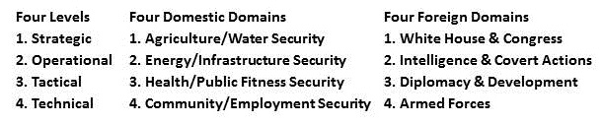
The review should have a mandate to examine the entire budget (i.e. a zero-based bottom-up review) but also a mandate to emerge with recommendations that are job and revenue neutral across the political landscape. This is not as impossible as it may seem if we are allowed to trade off-off domestic-oriented jobs and domestically-based soft-power jobs (e.g. a new Inter-Agency Development Corps) against heavy-metal military jobs.
In 1989 I ghost-wrote an article for the Commandant of the Marine Corps calling for a greater focus on emerging non-state actors and followed that up with my own published work in 1990, finally presenting four threat classes and four needed forces after next at the Marine Corps University in 1992. We were ignored. In 1998 the Army War College addressed the asymmetric threat and the need to restructure ourselves. In 2008 the Army War College addressed the need to rebalance the instruments of national power. For a quarter-century the loyal dissidents striving to serve the Republic have been ignored. We have wasted trillions of dollars and millions of lives and we are on the verge of becoming a Third World nation, broken at home and impotent abroad, because our political process is in grid-lock.
A grand strategy review led by the Vice President and committed to a balanced program of reform that is job and revenue neutral across the political landscape is our only hope for restoring our homeland prosperity and our foreign punch.
I have developed my own answers, limiting myself to the national security domain, in a published white paper, An American Grand Strategy: Evidence-Based, Affordable, Balanced, Flexible. Below is the executive chart. I have no doubt a broader group will achieve better results, but I am quite certain that if we do not attempt this process, with buy-in from the White House and Congress, the current Administration will end with a whimper, and the military will be incapacitated for the next two to ten years.
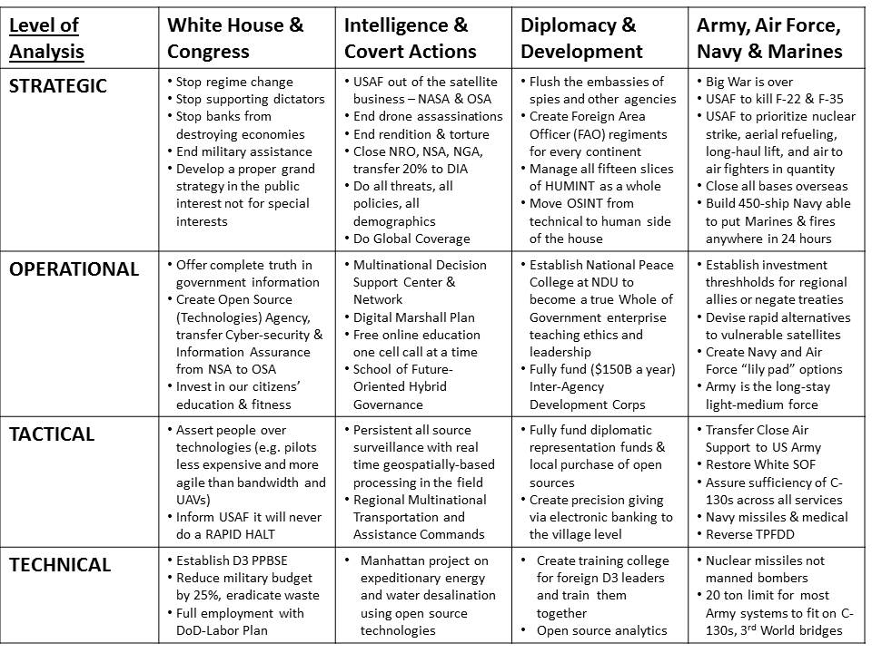
Central to this grand redesign is an Open Source (Technologies) Agency such as I have proposed to the Vice President, copied to the Secretaries of State and Defense. That agency would be an open source innovation engine for development, while also making possible necessary multinational “eight tribe” information sharing and sense-making on climate change, poverty, and other non-military threats that now require military-level attention and spending. I have proposed that the Vice President be the Chairman of the Board of Visitors for this new agency, and stay on in that position beyond his political term of office.
The above – and my longer white paper – are nothing more than a starting point for a broader discussion. The time/distance challenge must be joined by the weight/energy challenge, with the lethality challenge and the fiscal challenge always present. We can no longer afford to pretend to be strong. We can no longer afford to accept Congressional largesse that detracts from our ability to create real capabilities needed in the real world. We can no longer accept “budget share” as the foundation for defense allocations. We can no longer afford to short-change diplomacy and development. We can no longer afford to make decisions lacking in intelligence and integrity.
What we can do is get a grip on reality, have a conversation, and put our house in order. My commitment to job and revenue neutrality across the political landscape is a serious one. I seek one person in the White House and one person in Congress with whom to have this conversation.
Robert David Steele is CEO of Earth Intelligence Network, a 501c3 educating leaders in holistic analytics, true cost economics, and open source everything engineering. A former spy, he has been co-creator of the Marine Corps Intelligence Activity and CEO of Open Source Solutions, Inc. He has personally trained over 7,500 mid-career officers from across 66+ countries.

ENDNOTES

According to Federal Bureau of Investigation (FBI) whistle-blower Sibel Edmonds, author of the non-fiction book Classified Woman-The Sibel Edmonds Story: A Memoir (Sibel Edmonds, 2012) and the truth as fiction book The Lone Gladio (Sibel Edmonds, 2014), Gladio is very much alive today. An excellent summary is provided by Nafeez Ahmed, “Special Report: Why was a Sunday Times report on US government ties to al-Qaeda chief spiked?,” Ceasefire, May 17, 2013. See also the many search results for Gladio at Phi Beta Iota Public Intelligence Blog. The first entry is the original 1992 BBC documentary Operation Gladio, with direct personal interviews, highly relevant to understand why the latest Paris attacks emerged from Belgium.
Nafeez Ahmed, “NATO is harbouring the Islamic State,” Insurge Intelligence, November 20, 2015.
Robert Parry, “Can Obama Level with the People?,” Consortiumnews.com, 14 November 2015.
Israel Shahak, “’Greater Israel’: The Zionist Plan for the Middle East – The Infamous ‘Oded Yinon Plan,’” Global Research Newsletter, November 7, 2015.
Fred Burks, “Origins of ISIS aka Islamic State: Well Researched Essay Exposes ISIS and War Agenda,” WanttoKnow.info, November 19, 2015.
Arjun Walia, “BREAKING: Putin Reveals 4O Countries That Are Funding ISIS At The G20 Summit,” Collective Evolution, November 16, 2015.
Barry M. Lando, Web of Deceit: The History of Western Complicity in Iraq, from Churchill to Kennedy to George W. Bush (Other Press, 2007); Jeremy Brecher et al, In the Name of Democracy: American War Crimes in Iraq and Beyond (Metropolitan Books, 2005).
Lou Dubose and Jake Bernstein, VICE: Dick Cheney and the Hijacking of the American Presidency (Random House, 2006) and Charles Lewis, 935 Lies: The Future of Truth and the Decline of America’s Moral Integrity (PublicAffairs, 2014); James Bamford, Pretext for War: 9/11, Iraq, and the Abuse of America’s Intelligence Agencies (Anchor, 2005); Liz Sly, “The Hidden Hand Behind the Islamic State militants? Saddam Hussein’s [and Paul Bremer’s],” The Washington Post, 4 April 2015;
James Risen, Pay Any Price: Greed, Power, and Endless War (Mariner Books, 2015); Theresa Amato, GRAND ILLUSION: The Myth of Voter Choice in a Two-Party Tyranny (The New Press, 2009).
Supra Note 5.
Al Gray, “Global Intelligence Challenges in the 1990’s,” American Intelligence Journal (Winter 1989-1990); Robert David Steele, “Intelligence in the 1990’s: Recasting National Security in a Changing World,” American Intelligence Journal (Summer/Fall 1990).
Lloyd J. Matthews (ed.), Challenging the United States Symmetrically and Asymmetrically: Can America be Defeated? Carlisle, PA: Strategic Studies Institute, U.S. Army War College Press, July 1998.
“2008 Rebalancing the Instruments of National Power–Army Strategy Conference of 2008 Notes, Summary, & Article,” Phi Beta Iota Public Intelligence Blog, May 9, 2008.
Free online at “Robert Steele: A Notional Grand Strategy — Request for Comments,” Phi Beta Iota Public Intelligence Blog, October 31, 2015; for those who prefer Kindle, available for 99 cents as An American Grand Strategy: Evidence-Based, Affordable, Balanced, Flexible, Seattle: WA: Amazon Kindle, October 2015.
My memorandum and supporting documentation can be found online at “The Future: Recent “Core” Work by Robert Steele,” Phi Beta Iota Public Intelligence Blog, November 5, 2015.

