Robert David Steele

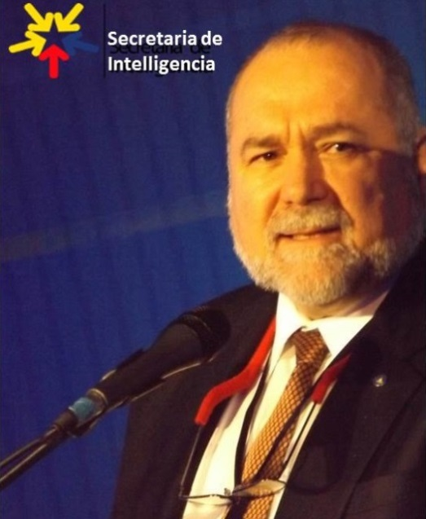 | Robert David Steele is a holistic strategic analyst and educator of individuals and organizations – governments, corporations, non-governmental organizations, and universities in particular. He is competent at all-source collection management (know who knows); geospatially-based visualization of complex data; multidisciplinary and multilingual analytics; and compelling interaction with decision-makers facing painful choices and confusing opportunities. A former senior intelligence professional for the USA, an honorary hacker, and a top Amazon reviewer for non-fiction, reading in 98 categories, he has been CEO of a for-profit company, Open Source Solutions Network, Inc., and is today CEO of an accredited educational non-profit, Earth Intelligence Network. Robert is known for his early proponency of Open Source Intelligence (OSINT), teaching 7,500 mid-career officers from across 66 governments (NATO/PfP, others) and is today the leading proponent for Open Source Everything Engineering (OSEE), inclusive of Applied Collective Intelligence, which integrates Holistic Analytics and True Cost Economics, the three together being an engineering and information management approach that is affordable, interoperable, and scalable.
The two most recent books by Robert Steele are entitled THE OPEN SOURCE EVERYTHING MANFESTO: Transparency, Truth, & Trust (North Atlantic Evolver Editions, 2012), and INTELLIGENCE FOR EARTH: Clarity, Diversity, Integrity, & Sustainability (Earth Intelligence Network, 2010). He has been recognized as a thought leader since 1994 when he was featured by Alvin Toffler in a chapter on “The Future of the Spy” and listed by Microtimes as an unsung hero striving to change the world for the better. Only recently has the larger public, shocked by Climate Change, Ebola, and rampant destabilization across Central Asia, the Middle East, and North Africa, begun to understand that we must achieve foresight through holistic design informed by true cost economics and manifested in Open Source Everything Engineering (OSEE). He is a mentor for those seeking to create organizations that are rooted in ethical evidence-based decision support. His motto, “the truth at any cost lowers all other costs,” is one that can help any organization thrive in times of chaos by achieving evidence-based foresight and shaping their future.
Accomplishments |  | Education & Experience
- Proponent for Open Source Everything (OSE)  - Funded architecture for World Brain & Global Game  - Created global practice of Open Source Intelligence  - Author, NATO, DIA, SOF OSINT Handbooks  - Primary OSINT contractor to SOF 1996-2007  - Created four strategic analytic models  - 2006 Earth Knowledge – Six Bubbles  - 1988 World Model – 144 Factors  - 1979 Cultural Intelligence Analysis Model  - 1976 Predicting Revolution – 12 Domains  - Most published intelligence pioneer in English  - Eight books, two with Forewords by Senators  - Curate 80+ strategic foresight bloggers @ Phi Beta Iota |  | Academic Visitor, Loughborough University (UK)  Research Adjunct, Strategic Studies Institute (SSI)  CEO (pro bono), Earth Intelligence Network (501c3)  CEO, Open Source Solutions, Inc. (C Corporation)  USMC Intelligence, 2nd ranking civilian at the time  CIA, top human and technical operations performer  USMC, infantry, intelligence, S-1/Adjutant  Naval War College (Defense Economics)  MPA University of Oklahoma (Strategic Information)  MA Lehigh University (Predicting Revolution)  AB Muhlenberg College (Multinationals Gone Wild)  Other Languages: Native Spanish, elementary French  21 years in Asia, Caribbean, Central & South America
Robert is passionate about helping organizations shape their future with the practice of ethical evidence-based decision-support for future-oriented hybrid governance that creates a prosperous world at peace.

Bio & Publications: http://robertdavid.steele.com Core Recent Work: http://tinyurl.com/Steele-Future

CHRONOLOGY OF THE EMERGENCE OF THE OPEN SOURCE EVERYTHING MEME

2016 Apr | Invited by Government of Denmark to brief military and intelligence, http://tinyurl.com/2016-OSINT and also to lecture on Open Source Everything Engineering (OSEE) a university.
2016 Feb | Invited by IEEE Computer to create a 3,500 peer-reviewed article on OSEE intended to inspire consideration of a new conference and perhaps a new journal.
2016 Feb | OSEE concept submitted to United Nations Sustainability Development Goals Report 2016 http://tinyurl.com/SDG-OSEE and brief created for Open Data Institute and Open Knowledge Foundation, http://tinyurl.com/Steele-Hack.
2015 Dec | Featured in Singularitywebblog with both an article and a video interview, concept of “ethics as an OS”
2015 Dec | Shuttleworth Foundation Flash Grant Awarded to bring OSE idea forward, OSEE featured in Futurism Magazine, “Interview on the Open Source Revolution”
2015 Oct | Memorandum to Vice President Joe Biden proposed Open Source (Technologies) Agency, a $2 billion a year grant-mapping agency intended to launch open source everything innovation
2015 Jun | Michel Bauwens agrees to create Category:Open Source Everything at P2P Foundation, Robert Steele inserts content, Michel Bauwens, Marcin Jukubowski (Open Source Ecology, Shuttleworth fellow) polish Robert’s suggests nine categories and 27 sub-categories.
2015 Jun | Hans Kern Interviews Robert Steele for Rag ‘n Rock: World Brain II.0
2015 Mar | Open Power concept developed in an essay on Democracy Lost, subsequently published as a KINDLE at Amazon, Open Power: Electoral Reform Act of 2015 – Open Source Activist Tool-Kit
2014 Dec | Provide answers to Richard Olivier of Findhorn Foundation on Leadership in the 21st Century
2014 Sep | Funded (travel only) by the Findhorn Foundation to present the Open Source Everything concept to their annual conference on new innovative socio-cultural concepts. Video online here.
2014 Aug | Created new PhD program idea of Loughborough University (appointed a visitor but funding fell through) with new graphic showing how OSEE could eliminate waste and embed intelligence in everything
2014 Jul | Hans Berghel of IEEE Computer interviews “Robert David Steele on OSINT” including Smart State
2014 Jun | Nafeez Ahmed publishes a profile of Robert Steele and Open Source Everything in The Guardian, “The open source revolution is coming and it will conquer the 1% - ex CIA spy,” it receives 33,000 shares in 3 days and is now up past 68,000 shares. This led to the Findhorn invitation.
2014 May | Invited by the Internet Society of New York to lecture on The Open Source Everything Manifesto: Transparency, Truth, & Trust, available as a video http://tinyurl.com/Steele-LibTechNY
2013 Apr | In six parts, interviewed by David Balaban for Privacy PC, “Open Everything: Interview with Robert David STEELE Vivas http://tinyurl.com/Steele-PrivacyPC
2013 Feb | Open Letter on need for a larger open source everything approach to the Internet, tools, and the cloud http://tinyurl.com/2014-Open-Letter
2012 Oct | John Maguire posts YouTube interview, “Robert Steele, Open-Source, and You” (6:30)
2012 Aug | Book Page and later (2013 Mar) Home Page created for The Open Source Everything Manifesto: Transparency, Truth, & Trust (North Atlantic Books) as published
2012 July | Twitter hashtag #openall created
2012 Apr | Call to Arms to Occupy: End Rule by Secrecy and the Two-Party Tyranny with Open Everything
2012 Mar | Invited to present to the Washington Academy of Sciences with the title of “Refexivity as Integrity: Toward Earth/Life 4.0,” http://tinyurl.com/WAS-Steele
2009 Mar | The Ultimate Hack: Re-Inventing Intelligence to Re-Engineer the World (Faculty of Advanced Engineering University of British Columbia March 2009) – this led to the 2012 book and the Denmark brief & chapter
2008 Jul | Michel Bauwens creates Category:Open at P2P Foundation inspired by the Open Everything Project of Mark Surman (Mozilla, Shuttleworth Fellow) and David Eavers, he uses Robert Steele’s first graphic on the Open Source Tri-Fecta as the opening illustration.
2007 Jul | Keytone speaker at Gnomedex (bloggers), “Open Everything: We Won, Let’s Self-Govern”
2007 Jan | Capstone speaker to Amazon Developers Conference, “Amazon as Hub of the World Brain”
1988 Oct | Created and began leading the Open Source Intelligence (OSINT) revolution across 66+ countries, publishing many books, articles, chapters, created conference training 7,500 from 1992-2006.

