AN OPEN LETTER TO DONALD J. TRUMP
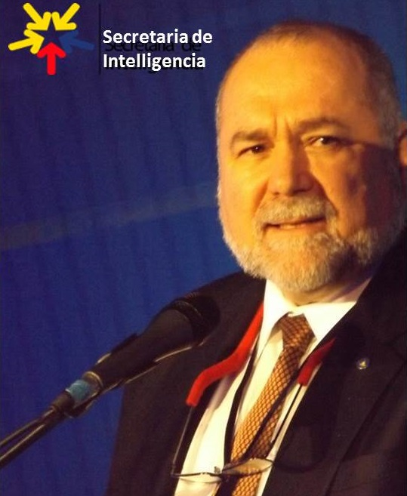
Mr. Trump,
You announced your presidential bid on June 16, 2015. Since then I have made multiple respectful attempts to connect with you directly, with Roger Stone, Cory Lewandowski and with your campaign staff. I wrote and published CounterCoup: How Trump Can Win, on 14 August 2015 in CounterPunch. I was unsuccessful in the months that followed. Worried about you, last week I turned to a retired hedge fund manager, now a philanthropist, and asked him who he talked to when he did his standard high dollar donation. Here’s what he told me:
Robert, it would surprise you how many people are attempting to reach Donald Trump right now. There is no campaign as we know it, no structure, no national coordination, no desire to connect with state/local GOP leadership—chaos is reigning supreme. The only people I know that were able to reach him (past tense) are the REDACTED folks, and that was through REDACTED.
Now I understand from Neil Keenan that, with the dynamism of the entrepreneur, you prefer to carry most of the load yourself, are very uncomfortable bringing in new direct reports, and may be confident you easily can beat Joe Biden and Elizabeth Warren, who will be aided by massive electoral fraud – one reason I want an Electoral Reform Act in time to assure your legitimate win cannot be stolen. [I expect Hillary Clinton to be indicted before the convention and to watch Election Day from a courtroom if not from Martha Stewart’s former cellblock in West Virginia.]
More is at stake here than restoring democracy and putting Main Street back in the saddle in the USA. This election is about the future of the Earth, the restoration of humanitarian focus, and the elimination of the criminal powers over economies now exercised by a financial cabal we all know by name but that only you can “settle.” A global game plan, not just a national game plan is needed – a series of Truth & Reconciliation meetings will be needed in and out of the USA to demonstrate that you alone can reconcile the restored economic powers based on tangible assets, and the retiring financial fraudsters who must be assured a “soft landing” on their way out the door.
I regret the time that I, Russ Verney, Cynthia McKinney, and many others have not been able to spend working toward your landslide victory for lack of our ability to connect with you directly. If you embrace these ideas, you are the one man on the planet that could execute them within 30-90 days. I hope that you do.
Let’s start with the playing field. We not only want you to win in a landslide, we need to create a Congress that you can work, an effective Congress that is truly representative. We do this with a combination of an Electoral Reform Act that wipes out Hillary Clinton’s superdelegate advantage while opening the door to viable Congressional candidates from across the political spectrum; and a series of national conversations that will bring all eligible voters back into the democracy that you will restore and lead. I had to run for President myself to learn that we have eight accredited national parties; the six blocked from ballot access are the Constitution, Green, Libertarian, Natural Law, Reform, and Socialist. For the first time since 1896 when 79.3% of eligible voters voted, we need for you to achieve a 75% or greater turn-out by eligible voters regardless of party affiliation. However dynamic your leadership might be, we cannot make America great again without assuring the inclusion of ALL eligible voters – 85% to 90% is achievable if you execute this plan. You have demonstrated, in a way unlike anyone else in the history of the Republic, the capacity to bring people back to the process. I believe the action plan I present below will allow you to exceed all expectations in relation to the 70% who are marginalized today—Barack Obama was re-elected by 26% of the eligible voters.
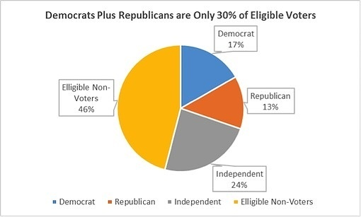
There are seven specific actions you can do to re-engage the recalcitrant conservatives, woo the small parties (two of which are ultra conservative) and energize everyone else to win by a landslide while restoring integrity to Congress so it can execute its Article 1 responsibilities.
01 Virtual Constitutional Convention with Governor Greg Abbott and Mark Levin in Texas. Focus on state rights, build the national consensus for cutting the federal budget in half. Fund eight citizens from each State, a total of 400 for a live week, selected through a four week online process that engages hundreds of thousands more – shoot for C-SPAN coverage of the week and a national television audience of 100 million when the proposed Constitutional changes are announced in prime time.
02 Unemployment Workshop in NYC. Shaming all the banks and corporations, announcing a commitment to full employment and zero inflation – the real unemployment rate is 23% -- bring together John Williams of ShadowStats.com and other serious economists, include the Congressional Research Analyst documenting a 40% non-participation rate of adults in the US economy.
03 Electoral Reform Summit in California with Ron Paul and Dennis Kucinich, Jesse Ventura, Cynthia McKinney, Jill Stein, Gary Johnson and many others, perhaps repeated in Ohio. Ask Tom Steyer and Mike Bloomberg to co-sponsor this event. It changes everything – if Senator Rand Paul will introduce it in the Senate and Speaker Paul Ryan (who finally endorsed you yesterday) will introduce it in the House, in one stroke you will have eclipsed all others in terms of an authentic commitment to making America great again by putting the citizens – all of them – back into democracy.
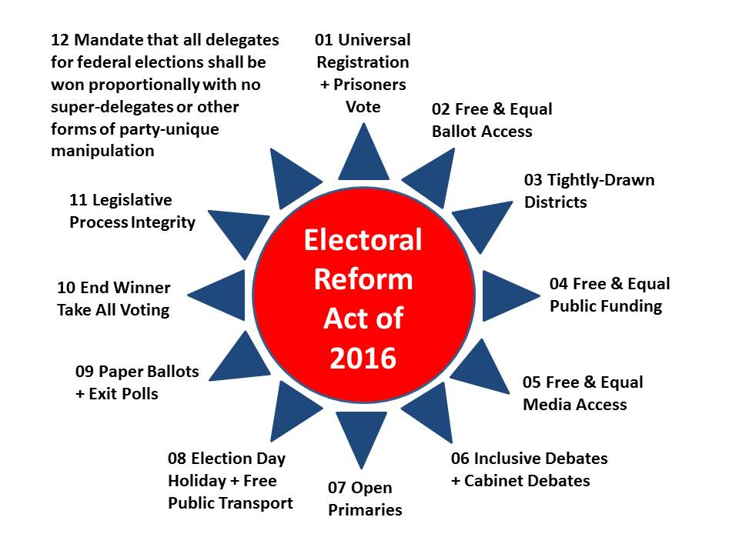
Senator Bernie Sanders and his staff (bernie@bernie.org) have refused EIGHT TIMES to introduce this Act, an Act whose 12th point would bury Hillary Clinton. Time to call him out while working with Senator Rand Paul and Speaker Paul Ryan to get at least 10 Libertarians and 10 Independents elected into the new Congress – a few Constitutions and Greens would demonstrate full spectrum democracy is back in town.
04 Black Mobilization leveraging Cynthia McKinney as well as the robust men and women of color who already support you. You can watch Cynthia McKinney and me on Alex Jones where among other points we note that because of the Clintons and their Prison Act, there are more African American people in jail today than there were slaves at the beginning of the War of Secession (wrongfully called the Civil War). Combine with my Latino reconciliation program and your winning over the dispossessed youth that support Bernie Sanders and this makes it “Game Over.” Your support among African American men in particular is deeper than any of the political media reporters are willing to admit, and the same is true among Latino men that understand “machismo” and tough talk. We can discuss women whose dreams have been dashed – your instincts are about the demographics are on target but you need a vastly better team and a more intense outreach program across the board, something you cannot do alone.
05 Take http://bigbatusa.org and raise $1B in 90 days (50 million times $20 each). We should have been doing this since September 2015. With a good team we can make up for lost time.
06 At BigBatUSA, engage the public in forming multiple notional Cabinets each responsible for offering up a Balanced Budget – I fully expect that you already have a full Cabinet in mind but this national engagement will change how all citizens see you and the business-like give and take that can be achieved across 200 million eligible voters welcomed online. Only you can do something this big in scope but you need to grow your team and trust those of us who seek to explode your appeal with substantive online discussion and town hall meetings such as no one has ever seen before – a rolling series of Chautauqua buses, one for each of the “Nine Nations” of North America less Quebec. We can and should devise a complete national security and national prosperity strategy prior to Election Day, covering all ten high-level threats to humanity, across all twelve core policy domains. No else is capable of doing this and doing it with full transparency. You cannot let the Democrats get away from the facts – facts such as (in addition to the Clinton incarceration of more black people than there were slaves in 1861):
a) The military budget is consuming 60% of the disposable federal budget in FY2015
b) Documented fraud waste and abuse in the military runs from 45% in weapons acquisition to 75% in Afghanistan
c) The infantry, 4% of the force that takes 80% of the casualties and gets 1% of the military budget – everything else is pork that does not work as advertised – stuff that is too big, too expensive, and not effective.
d) We need a 450 ship Navy, a long-haul Air Force, and an air mobile Army at the same time that we need a better balance among defense, diplomacy, and development – we can do both while cutting the bloated military budget in half and moving those savings toward everything at home that has been neglected by the financialization of the economy.
Main Street, not Wall Street, must be restored as the heart and soul of who we are and how we govern ourselves.
The good men and women of the military and of law enforcement are your best friends but you must make it clear to the rest of America that we have failed to do our jobs by them – our military should not have been sent in harm’s way to further the profits of the deep state and the military-industrial-financial complex and our police should not have been militarized in the failed drug war augmented by the prison industry complex created by Bill and Hillary Clinton.
I must be blunt: you might be able to win an election, even against the massive electoral fraud that the Democrats are able to execute, but you cannot govern and you cannot make America great again without the specific recommendations I am making to you, this one being the most nuanced and the most difficult to execute. I was featured in Kevin Booth’s movie, American Drug War: The Last White Hope. I know and love Ricky Ross as an entrepreneur and I despise the two-tiered legal system built by the Clinton’s and deepened by the Bush’s that treats the 99% as expendable cannon fodder and road kill. We are all black now. That is the central tenet of this electoral cycle, and that is the core point I am not sure you have ingested yet. It’s not enough to achieve election – you must restore integrity to the entire process, and give voice and vote back to the totality of the earnest public that loves America the Beautiful and the US Constitution in spite of all of the abuse heaped on them by the banks and the government and local extensions of the banks and the government since the assassination of John F. Kennedy.
07 Commit to ending all income taxes, to full employment, and to an end to inflation. The Automated Payment Transaction Tax (APT) as devised by Dr. Edgar Feige of the University of Wisconsin, ends the burden of income taxes on all citizens and small businesses and corporations, while exploding the revenue pie to include all banking transactions – a tiny fractional tax adds up to no more deficit or debt. Add to that your adoption of the Ronald Reagan Joint Defense-Labor plan devised by Deputy Secretary of Labor Del Spurlock and your commitment to ending financial manipulation of the economy and the inflation tax on Main Street and we are looking at the beginning of the Trump Era with a twist: we lead by example.
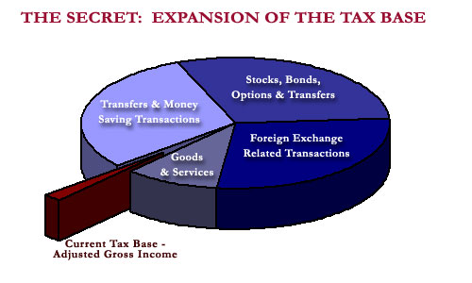
Sincerely yours,
Robert David Steele
Son of New York, Resident of Virginia

Additional References:
Steele, Robert. Democracy Riots! We are all black now – deal with it!, Amazon Kindle, March 22, 2016, 24 pages, 99 cents.
Steele, Robert. REVOLUTION!: How Donald Trump Can Win and Govern by Championing Electoral Reform, a Coalition Cabinet, a Balanced Budget, and a Constitutional Convention in 2018, Amazon Kindle, March 16, 2016, 111 pages, 99 cents.
Steele, Robert (2015). Open Power: Electoral Reform Act of 2015, Open Source Activist Tool-Kit, Amazon Kindle, February 24, 2015. 216 pp. $2.99.
Steele, Robert (2008). Election 2008: Lipstick on the Pig, Amazon Kindle, April 20, 2015. 158 pp. 3.99.

